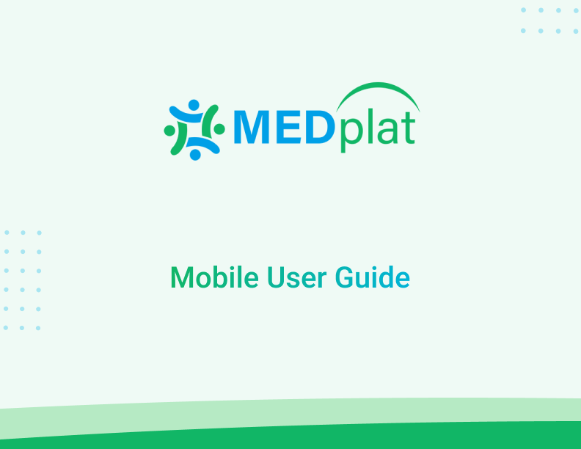

**Contents**

**Part 1 Introduction 3**

**Part 2 Getting Started 4**

Chapter 1 Installation and Setup 5

Chapter 2 Tour of The Application 8

Chapter 3 CFHC (Comprehensive Family Health Census) 11

3.1 How to fill out the CFHC form 12

Chapter 4 My People (RCH module) 19

4.1 Eligible Couples 19

4.2 Pregnant Women 26

4.3 PNC Women 47

# Part 1 Introduction

***MEDplat*** is a comprehensive, public health management framework that can be customized to create the required low-code solution. It is highly customizable and amenable to the diverse needs of different public and primary healthcare implementations. MEDplat’s interoperability with centralized government health-related portals is an added advantage. Over time, MEDplat has evolved in terms of its scale, usage, and acceptance in the field. It has been successfully implemented in different healthcare contexts in India and abroad.

The implementations are :

1. **TeCHO**: Gujarat, India.
2. **Impact Health**: Nigeria.
3. **ekavach**: Uttar Pradesh, India.
4. **Ammakosam**: Telangana, India.
5. **i-MoMCARE**: Cambodia.
6. **DDD PHMP**: Union Territory of Diu, Daman, Dadra and Nagar Haveli, India.

# Part 2 Getting Started

This MEDplat user guide is intended to assist users who will work using a mobile application.

The different modules of the MEDplat Mobile application have been added below as Chapters for assistance. The core/primary modules of the MEDplat mobile app i.e., CFHC, HIgh-Risk Women and Child, My Family (RCH), and features are explained comprehensively in the following chapters. The core modules are a necessity for setting up MEDplat in any country/context.

Application Credentials:-

• Username: fhw_test

• Password: 12345678

## Chapter 1 Installation and Setup

Installation of the MEDplat mobile application is a simple process. The user has to download the apk file from the login page of MEDplat and install it in the system as sown below.

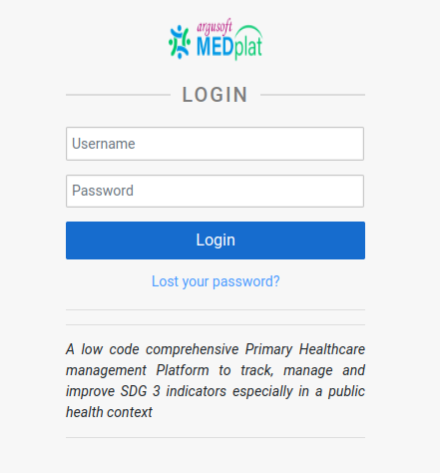

* Once the apk is downloaded successfully, the user needs to install it on their device. A step-by-step installation process is shown below

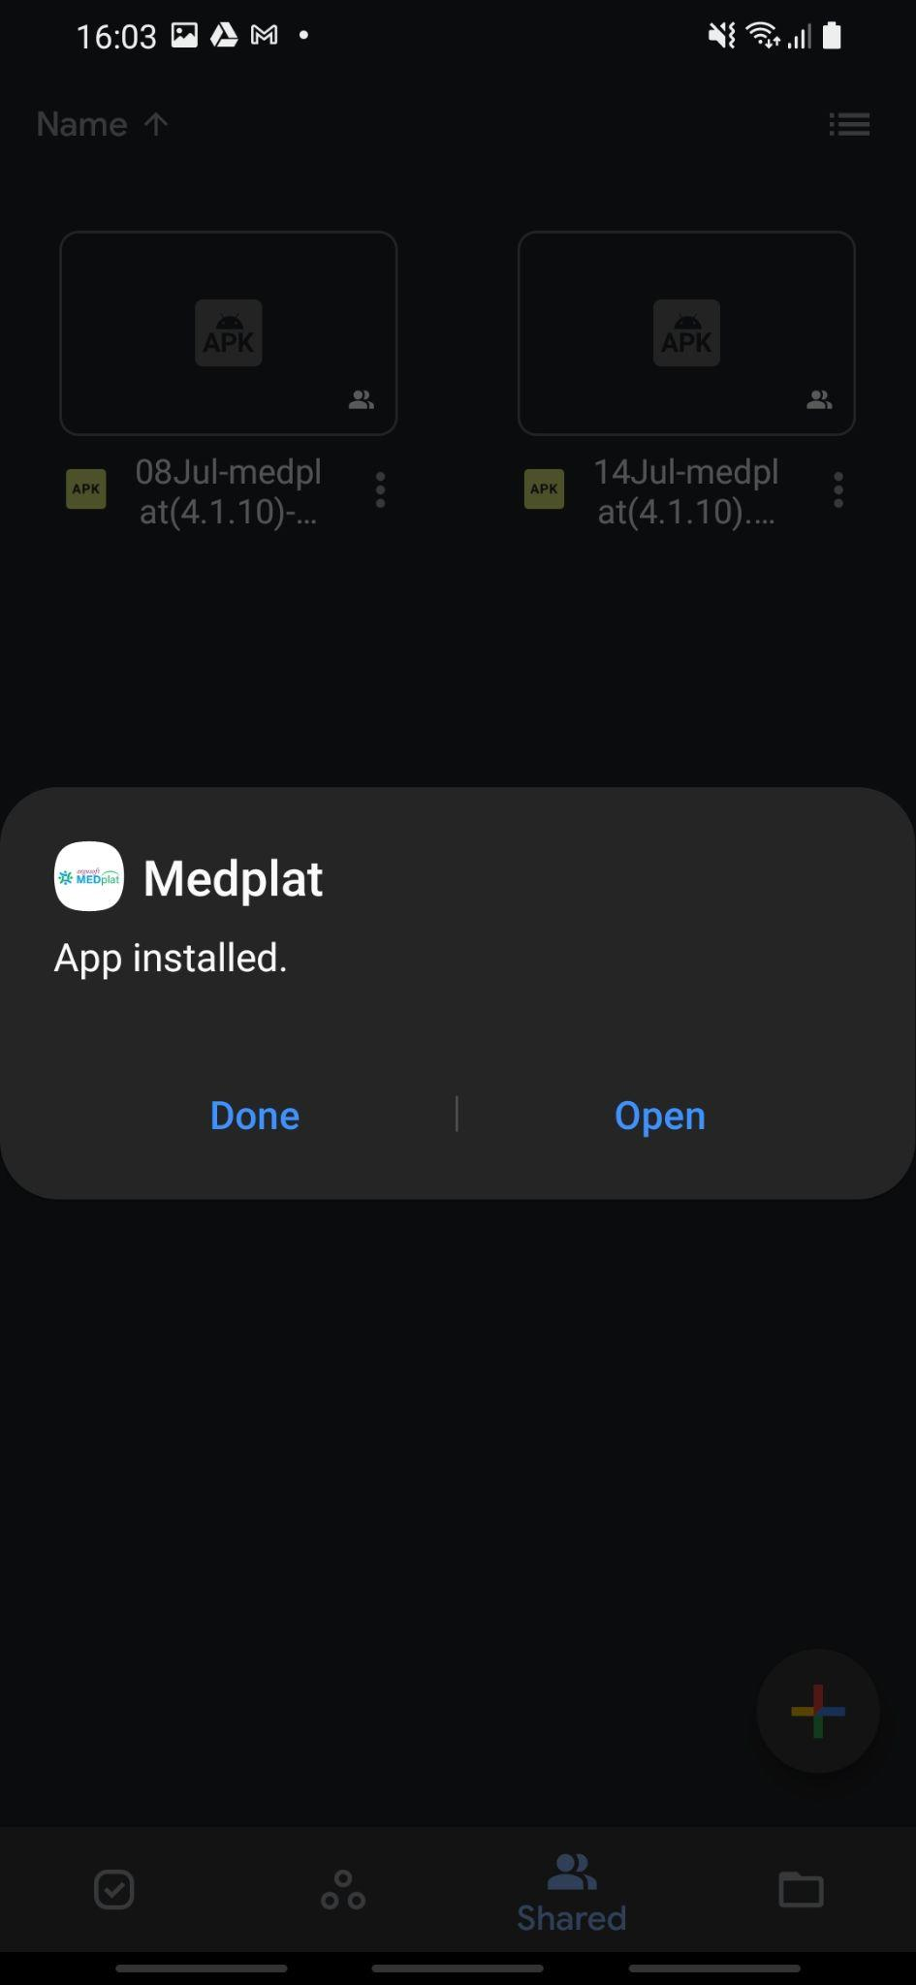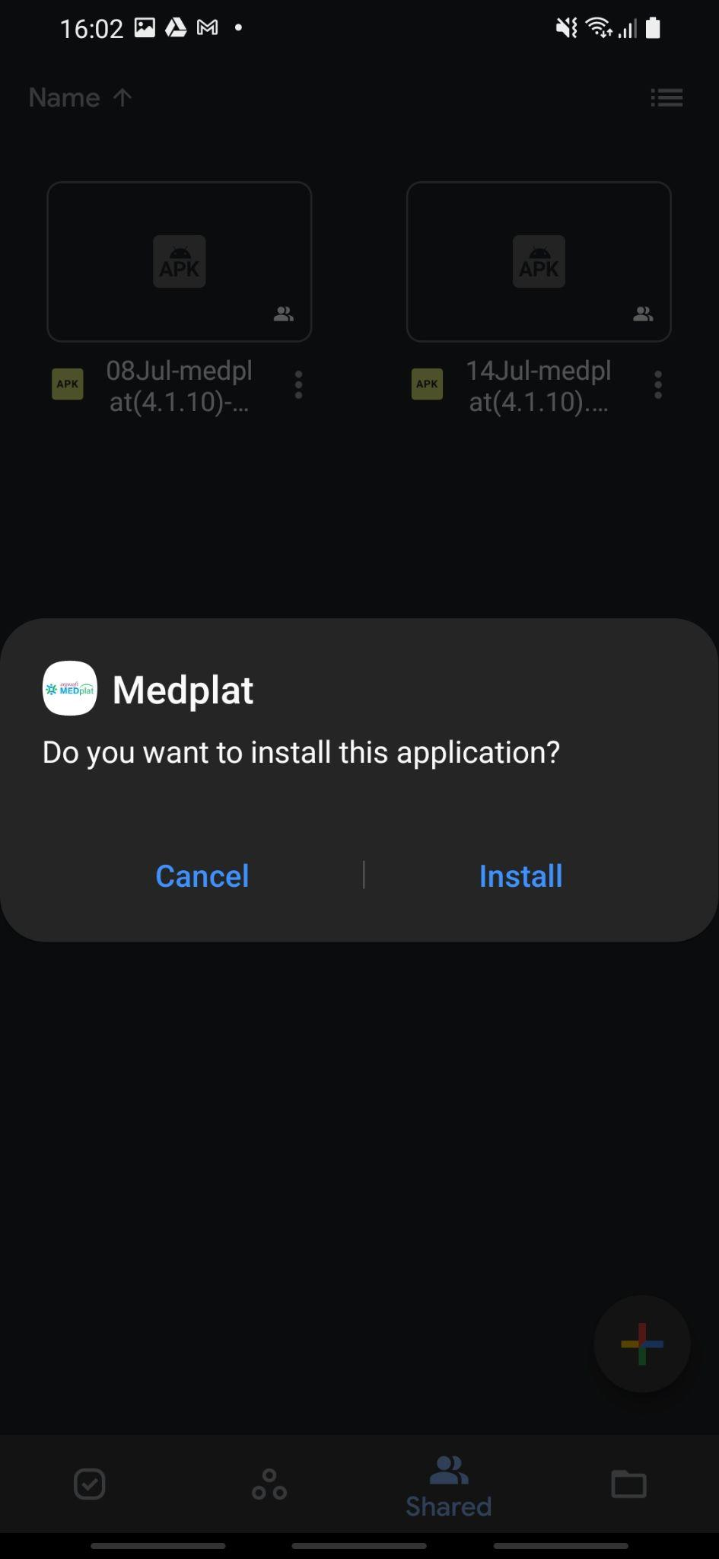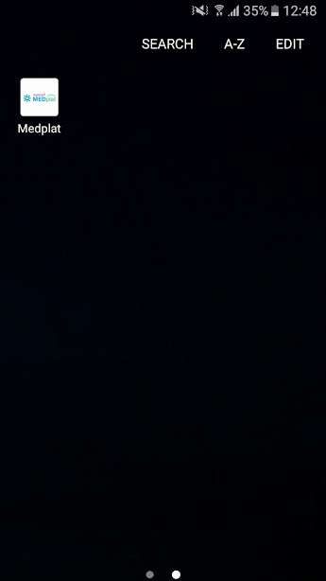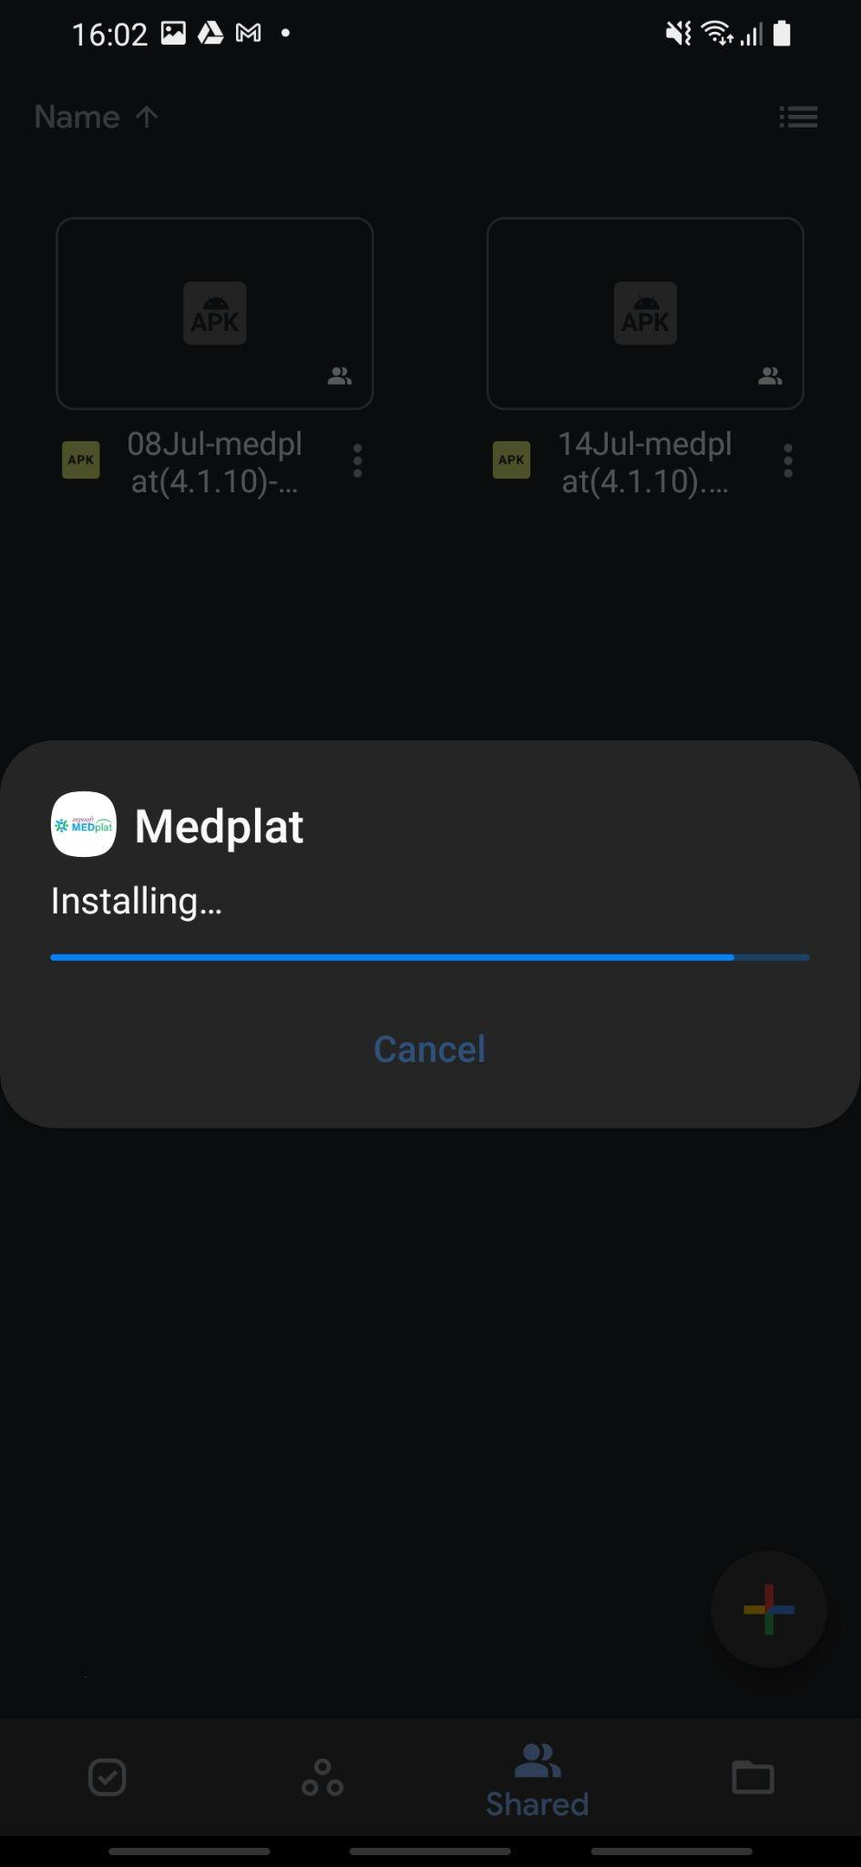

* Once the application is downloaded, the system will ask whether to install the app or not. The user needs to tap on the **INSTALL** button.
* The example of the app icon installed on a device is shown highlighted in the above screenshot.

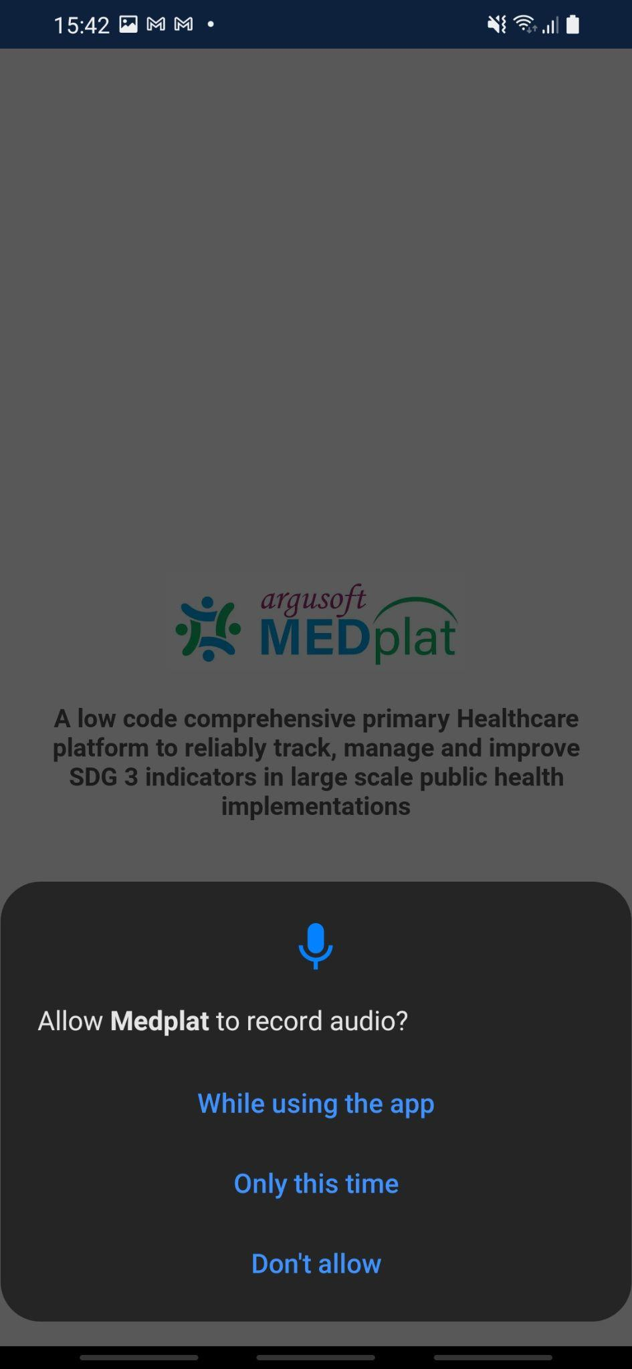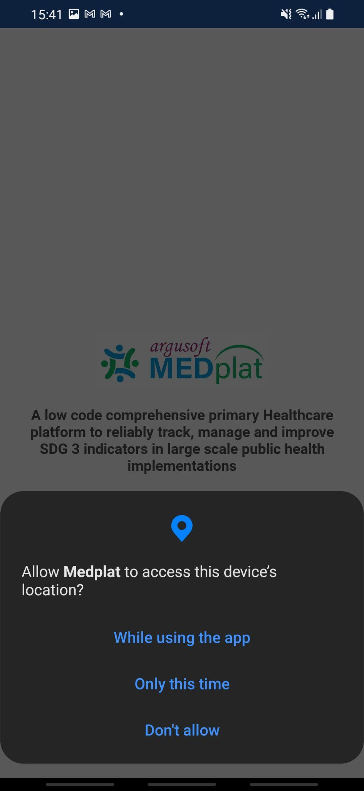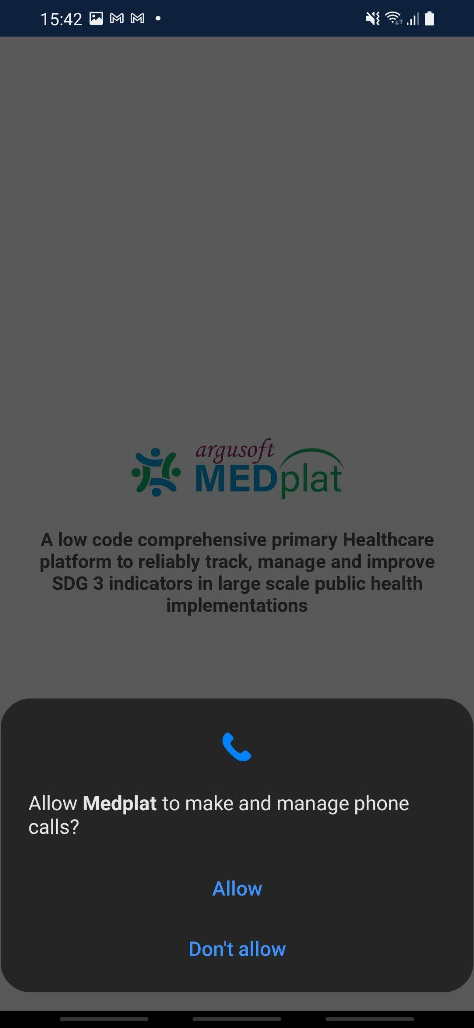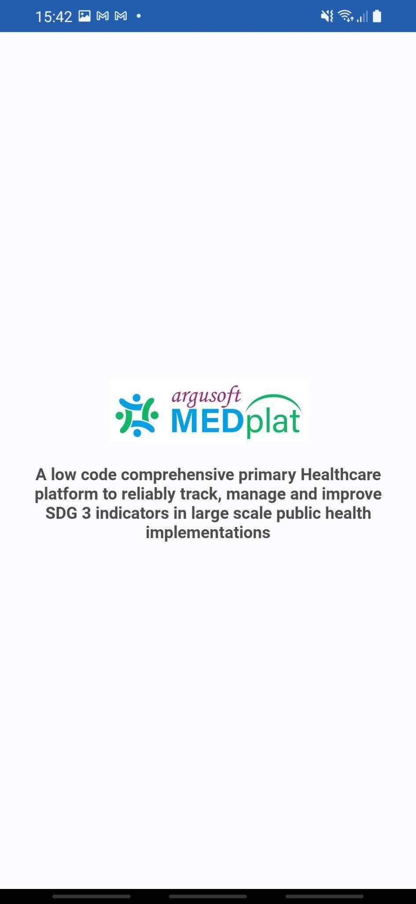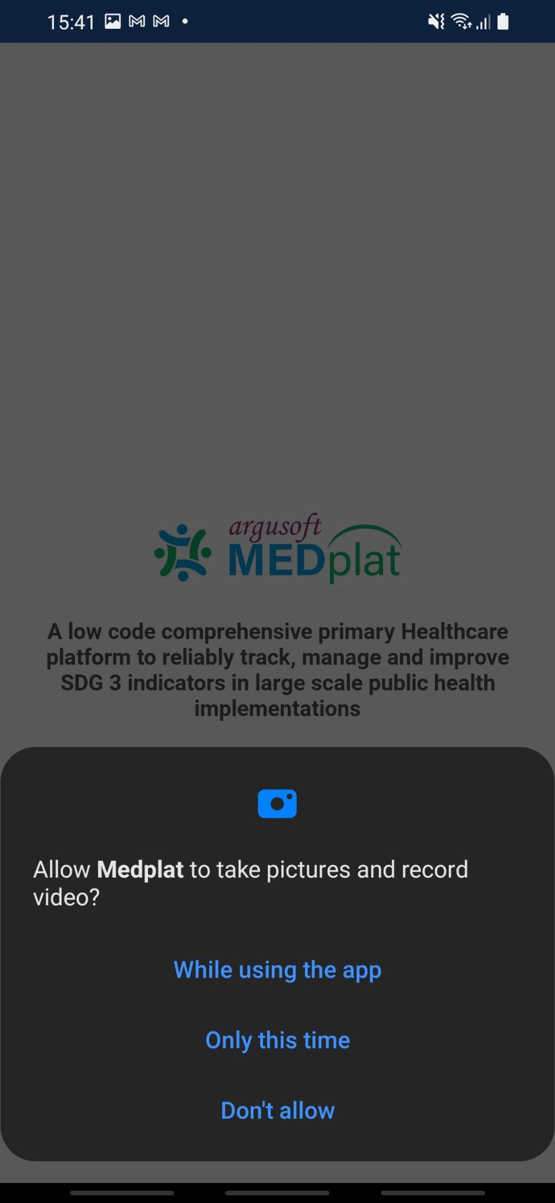

* After this the app will be installed and will be ready to use. When a user opens the application, it will ask for several permissions for a fresh installation. The user needs to allow each of the permission in order to proceed to the login screen.

## Chapter 2 Tour of The Application

* Once the user opens the application he/she needs to perform login.
* For login, the credentials will be shared with the user by the administrator or concerned authorities.
* After entering the credentials, the user needs to tap on the ***Login*** button.
* If the user is validated the system will show a confirmation message i.e., **login successfull with network** and for the first time it will take some time to load.
* If there is any error during login then the system will show “**Username or Password is incorrect”**

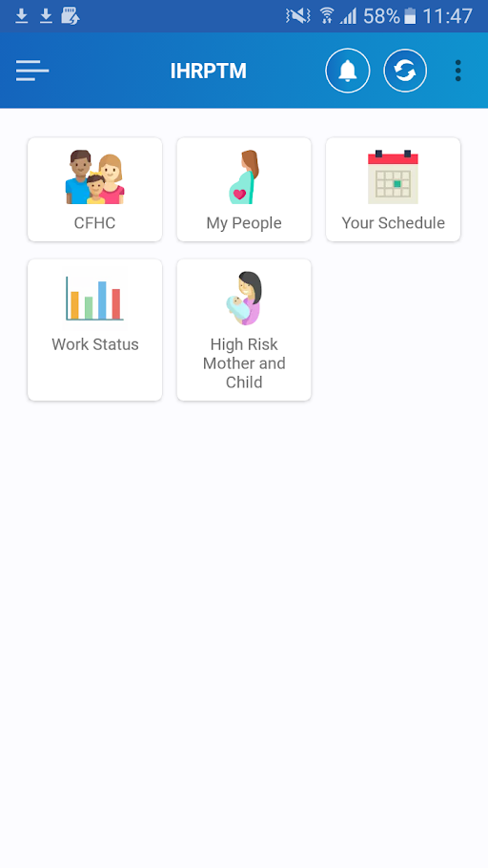

* Here is the home screen of the application. It contains different widgets assigned on the basis of the role of logged-in user. It is as follows:

1. CFHC - adding/Managing families.
2. My People - reproductive and child health care related services.
3. Your Schedule - contains list of all services to be provided.
4. Work Status - provides insights for the services provided till date.
5. High-Risk Mother and Child - dedicated widget to easily track all the high-risk children and pregnant women

### How to View the profile of the user……

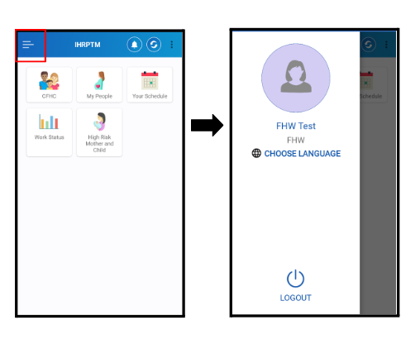

* As shown in the first image to change the language or to log out from the application click on the  symbol on the top right corner of the application.
* Once a user clicks on the symbol the new screen will have options to logout from the system and change the language.
* User can perform the actions according to the need.

### About in MEDplat….

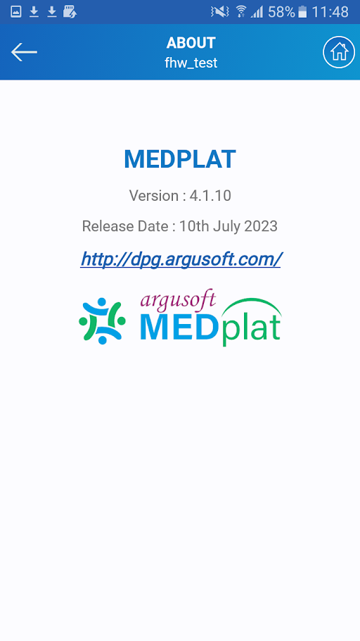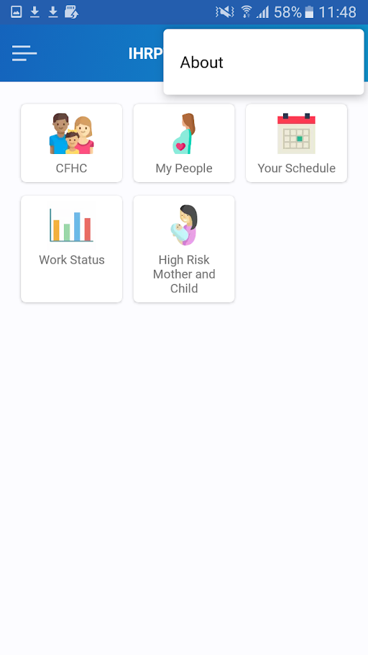

* If any users want to know about the current version of the application or any other relevant information then click on the top right corner of the home screen and there will be an option of About will pop up,
* Tap on About, and the user will see the about page containing several pieces of information such as release date, version, reference website, etc.

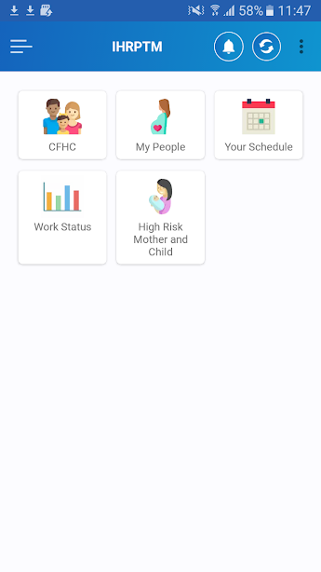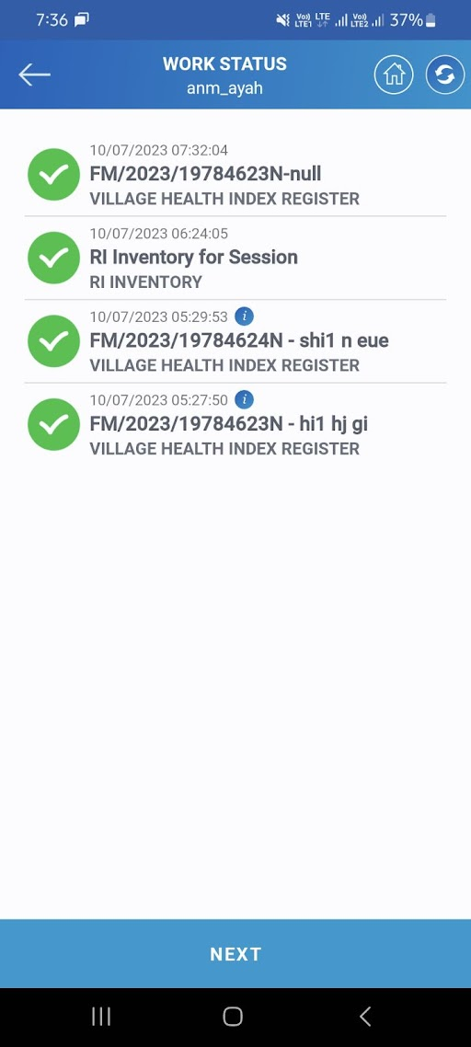

* Once a user clicks on the ***sync*** button i.e  system will redirect to the work log of the user
* There will be a list of work that the user has done
* User needs to tap on the sync button the submit the work in the system
* As the application runs in offline mode syncing the data is suggested at regular intervals
* The maximum amount of work log the system will have will be of 10 days without syncing
* Hence it is advised to sync the data before this

## 

***\*\*Note: Sync must be done after every visit in regular interval and also in the case of uninstalling the application\*\****

## Chapter 3 CFHC (Comprehensive Family Health Census)

CFHC stands for Comprehensive Family Health Census. The CFHC feature is a country-wide survey conducted by the health ministry to accommodate reliable and up-to-date family data. A complete set of details of each of the family and the related members is collected.

The primary goal of performing CFHC is to provide essential information on health and family welfare for RCH, NCD, Nutrition, etc. The family enumeration serves as a root in order to provide services across different national health programmes.

### 3.1 How to fill out the CFHC form

An ASHA/ANM/Health worker can fill out this form by tapping on the ***CFHC*** icon**.** The steps for the same are mentioned below.

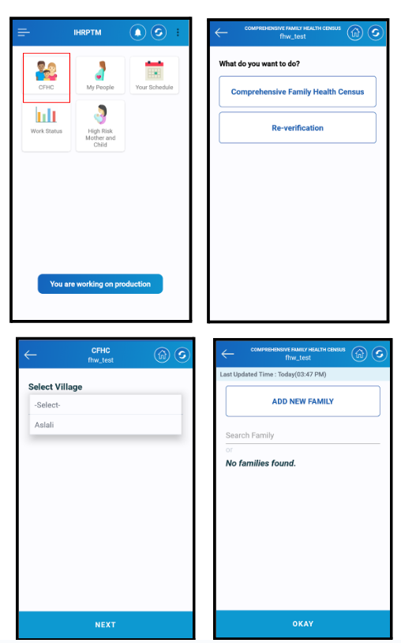

* User needs to tap on the ***CFHC*** which is highlighted on the screen. Once he/she taps on it she will be redirected to the next page as shown beside
* There are two buttons displayed on the screen:
* **Comprehensive Family Health Census**
* **Re-verification**
* To add a family, please tap on the ***Comprehensive Family Health Census*** button**.**
* Next screen will display the selection of location or name of the village. User will be able to see the list of villages that are assigned to him/her.
* Once the user selects the village and clicks on the ***NEXT***  button he/she will be redirected to the screen which shows the list of families if available and has the option to add a new family.
* User needs to tap on the ***Add New Family*** button to add a new family.

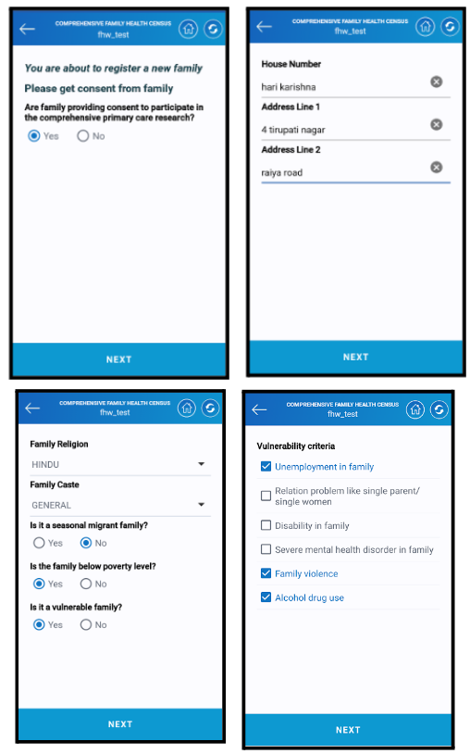

* The system will ask for the consent of the family to participate in the survey. User needs to click on yes after the consent is granted and tap on the ***NEXT*** button to move ahead.
* Next comes the address details. User must enter the address details in the relevant section.
* Once the details are entered tap on the ***NEXT*** button to proceed ahead.
* Next comes the other details such as religion caste etc. Asha needs to enter this data with respect to the family's situation.
* If the family is vulnerable then the next screen will ask about the criteria for vulnerability.
* Asha can select multiple options for the same. Once the options are selected tap on the **NEXT** button to proceed.

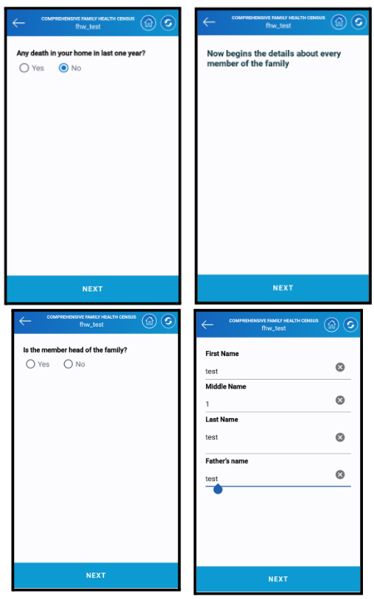

* The system will ask whether there is any death in the family in the last year or not. If there is any Asha needs to enter it.
* Once the above procedure is done the next part will be details of every family member.
* If the member is head of the family then select yes else no.
* Personal details such as name, middle name, last name and father’s name must be entered.
* Once all the details are entered click on the **NEXT** button to proceed ahead with the survey.

***\*\*Note: The head of the family should be older than 18 and the marriage age should be 15 years or above\*\****

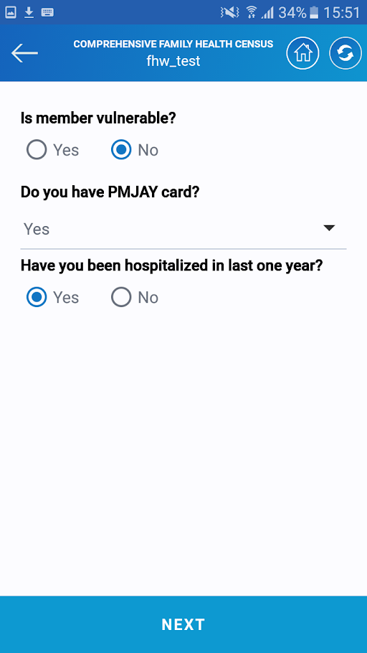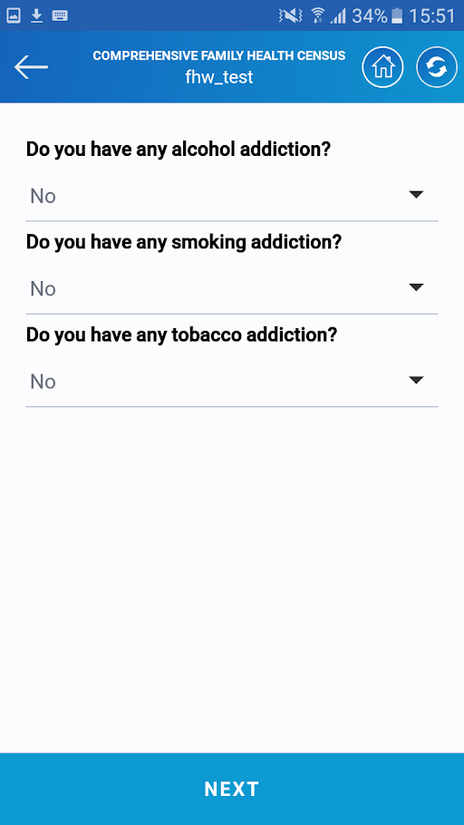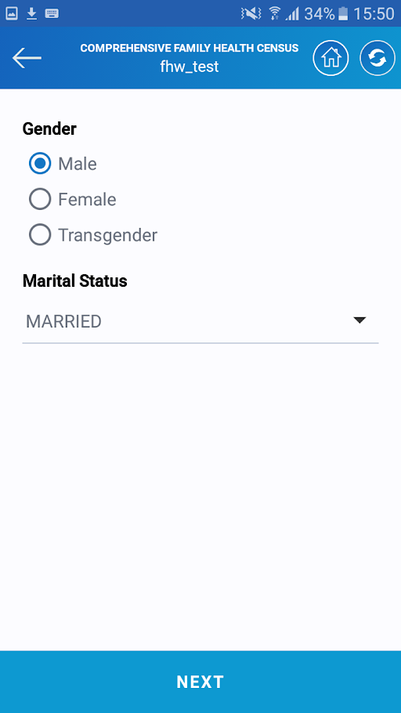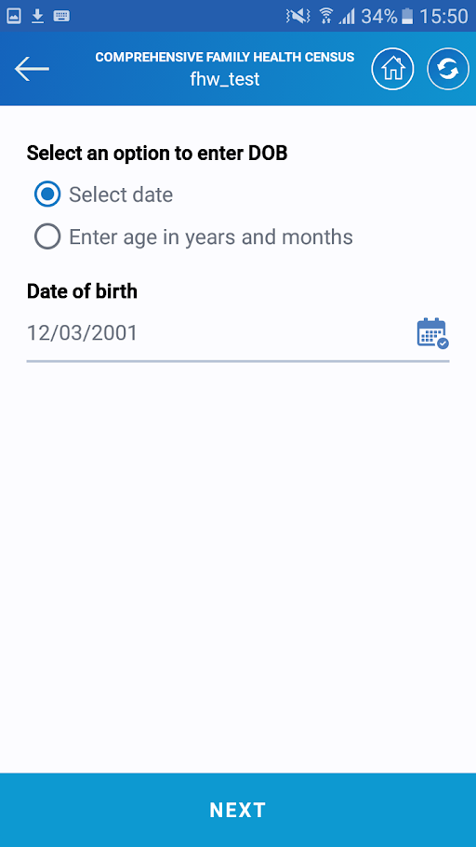

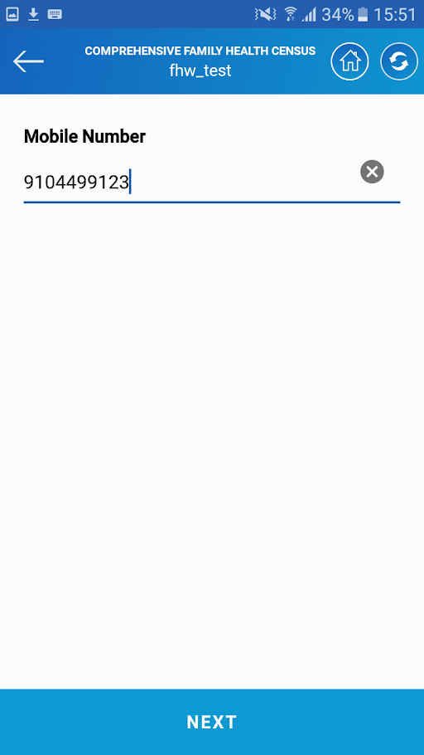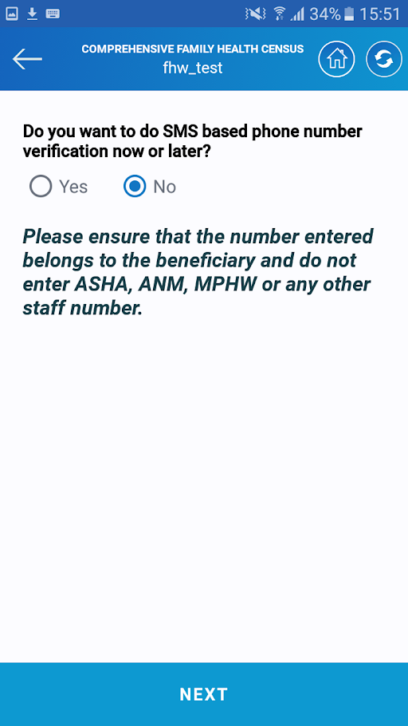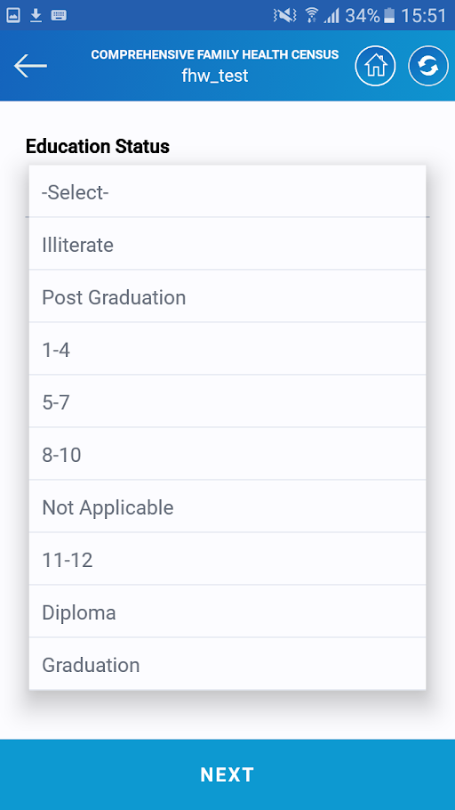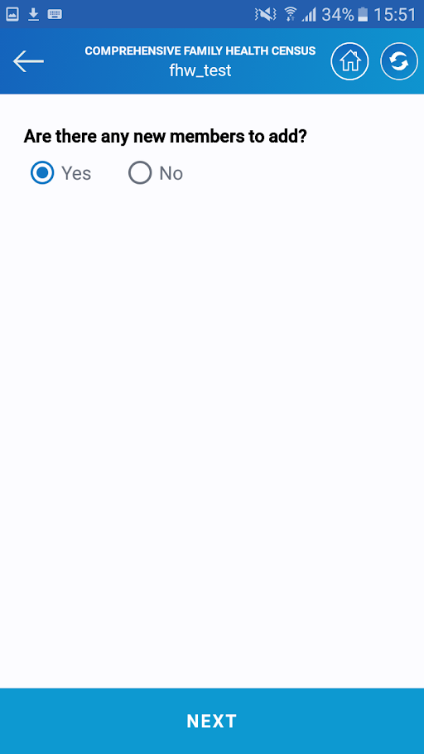

* The system will ask for the personal details of the family member such as date of birth, gender, marital status, other addiction-related questions, education, etc.
* Once all the questions are answered the system will ask to add another member's details if there are any.
* Asha has to click on **NEXT** to enter the details of another person in the family.

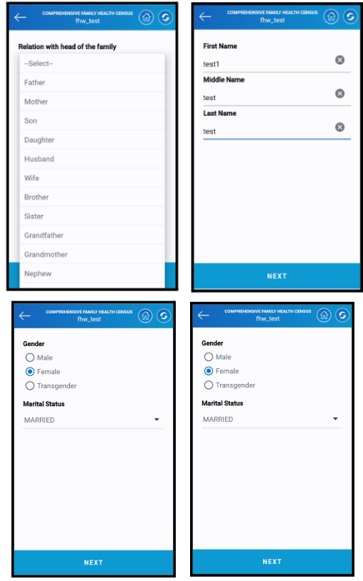

* The system will ask relationship of the new member with the head of the family. Asha needs to select the relevant ones.
* Once Asha selects the relation next screen will ask for the personal details such as name middle name and last name.
* Once the details are entered click on the **NEXT** button to proceed further.

* The next screen will ask for the details of gender and marital status. If the relation with the head of the family is wife or mother or sister the by default gender will be female and if someone tries to change it the system won't allow for the same

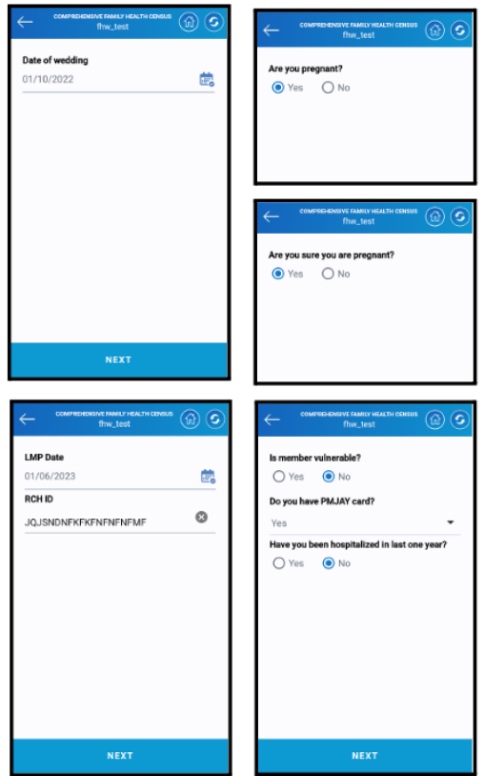

* The next question will be the date of the wedding in case of married
* The next question is whether the beneficiary is pregnant or not.
* If she is pregnant Asha needs to select yes and the next question will be the confirmation of pregnancy.
* Once both questions are marked then click on the **NEXT** button to proceed ahead.
* The next screen will be of LMP (Last Menstrual Period) date and RCH(Reproductive and Child Healthcare) Id.
* Once both the details are added click on the **NEXT** button and other questions related to the beneficiary will be asked.
* Once all the details are added click on the **NEXT** button to move ahead with the survey.
* The next question will be the same as personal details, education, any kind of addiction, etc. Asha needs to enter all of the data accordingly.

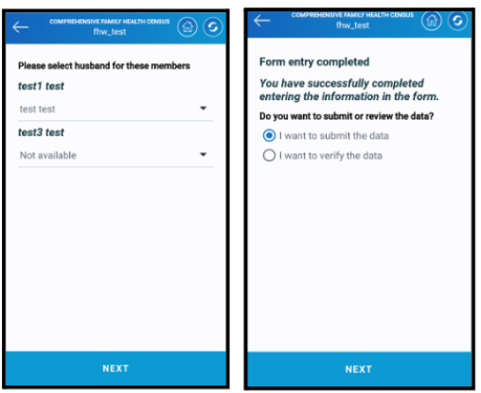

* Last Asha needs to select the name of the husband/ father/ mother etc of the respective members in the system.
* Once it is selected the system will ask to verify the data or submit the form.
* Asha needs to click on I want to submit the data to submit the form
* Once Done the registration will be completed and a family id will be generated along with the individual member id.

## Chapter 4 My People (RCH module)

RCH stands for **Reproductive and Child Health.** My people help to provide services to pregnant women, children, PNC visits for women, and services to Eligible couples.

My People is categorized into 5 categories:

1. Eligible Couples
2. Pregnant Women
3. PNC Women
4. Children
5. RCH Regester

Let us walk through all of them one by one

### 4.1 Eligible Couples

Eligible couples are characterized as the couples who are eligible for getting a child and who lie in the age group of 18-45 years of age. There are two services Reproductive Info Modification Visit and LMP follow-up Visit. Let us see both of these.

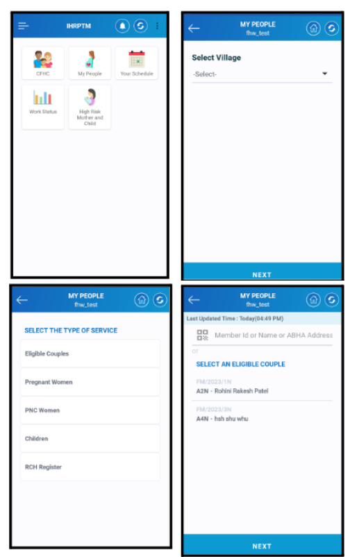

* On the home screen tap on the my people icon as highlighted in the image.
* Once the user taps on it the next screen will be of selecting the village in which Asha is working
* There is a list of villages which are been allocated to the Asha.
* Asha needs to select the current one
* The next is the selection of the type of service. There are 5 types of services as mentioned above
* Tap on the Eligible Coples to proceed ahead with the services.
* Next will be the list of beneficiaries for whom this is applicable.
* Asha needs to select one and tap on the NEXT button to proceed ahead.

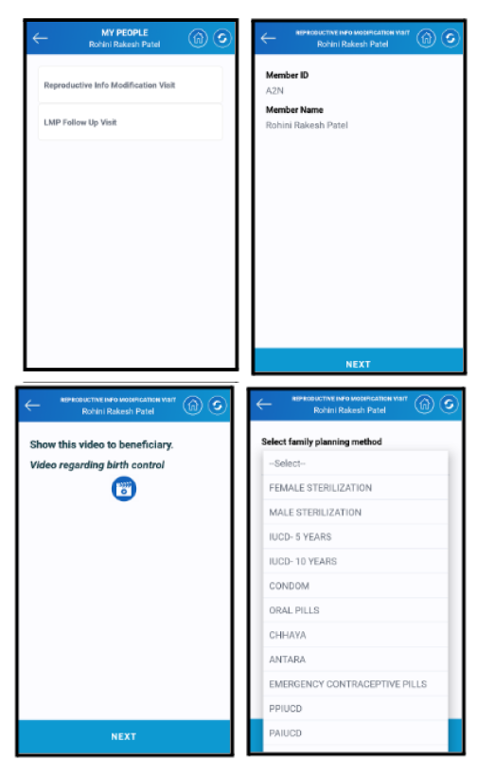

* There are two services that Asha can give. One is Reproductive Info Modification Visit and another is an LMP follow-up visit for Women.
* Once Asha taps on Reproductive Info Modification Visit the next screen will show the personal information of the beneficiary
* Tap on the NEXT button to proceed ahead with the service.
* The next screen has one video icon. Tap on the icon to play the video. Asha needs to show the beneficiary what are the benefits of family planning.
* Once the video is shown tap on the **NEXT** button to proceed.
* The next screen consists of different family planning methods. There is a dropdown, tapping on it a list will appear.
* Asha needs to select any one method according to the consent of the member.
* Tap on the **NEXT** button to proceed ahead with the service.

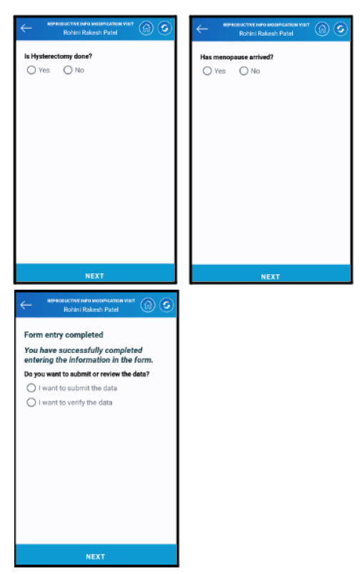

* The next couple of questions are related to the personal health of the beneficiary.
* Asha needs to ask these questions and fill in accordingly.
* Once done the application will ask to verify the data and submit it
* Asha needs to click on SUBMIT button to submit the data.
* Here the first service of eligible couples i.e Reproductive Info Modification visit gets completed

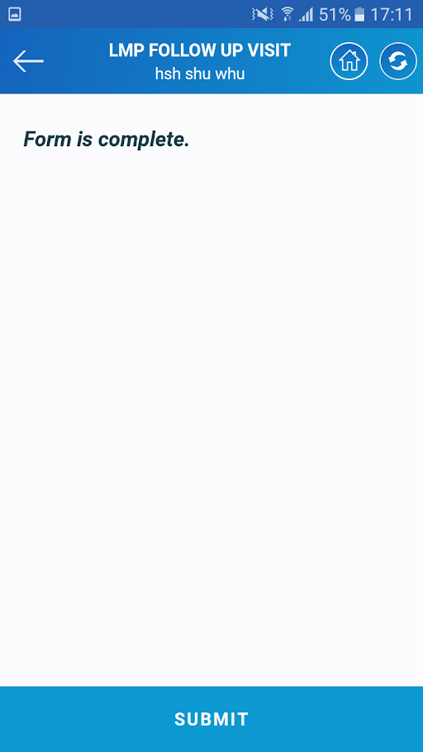

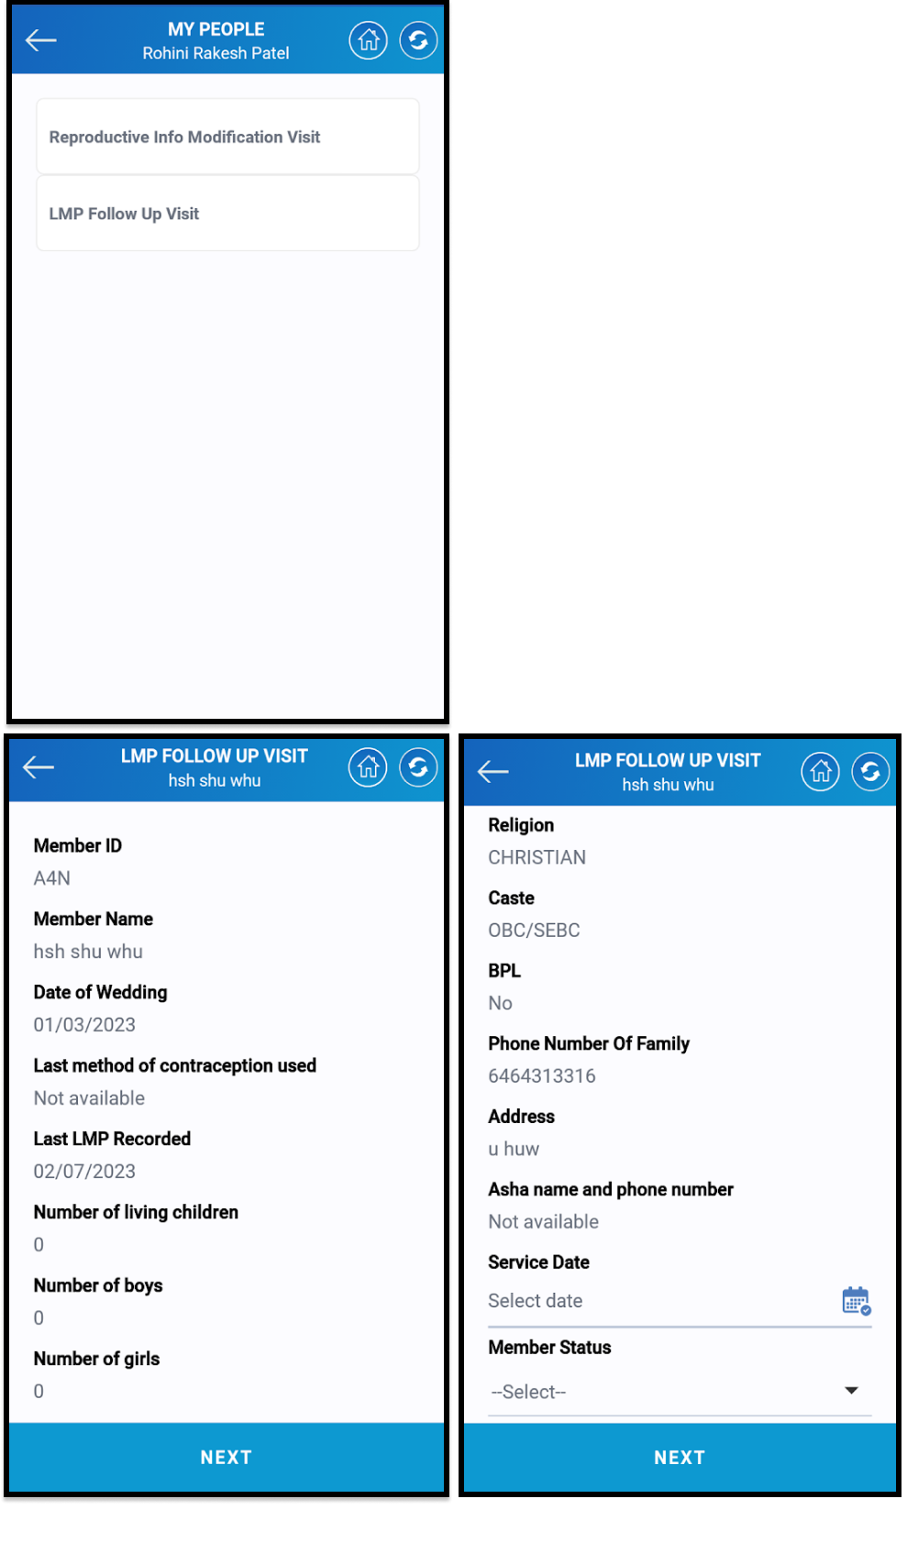

* The next comes LMP Follow up visit. LMP stands for the Last Menstrual cycle. This is for pregnant women.
* Tap on the LMP follow-up visit to proceed with the service.
* Once Asha clicks on the LMP visit the following screen will display the beneficiary's personal data.
* Asha needs to verify this and select the date of service.
* Asha also needs to select the marital status of the beneficiary
* Tap on the **NEXT** button to proceed ahead with the service.

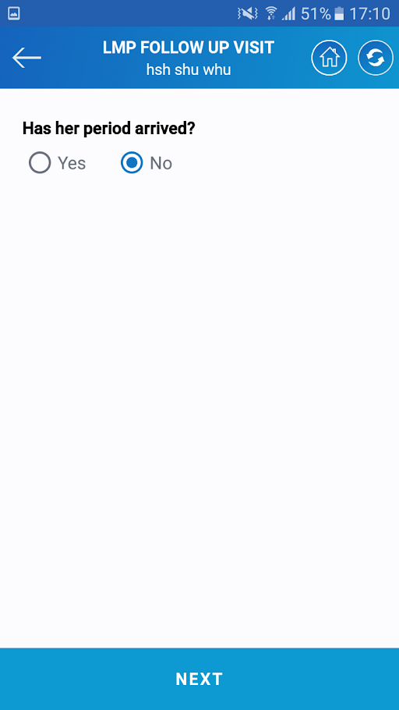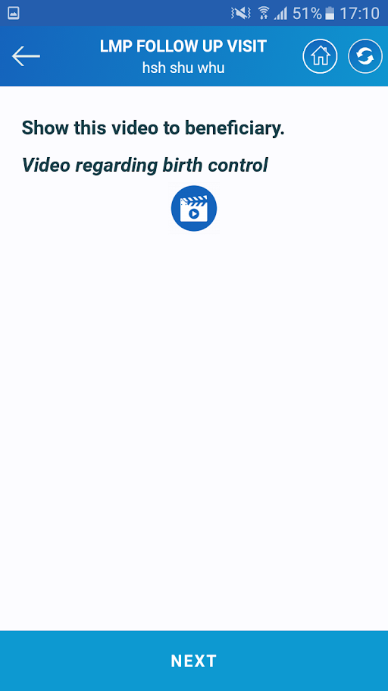

* 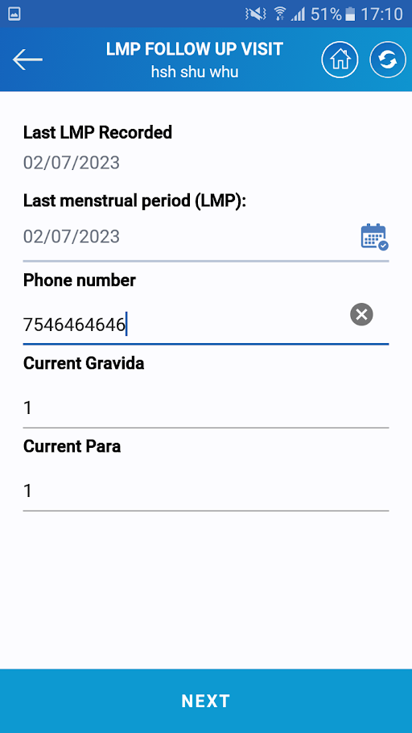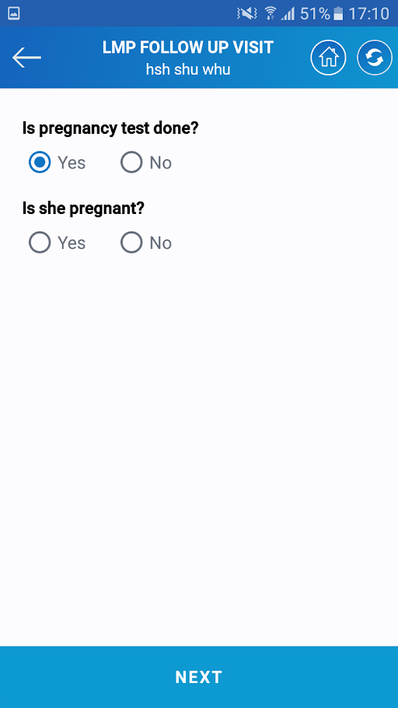The next is a video on birth control. Asha needs to show this to the beneficiary.
* Once the beneficiary watches the video, Asha needs to tap on the NEXT button to proceed ahead with the service.
* The next question is whether the menstrual period has arrived or not. Asha needs to confirm this and answer accordingly.
* If the LMP hasn't arrived the next question will be of whether the pregnancy test is done or not.
* If the pregnancy test is done the system will ask for confirmation of pregnancy.
* The next set of questions will be the date of the last LMP , phone numbers, gravida, and para.
* Asha needs to answer accordingly.
* Once all the questions are answered tap on the **NEXT** button to proceed ahead with the service.

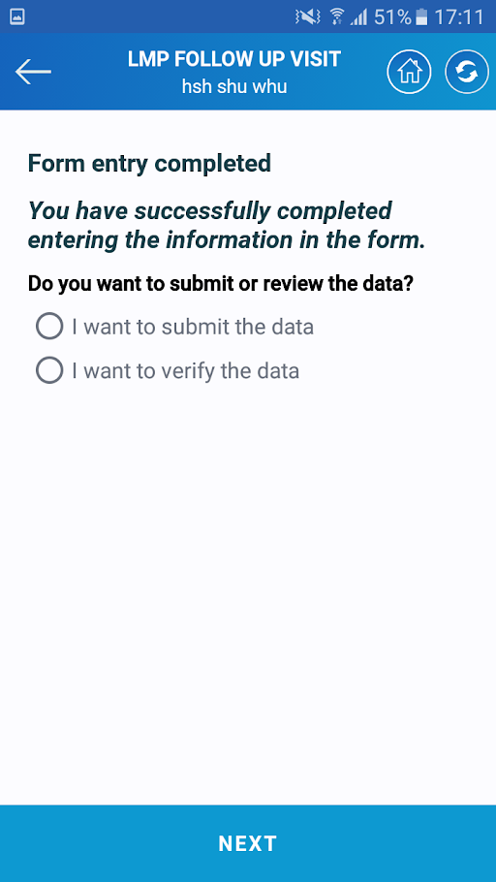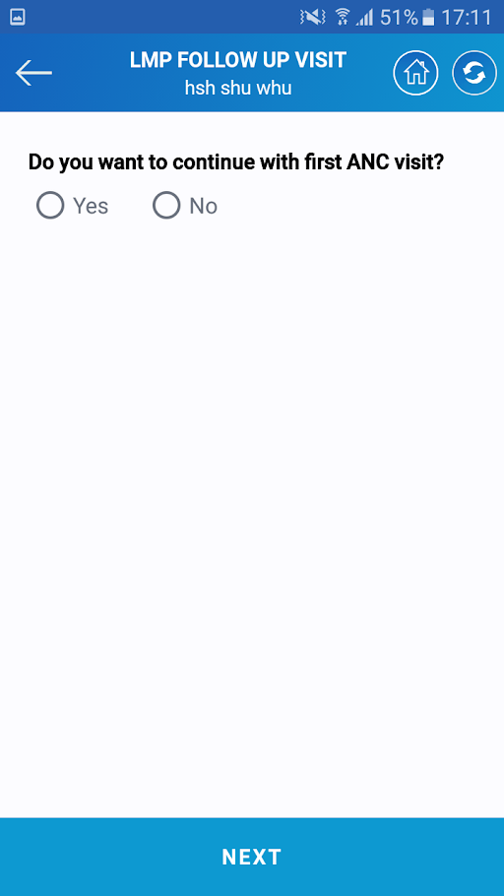

* The next question will be for ANC visit. If Asha selects yes the system will take for the ANC services. Else the system will ask for verification of data.
* If Asha selects verify the data the whole form will be displayed along with the response. If Asha selects to submit the data the system will submit the daft once tapping on the **SUBMIT** button
* Last the system will show a confirmation message of the submission of data.

### 4.2 Pregnant Women

A pregnant woman is an adult female who is expecting or carrying a developing fetus in her womb. She needs many services during the pregnancy for better child development. Hence there are 2 types of services available in Medplat. Once she is registered in the CFHC the details will be available in the list of different family members and Asha can serve her accordingly.

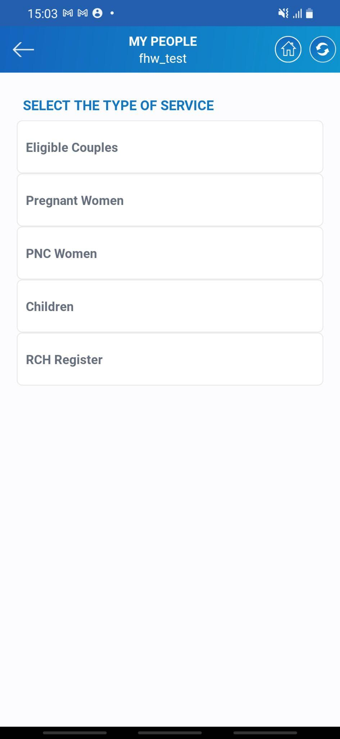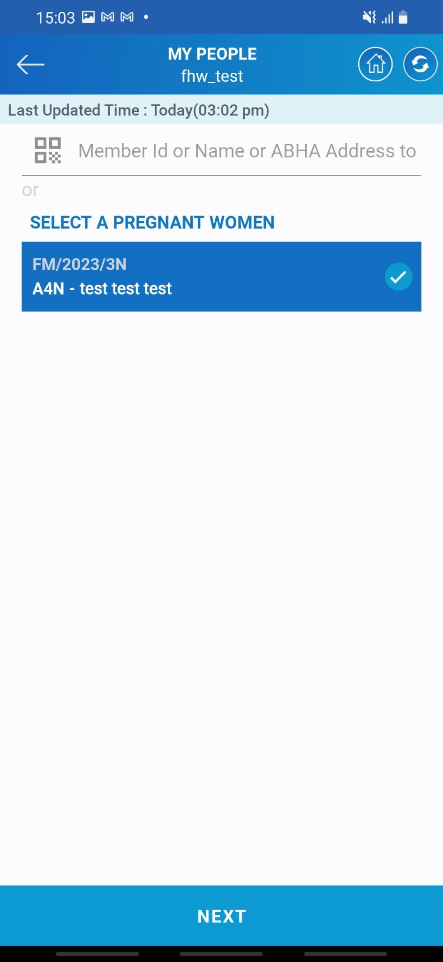

* As highlighted in the screen tap on Pregnant Women to proceed ahead with different kind of services.
* There will be a list of different pregnant women on the next screen. Asha can search with the heal of name, member id, or QR code which is assigned to each individual.
* Once the beneficiary is selected tap on it and the record will be highlighted on the screen.
* Tap on the **NEXT** button to proceed ahead.

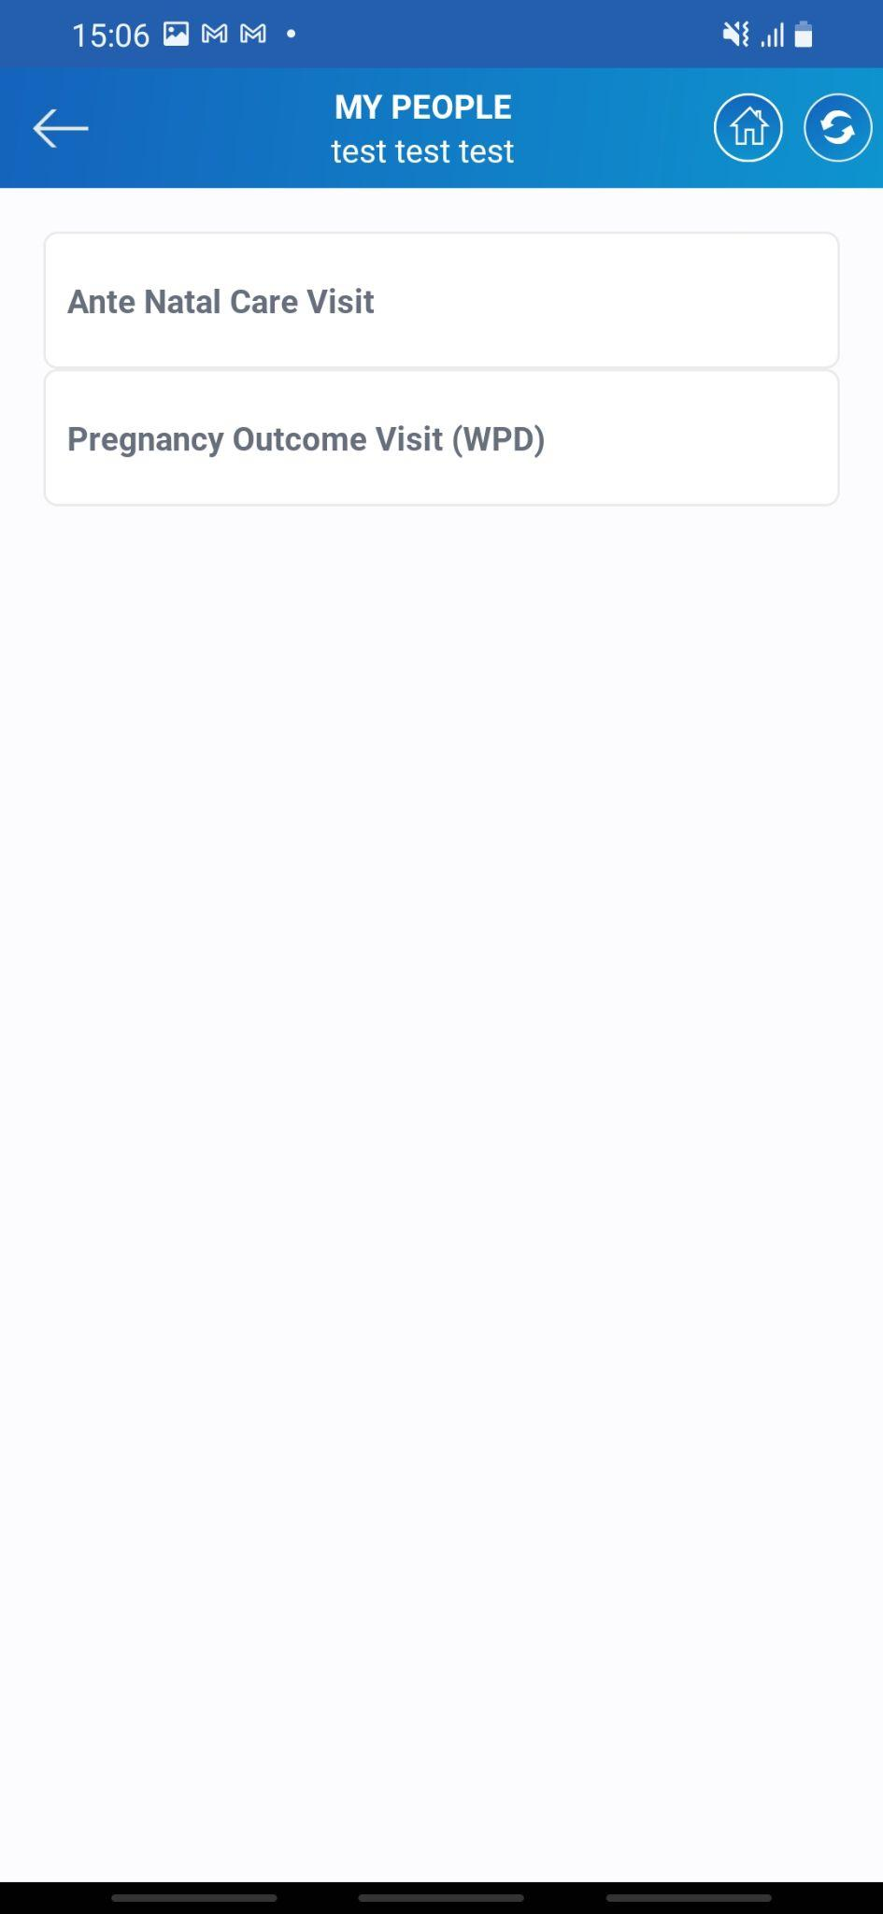

* There are 2 different services that can be provided to the beneficiary.

1. Ante Natal Care Visit (ANC)
2. Pregnancy Outcome Visit (WPD)

* Both have their own significance in providing health facilities to the beneficiary.
* ANC (Antenatal Care) visits have several essential applications in the context of pregnancy and maternal health. These visits involve regular check-ups and consultations with healthcare professionals during pregnancy.
* A Pregnancy Outcome Visit is a medical appointment that occurs after a woman has given birth, typically within a few weeks after delivery. The purpose of this visit is to assess the mother's health and well-being following childbirth and to evaluate the health of the newborn.
* Let us look at each one of these. Tap on the ANC to procced ahead with the first

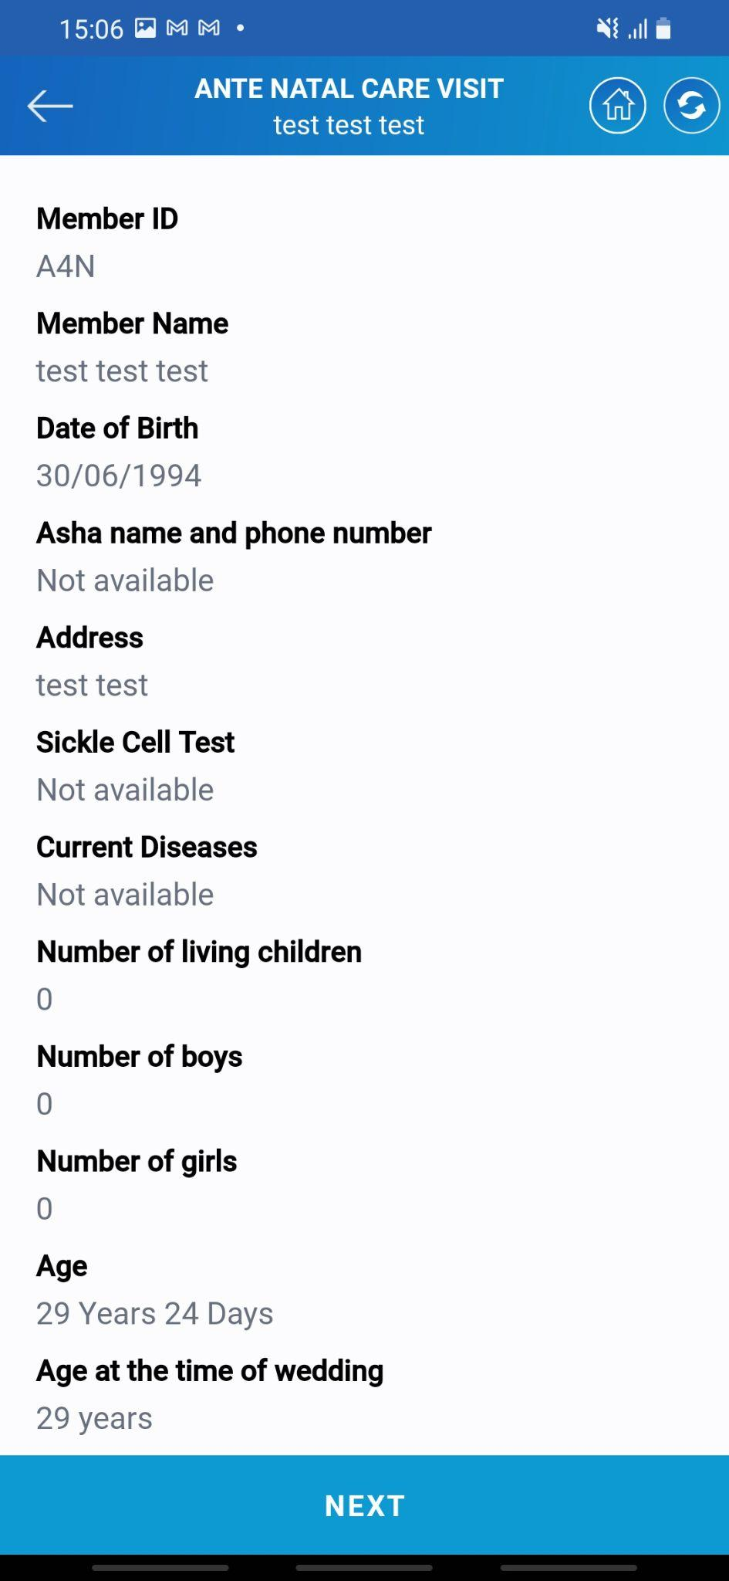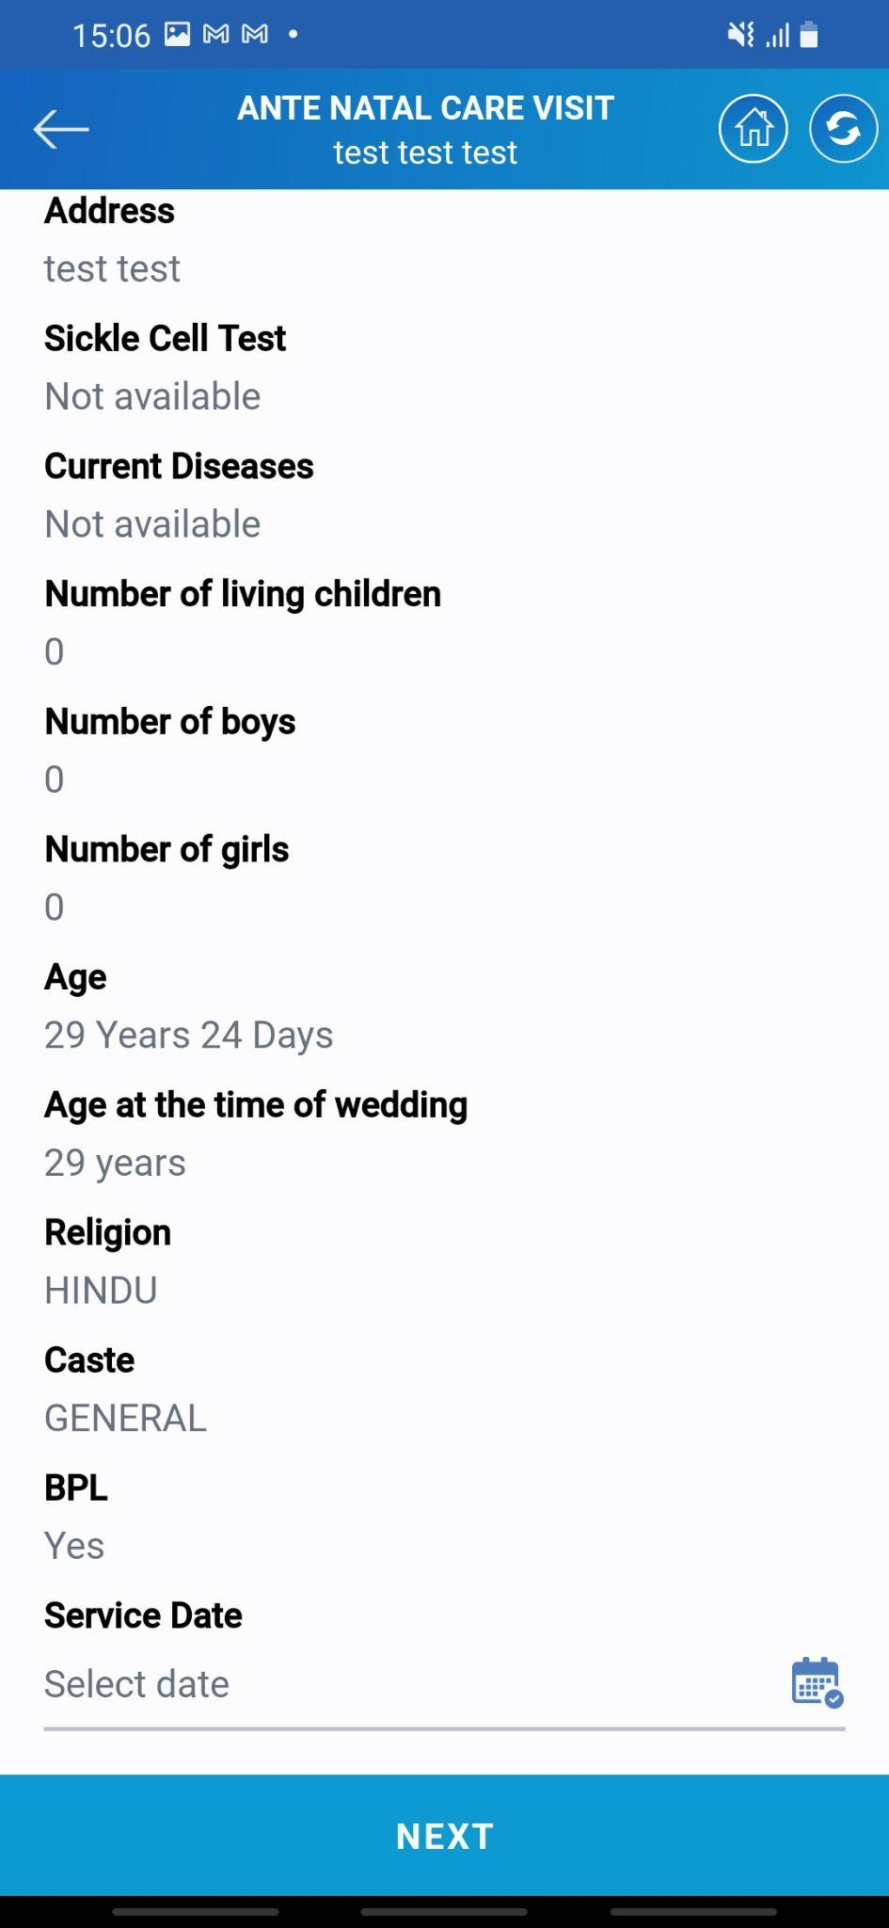

* The system will display the complete information of the beneficiary which is present in the system.
* Asha needs to select the date of service that she gave.
* The date can be of the current date or before it.
* Once the date is selected tap on the **NEXT** button to proceed ahead with the service.

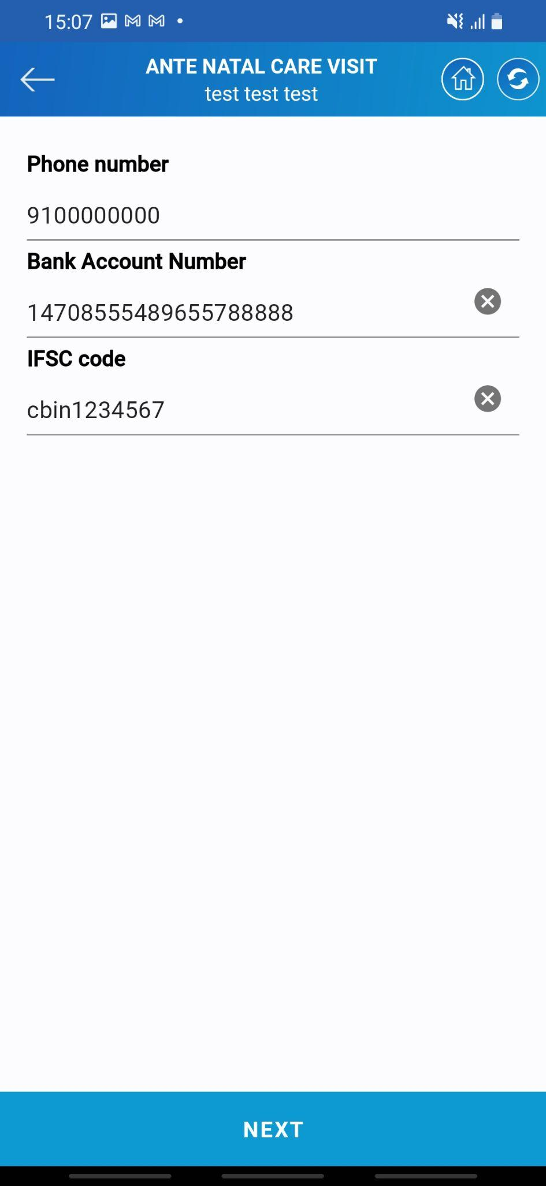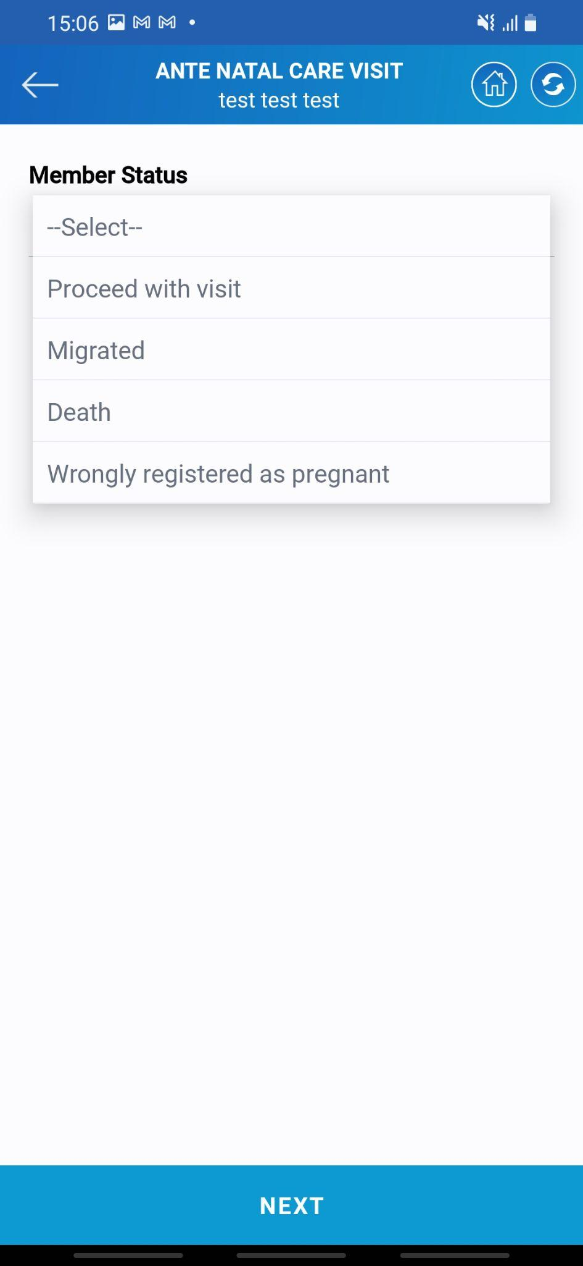

* Select the member status from the dropdown. There are different options available for the member. Asha needs to select the relevant ones on it.
* Tap on the **Next** button to proceed ahead.
* The next system will ask for contact details, bank account number, and IFSC code.
* Asha needs to enter this information as required
* Tap on the **Next** button to proceed ahead with the service.

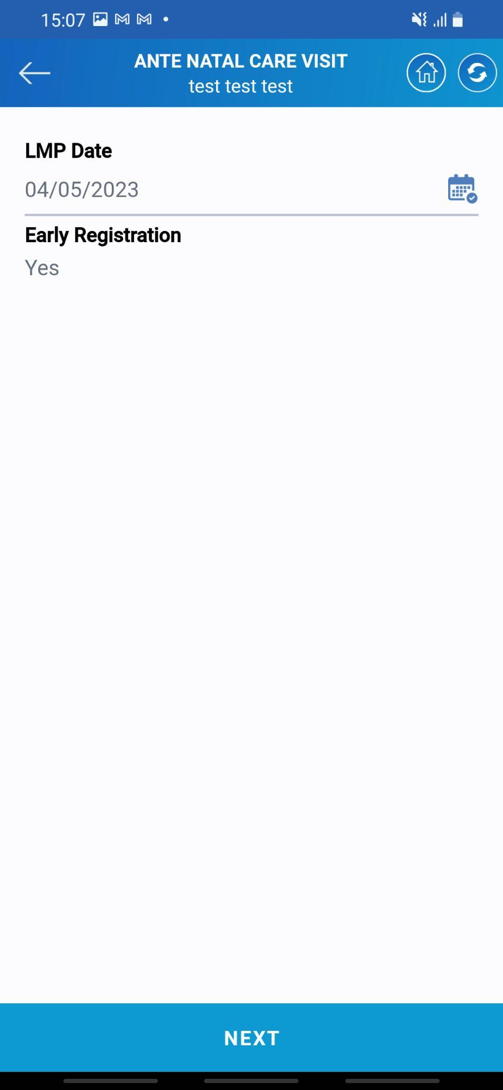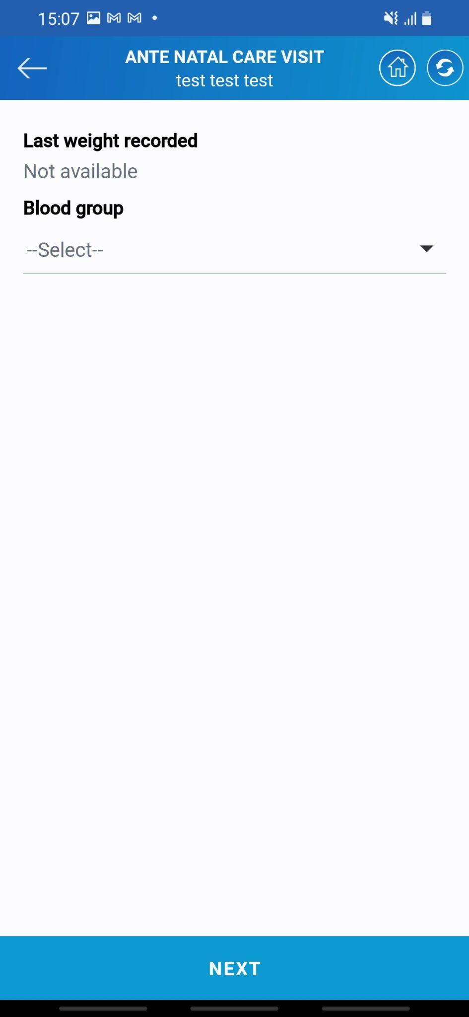

* Asha needs to enter the last menstrual period date.
* Tap on the **Next** button after adding the date.
* Select the blood group of the beneficiary.
* Tap on the **Next** button to proceed ahead with the service

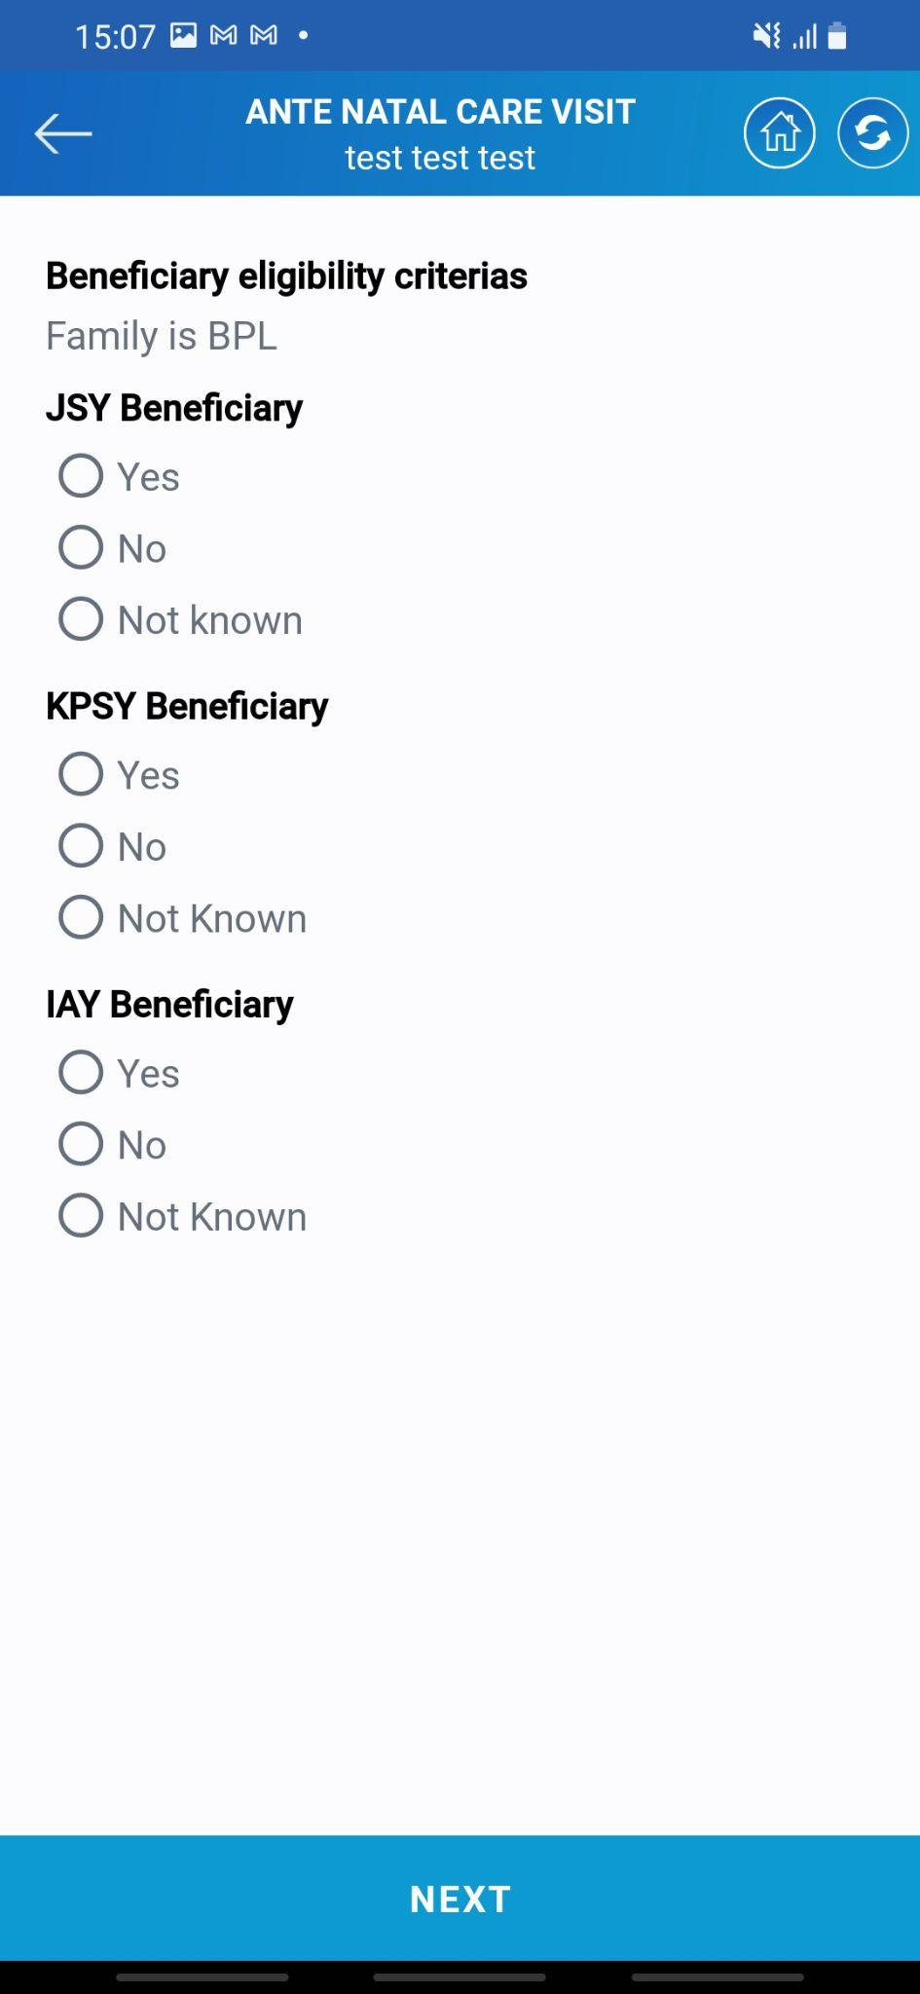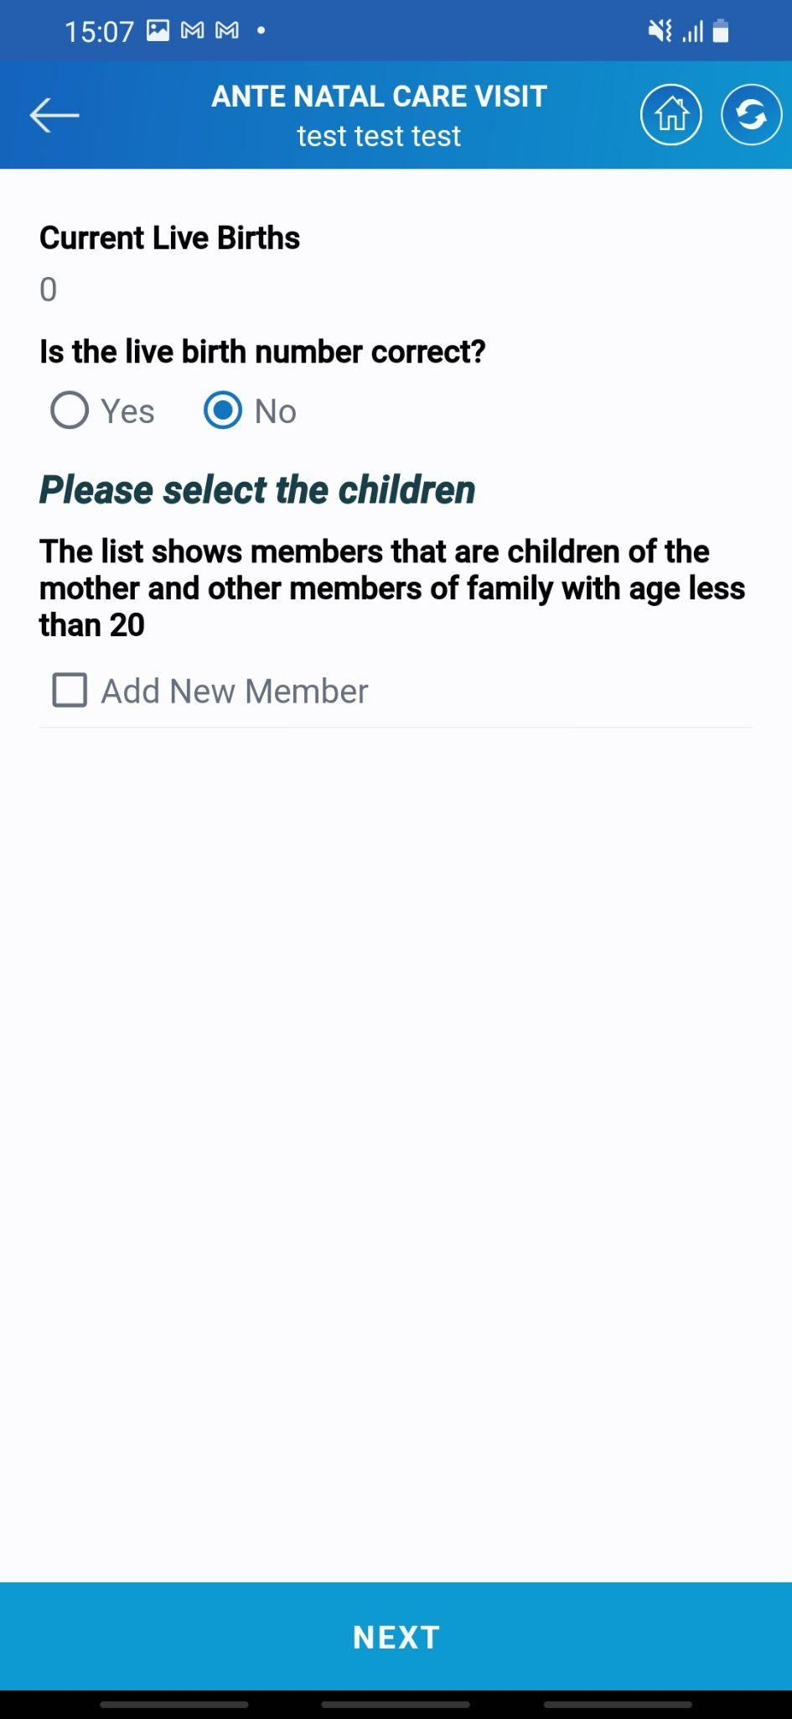

* The system will show the number of children of the lady.
* If there is any change in it select the “No” option and there will be an option to add a family member to the family list.
* The next will be the set of questions of different list of government welfare schemes
* If the beneficiary is eligible for any such than Asha needs to mark it in the system.
* Once all the details are filled tap on the **Next** button to proceed ahead with the service.

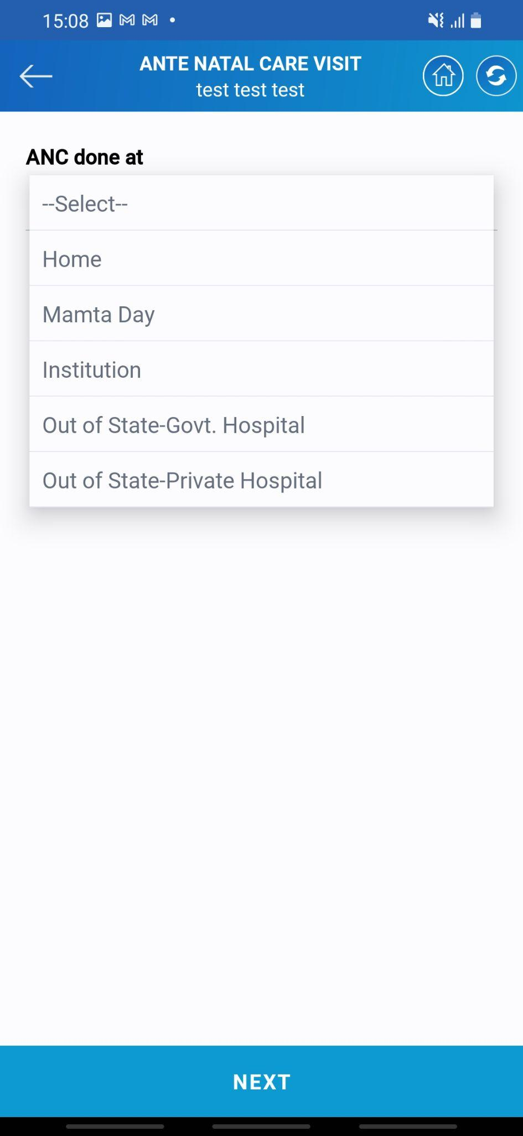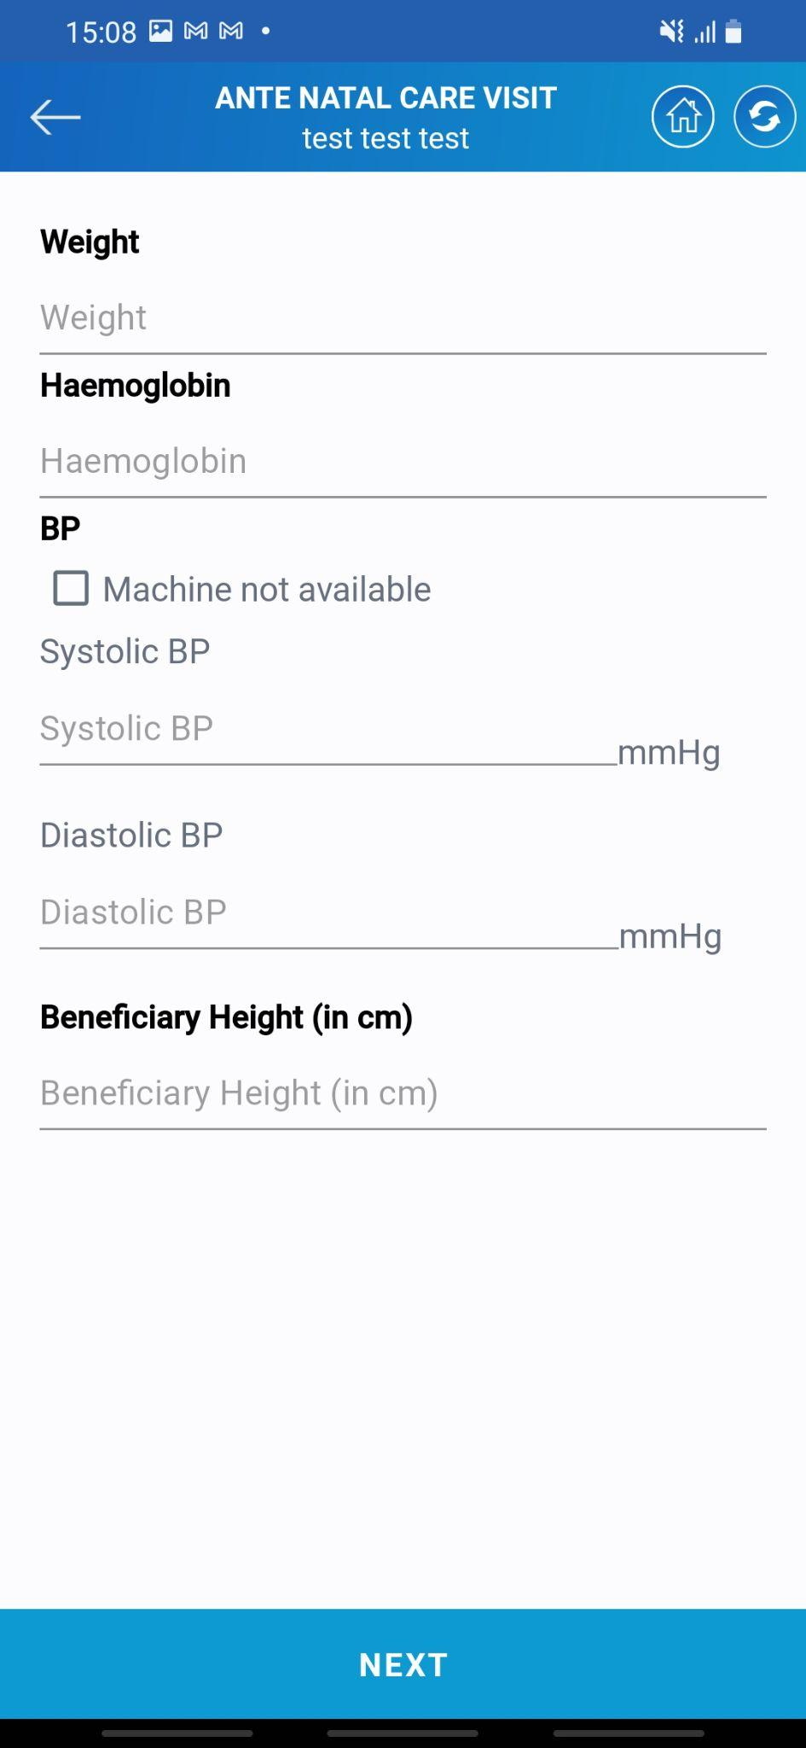

* The next step is to select the place of the ANC.
* There is a list of different options available. Asha needs to select any one of them and tap on the next button to proceed ahead.
* Asha has to fill in other details such as blood pressure, hemoglobin, weight, etc in the system.
* Once all the details are filled tap on the **Next** button to proceed ahead with the service.

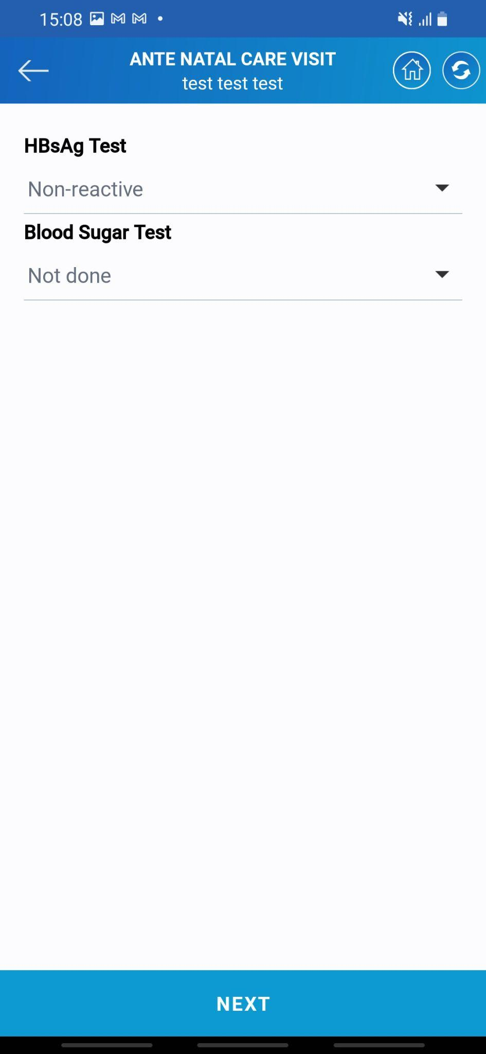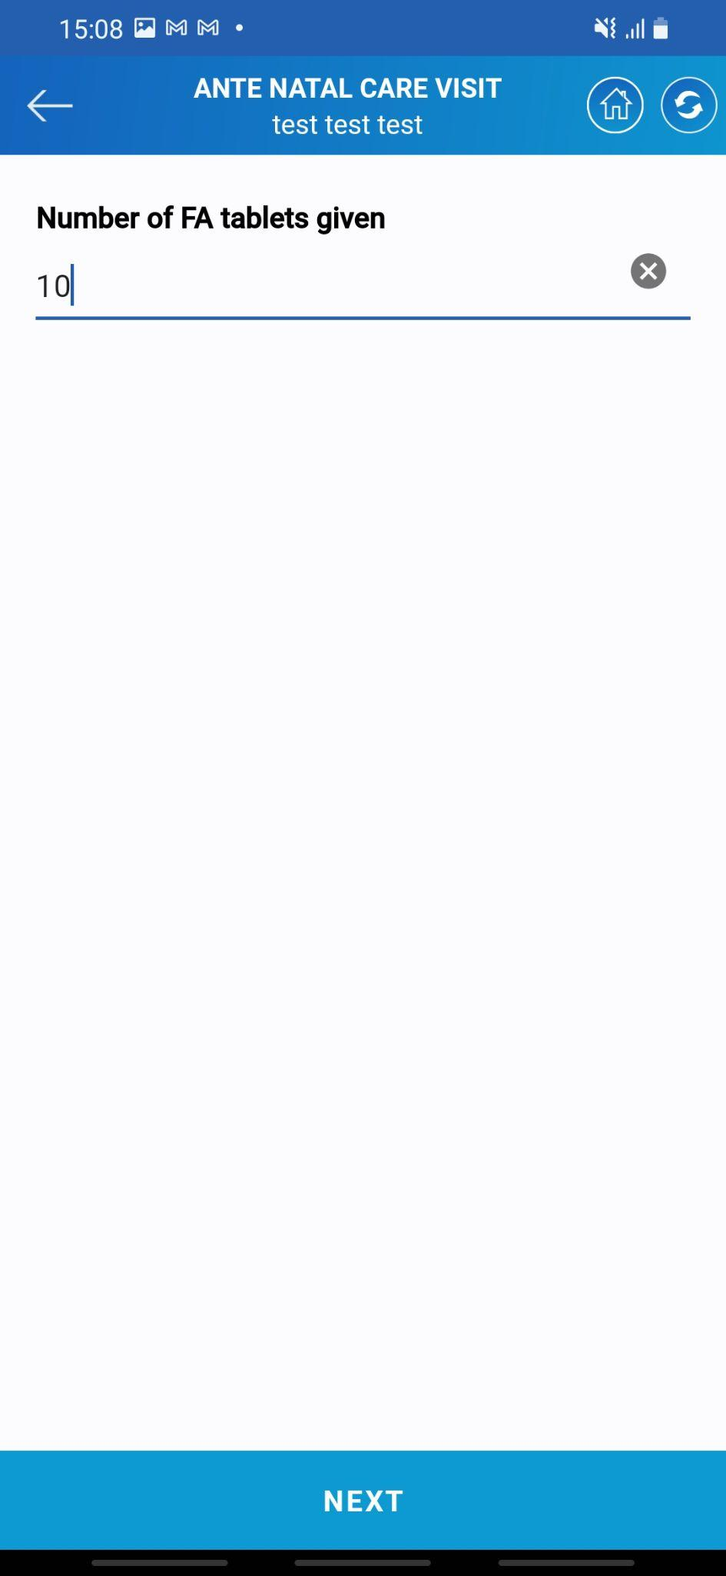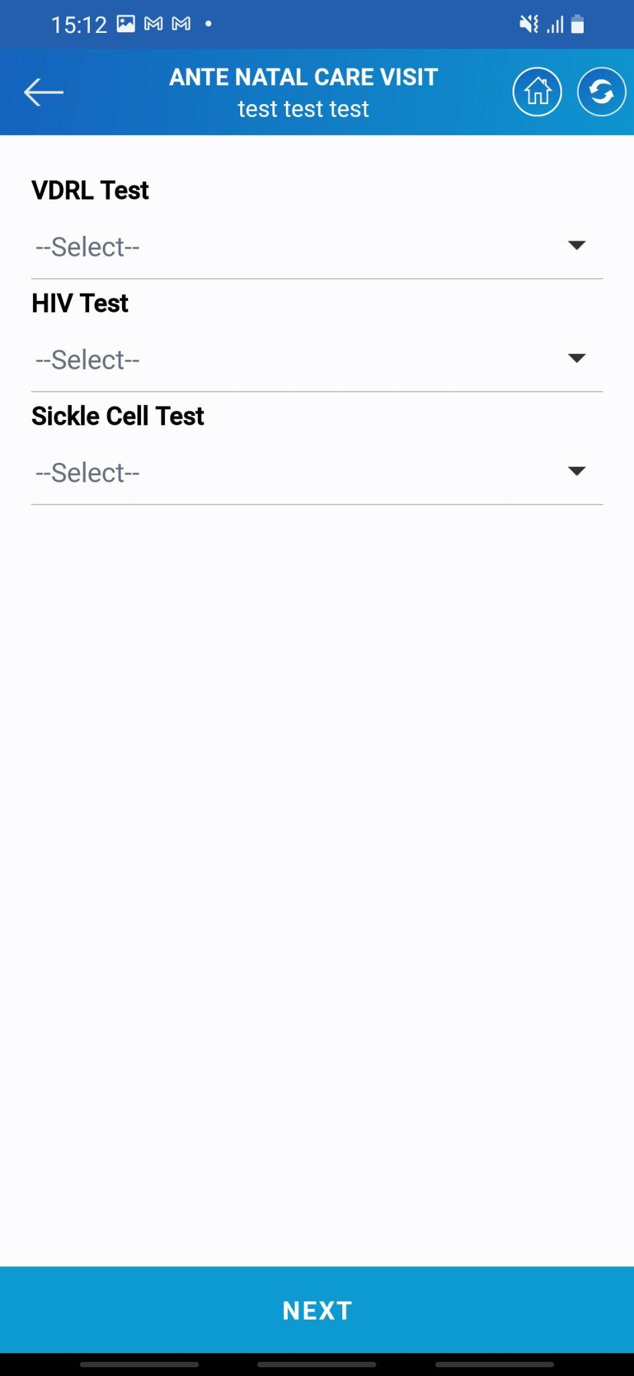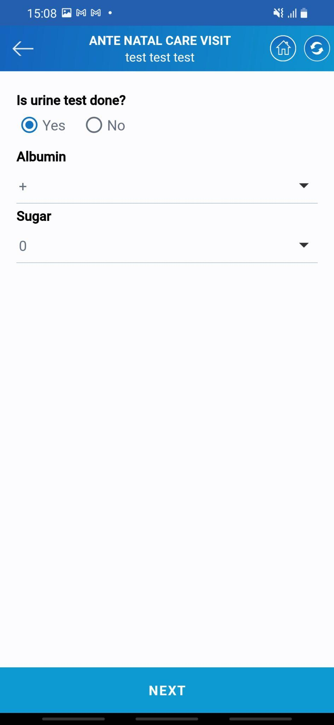

* The next couple of screens will be of different questions related to the different medical tests.
* Asha needs to answer all these questions after verification.
* Once all the details are filled tap on the **Next** button to proceed ahead with the service.

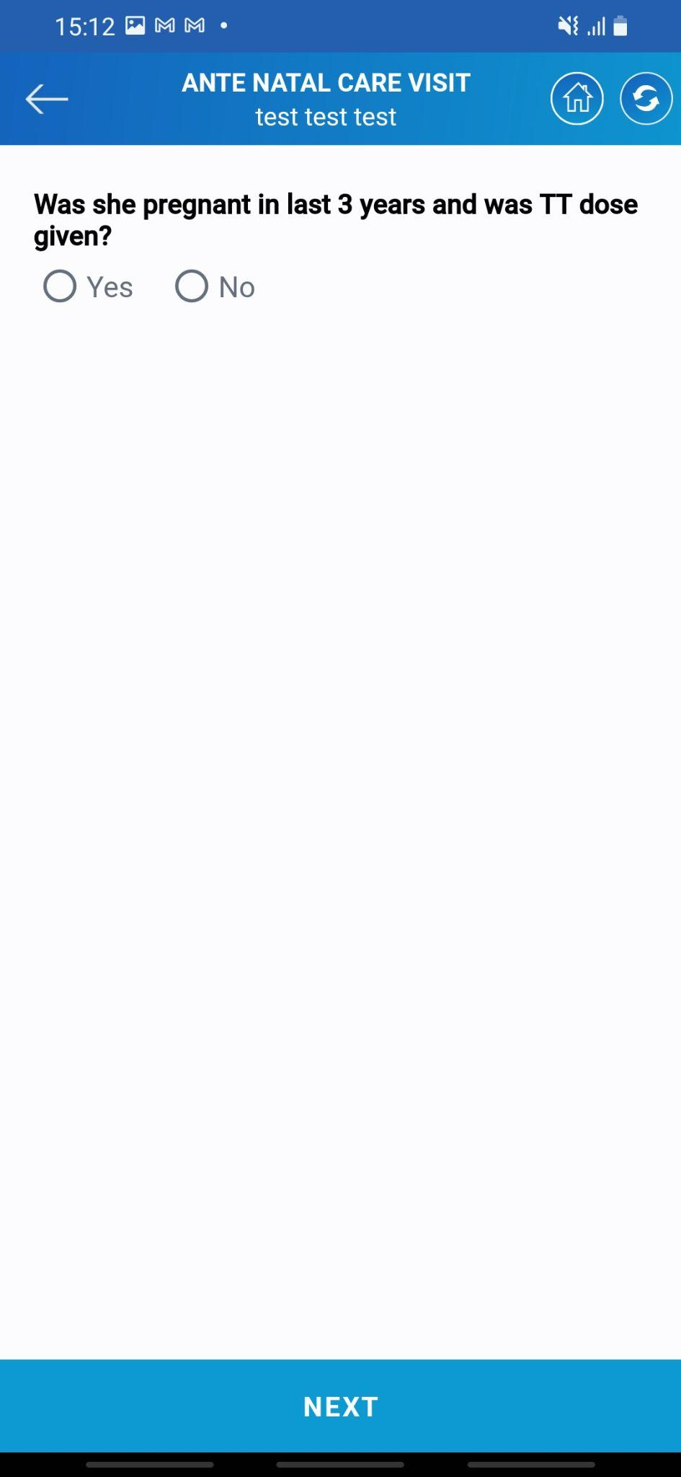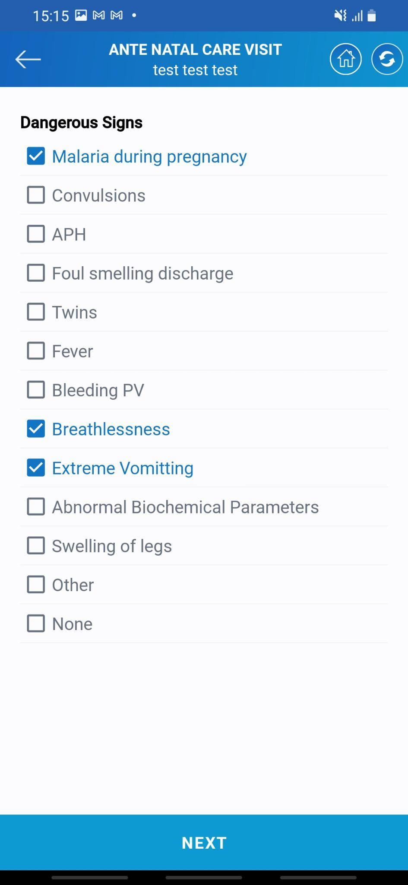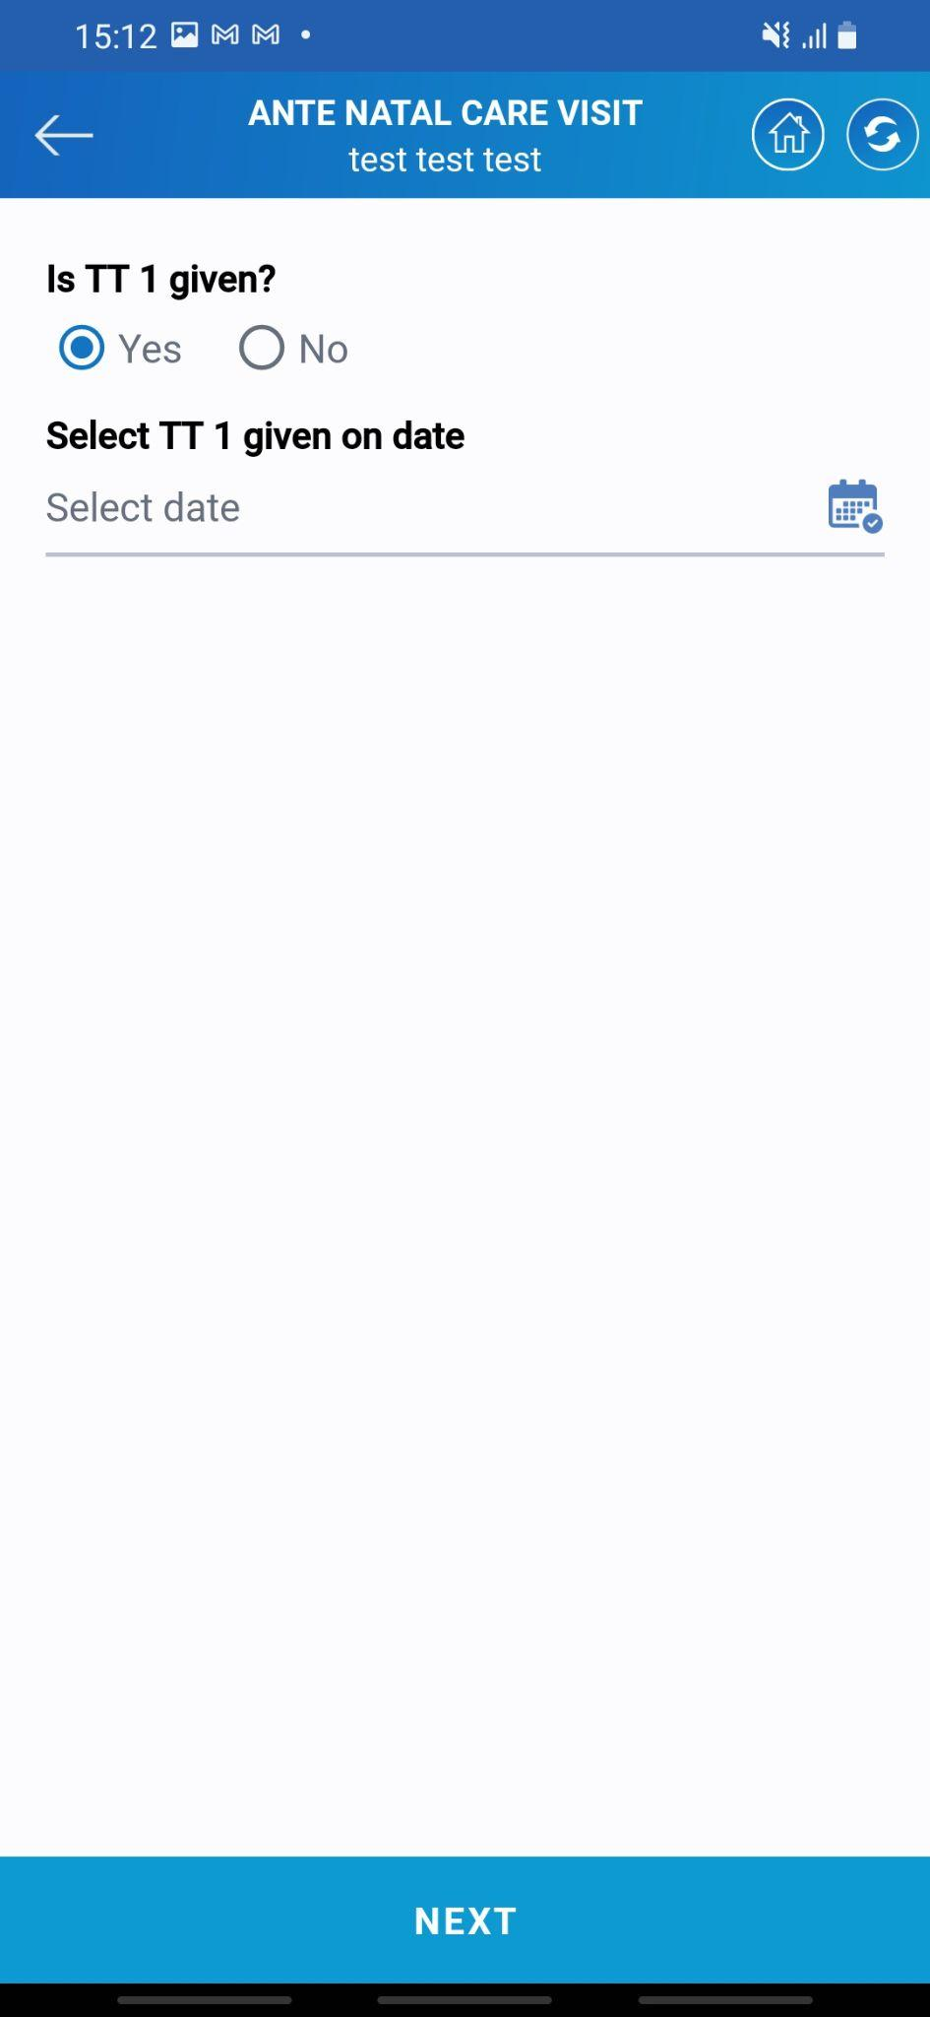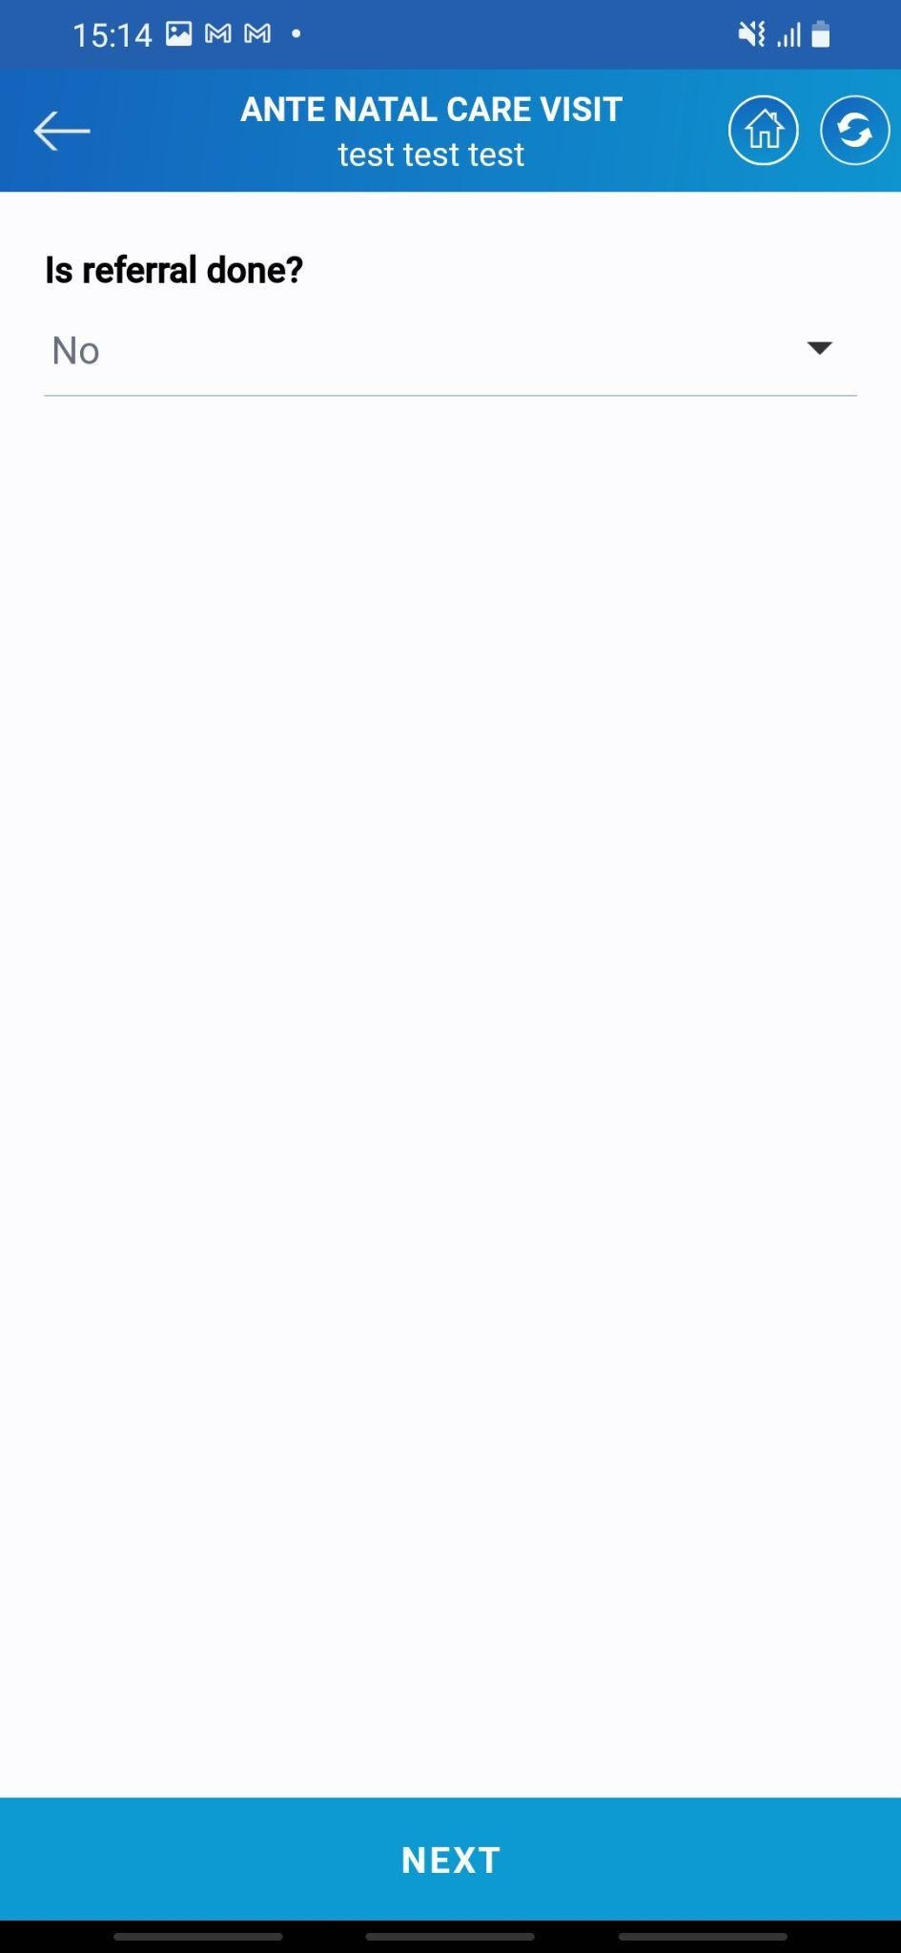

* If the lady was pregnant and the TT dose was given in the past 3 years mark it as yes else no.
* If TT1 is given to the patient Asha needs to select the date for dose.
* If the Refral is done to any place mark it as yeas and enter the details.
* If there are any dangerous signs seen in the lady mark it in the list given on the screen.
* Once all the details are filled tap on the **Next** button to proceed ahead with the service.

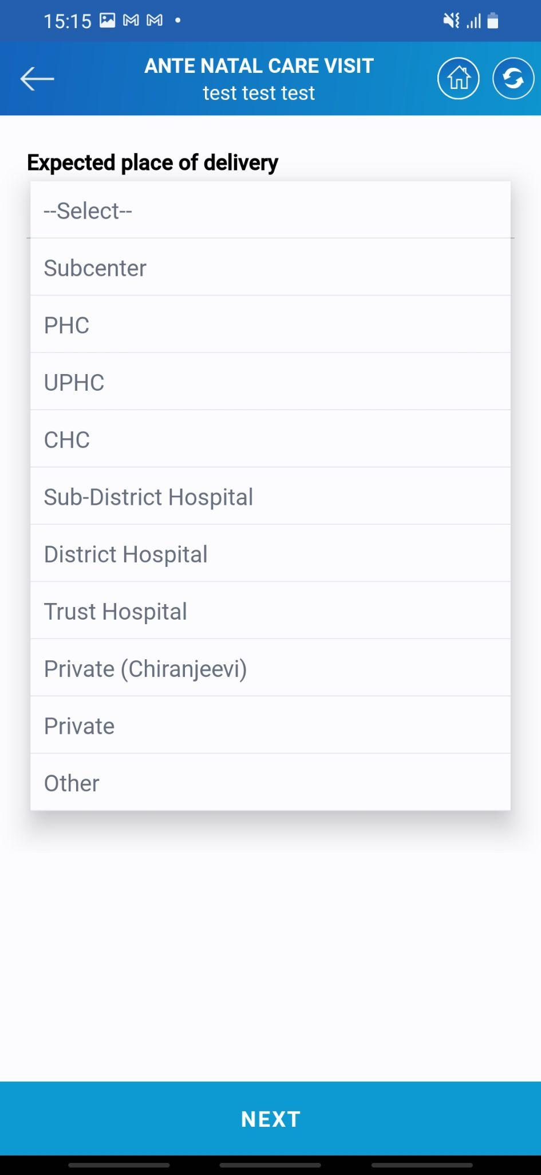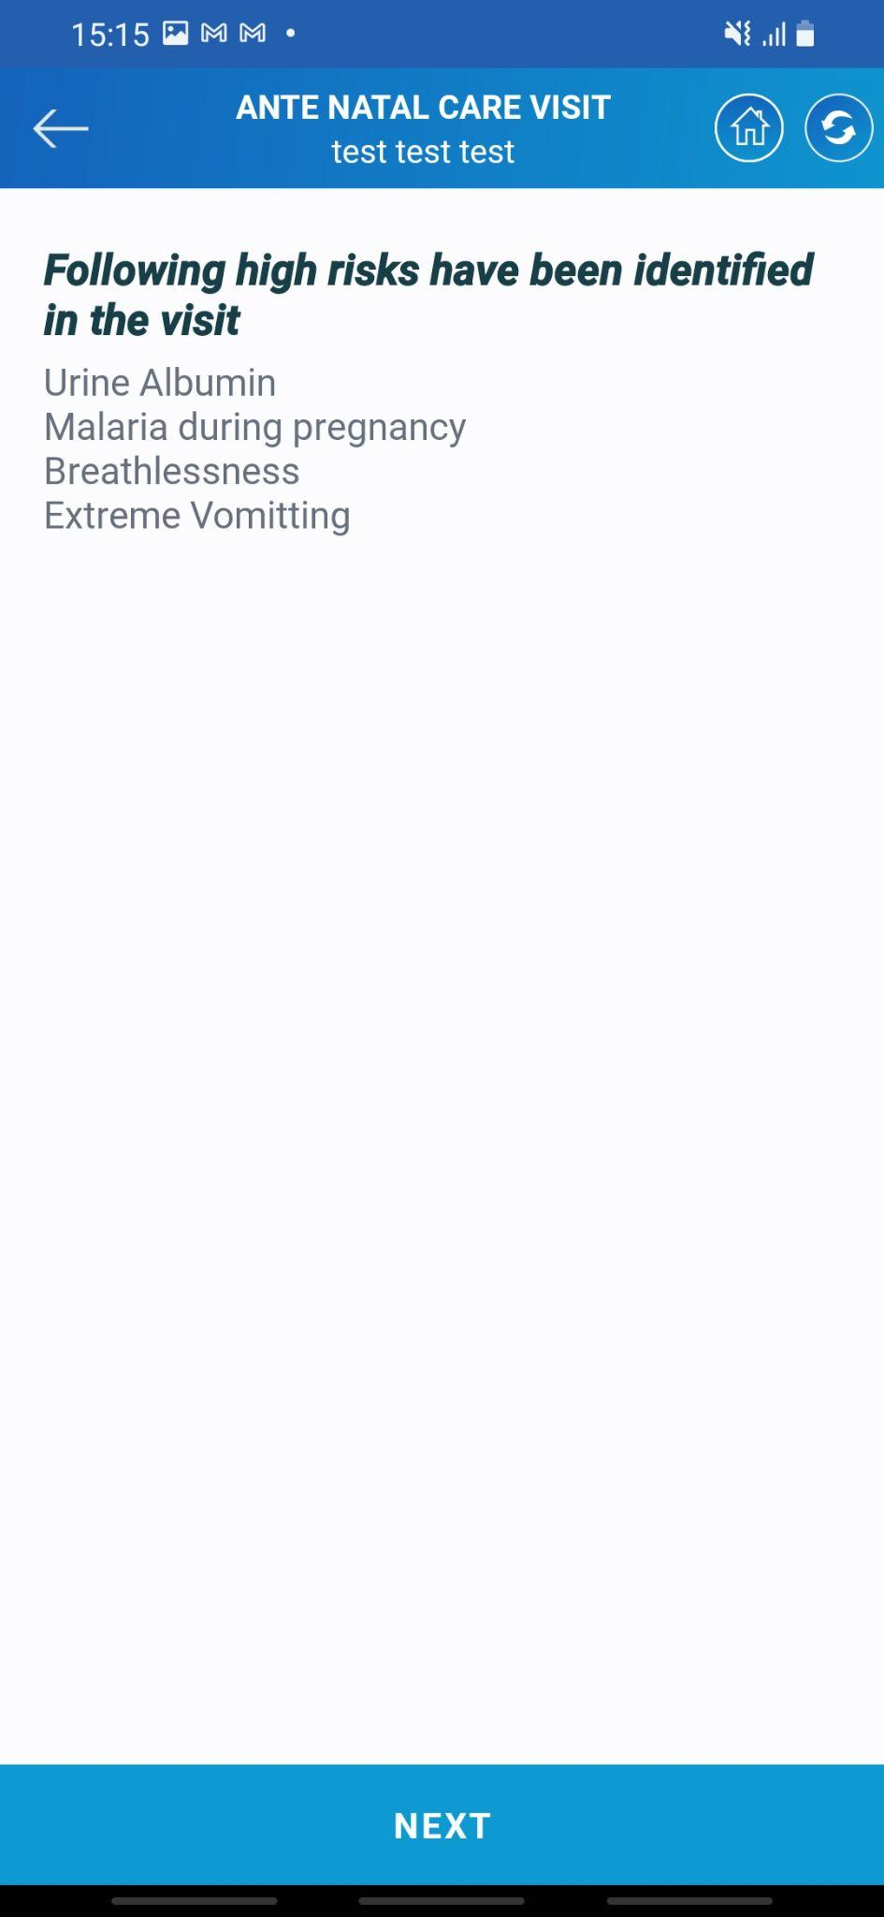

* Select the expected place of delivery from the list of different available locations.
* Once selected tap on the **NEXT** button
* The last screen will display the highlights of possible risks to the beneficiary.
* Once all the details are filled tap on the **Next** button to proceed ahead with the service.

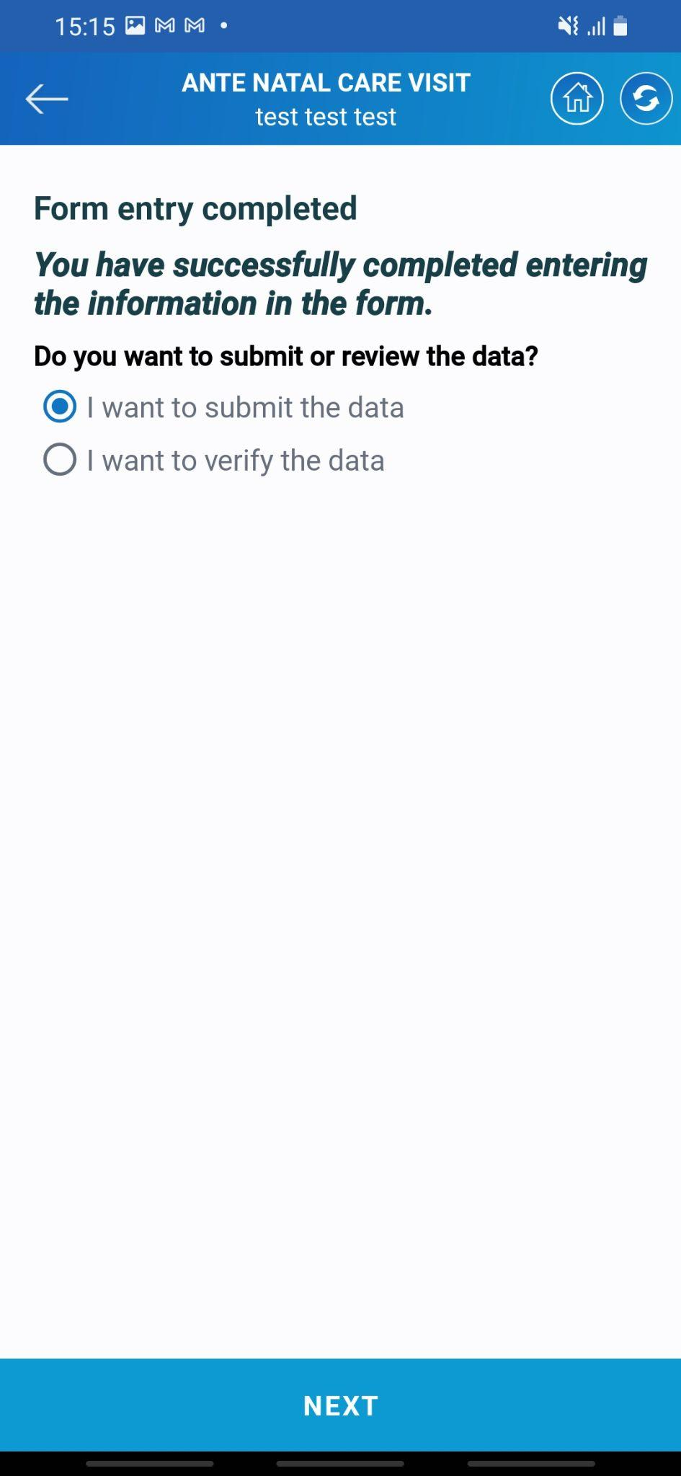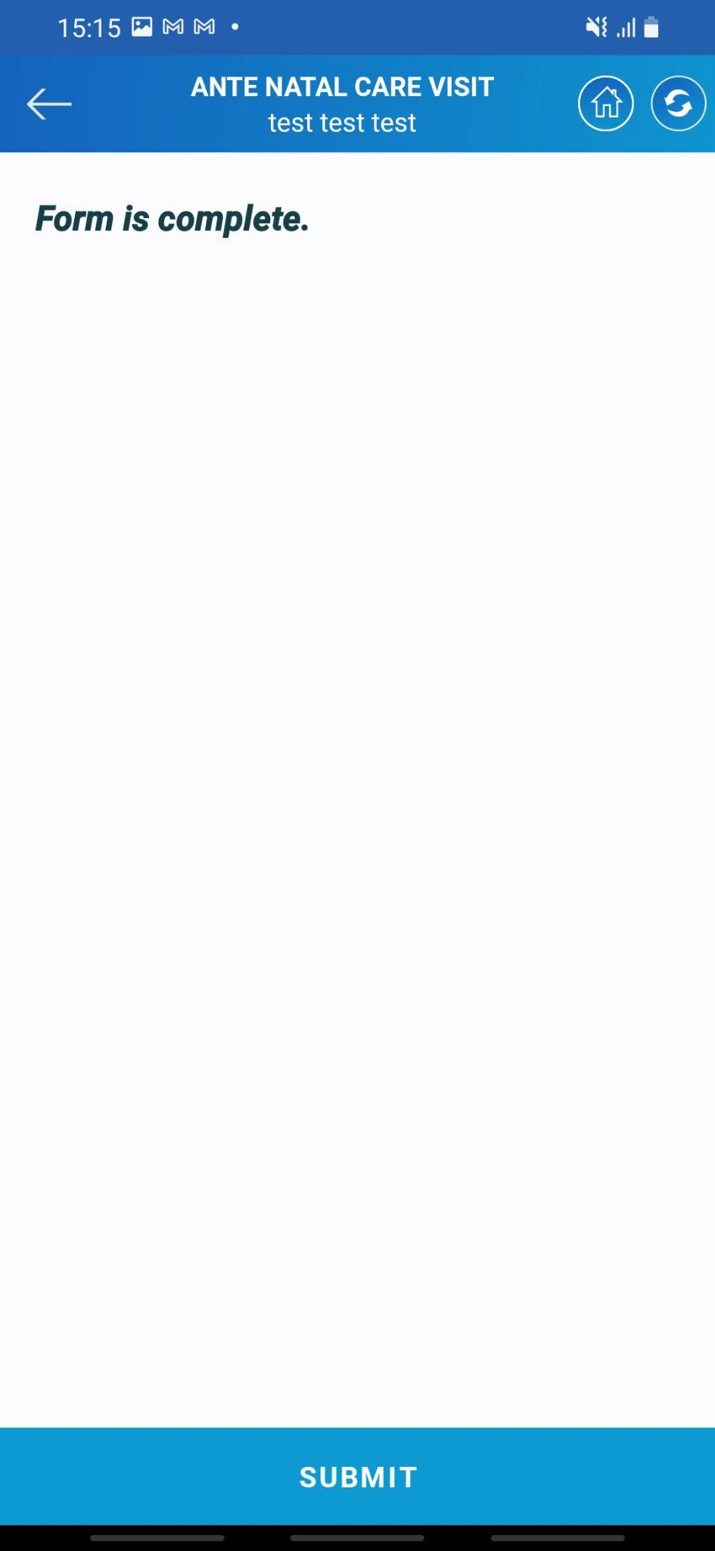

* The system will ask to verify the data. If Asha selects verify the data the system will show her the complete entered data.
* Select the Subbmit option to proceed ahead.
* Tap on the **NEXT** button to submit the data.
* At last the system will show the form is complete as the confirmation of submission of data.
* Here the ANC visit of the beneficiary gets over. Now we will start with the WPD visit i.e. Pregnancy outcome visit.



* A Pregnancy Outcome Visit is a medical appointment that occurs after a woman has given birth, typically within a few weeks after delivery. The purpose of this visit is to assess the mother's health and well-being following childbirth and to evaluate the health of the newborn.
* Tap on the Pregnancy Outcome visit (WPD) which is highlighted in red to proceed with the visit.

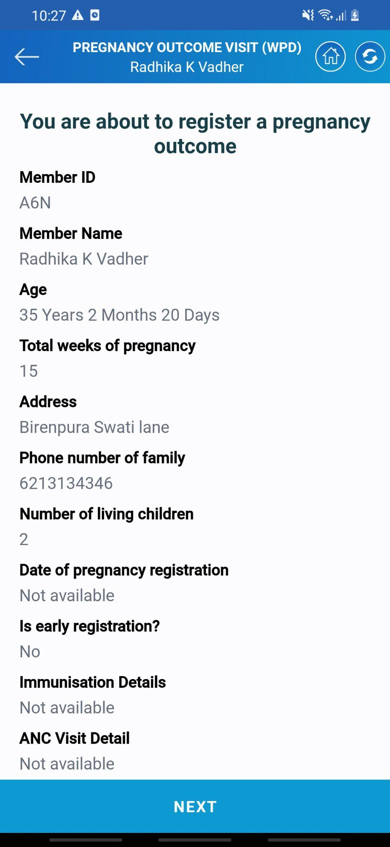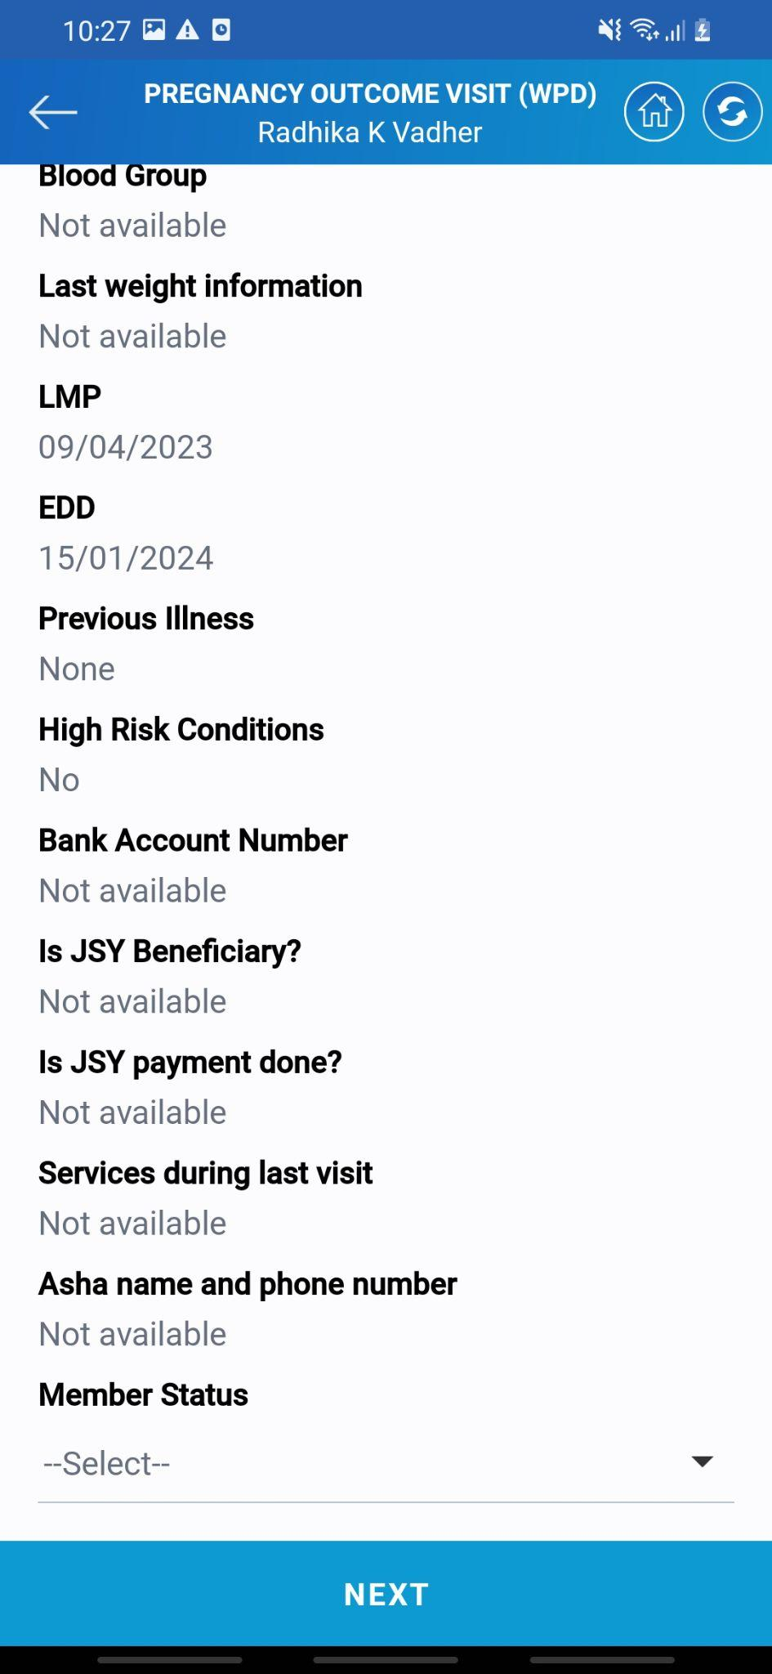

* The system will display the complete information of the beneficiary which is present in the system.
* Asha needs to select the date of service that she gave.
* The date can be of the current date or before it.
* Once the date is selected tap on the **NEXT** button to proceed ahead with the service.

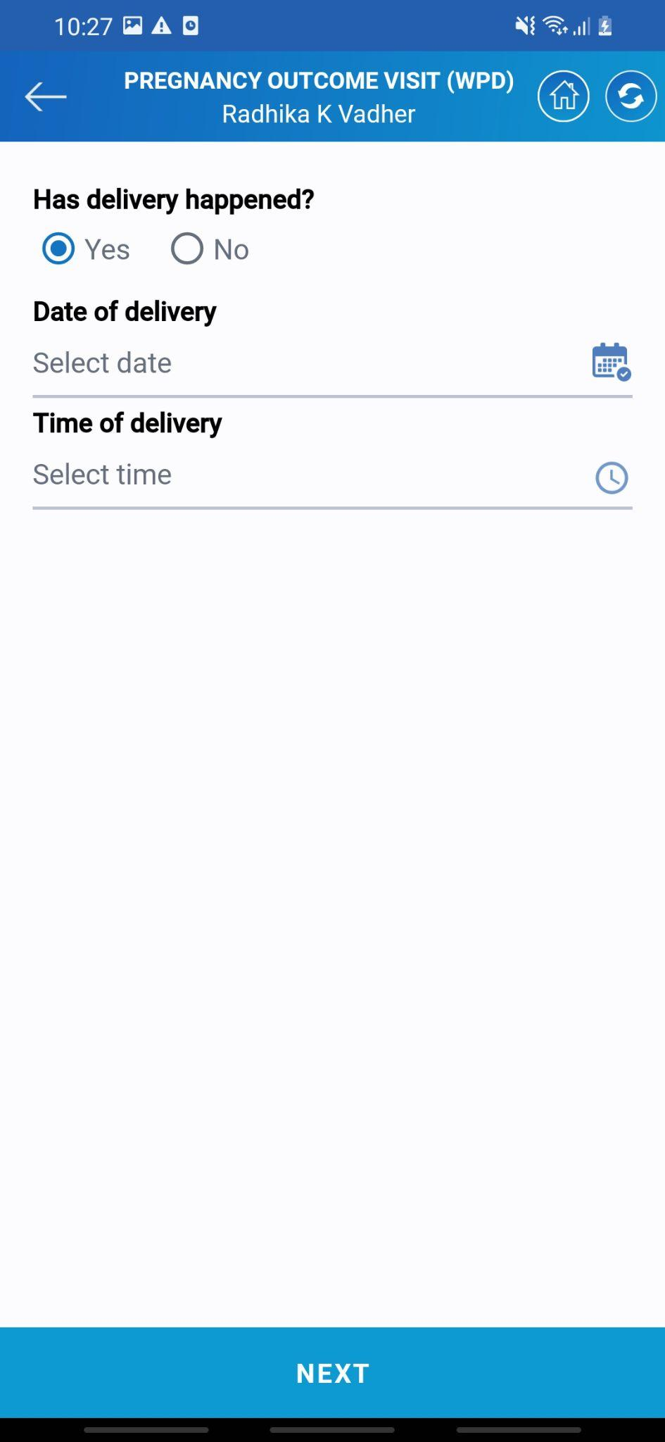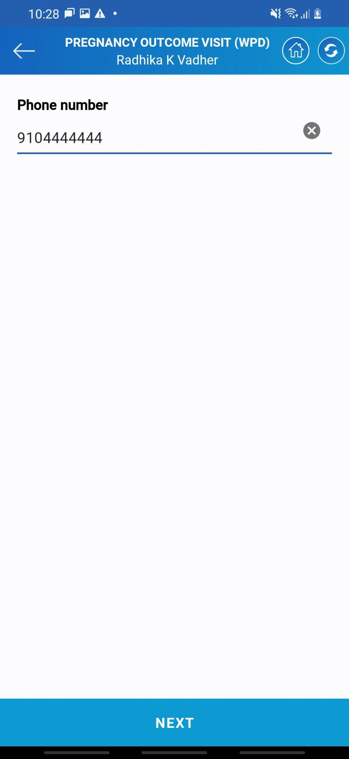

* The next set of options is related to delivery, date, and time of delivery.
* Asha needs to enter the date and time of delivery.
* Asha also needs to enter the phone number of the beneficiary.
* Once the details are filled tap on the NEXT button to proceed ahead with the visit.

***\*\*Note: Here the date of delivery cannot be less than 168 days.\*\****

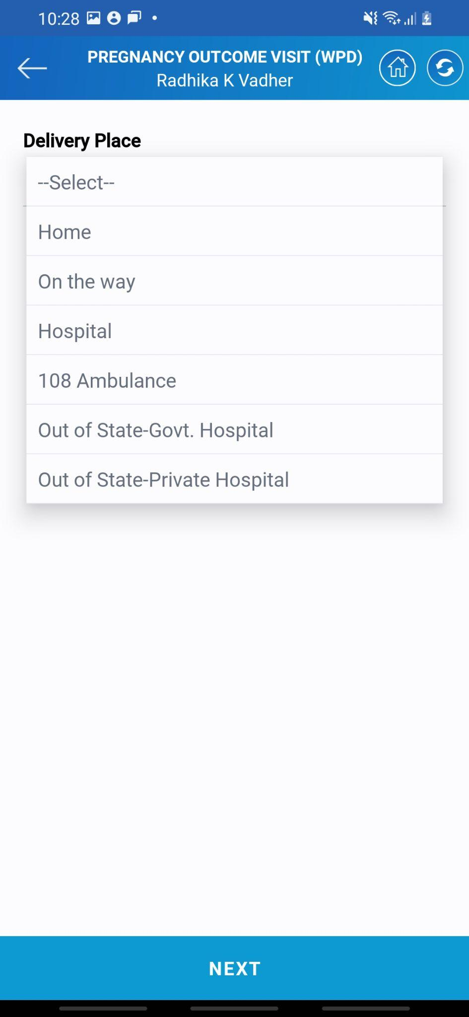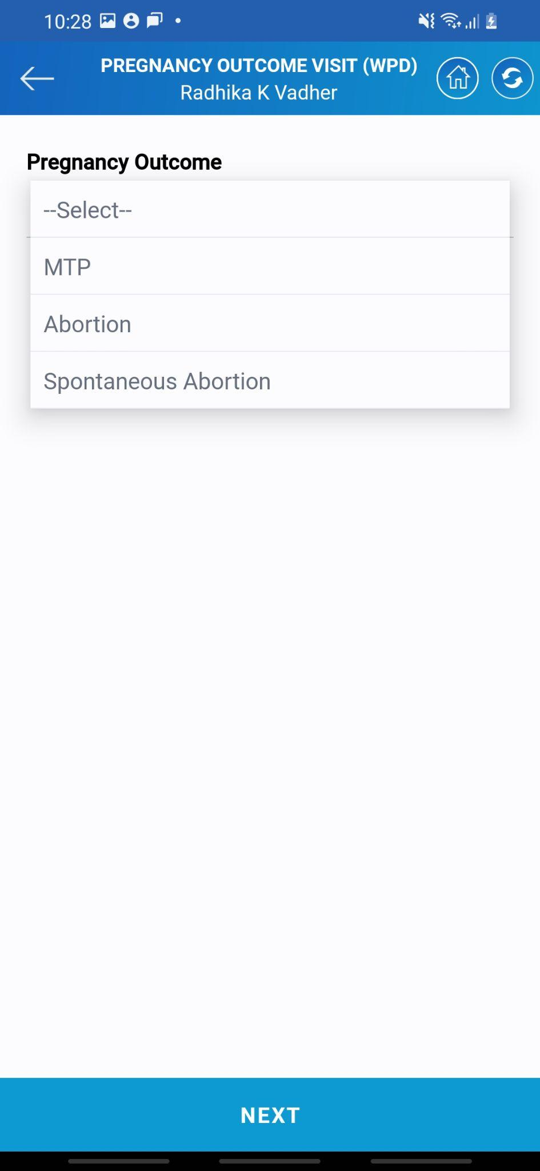

* The nest comes the pregnancy outcome. Asha has to select whether delivery occurred or abortion took place.
* Next comes the place where the delivery occurred. There are multiple options to select from.
* Once the place is selected tap on the **NEXT** button to proceed with the visit.

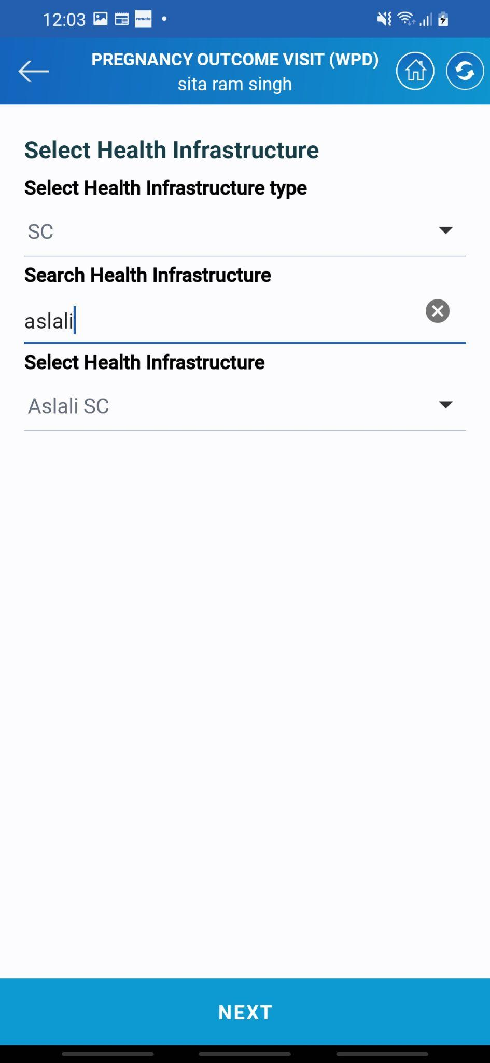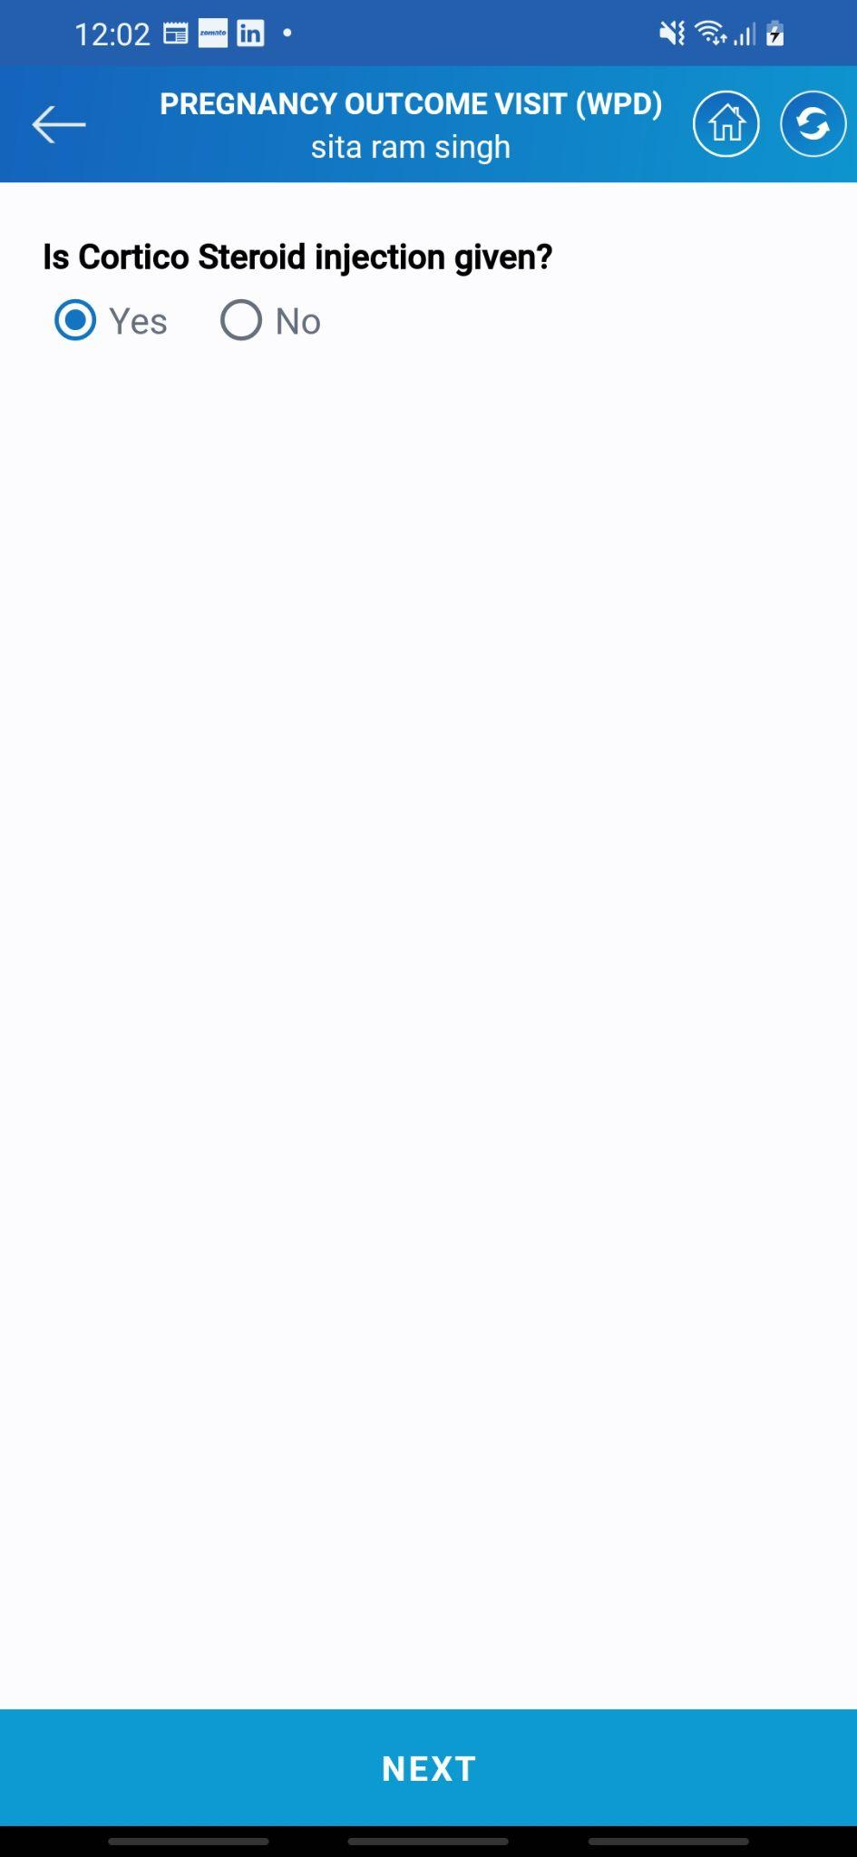

* The next set of questions will be of selecting the health infrastructure. Asha needs to select the place of delivery.
* System will ask whether the cortical steroid vaccine is given or not>
* If yes Asha needs to select yes. Else no

***\*\*Note: The question of Cortico Injection will only come in the case of a delivery done around 7 months of pregnancy\*\****

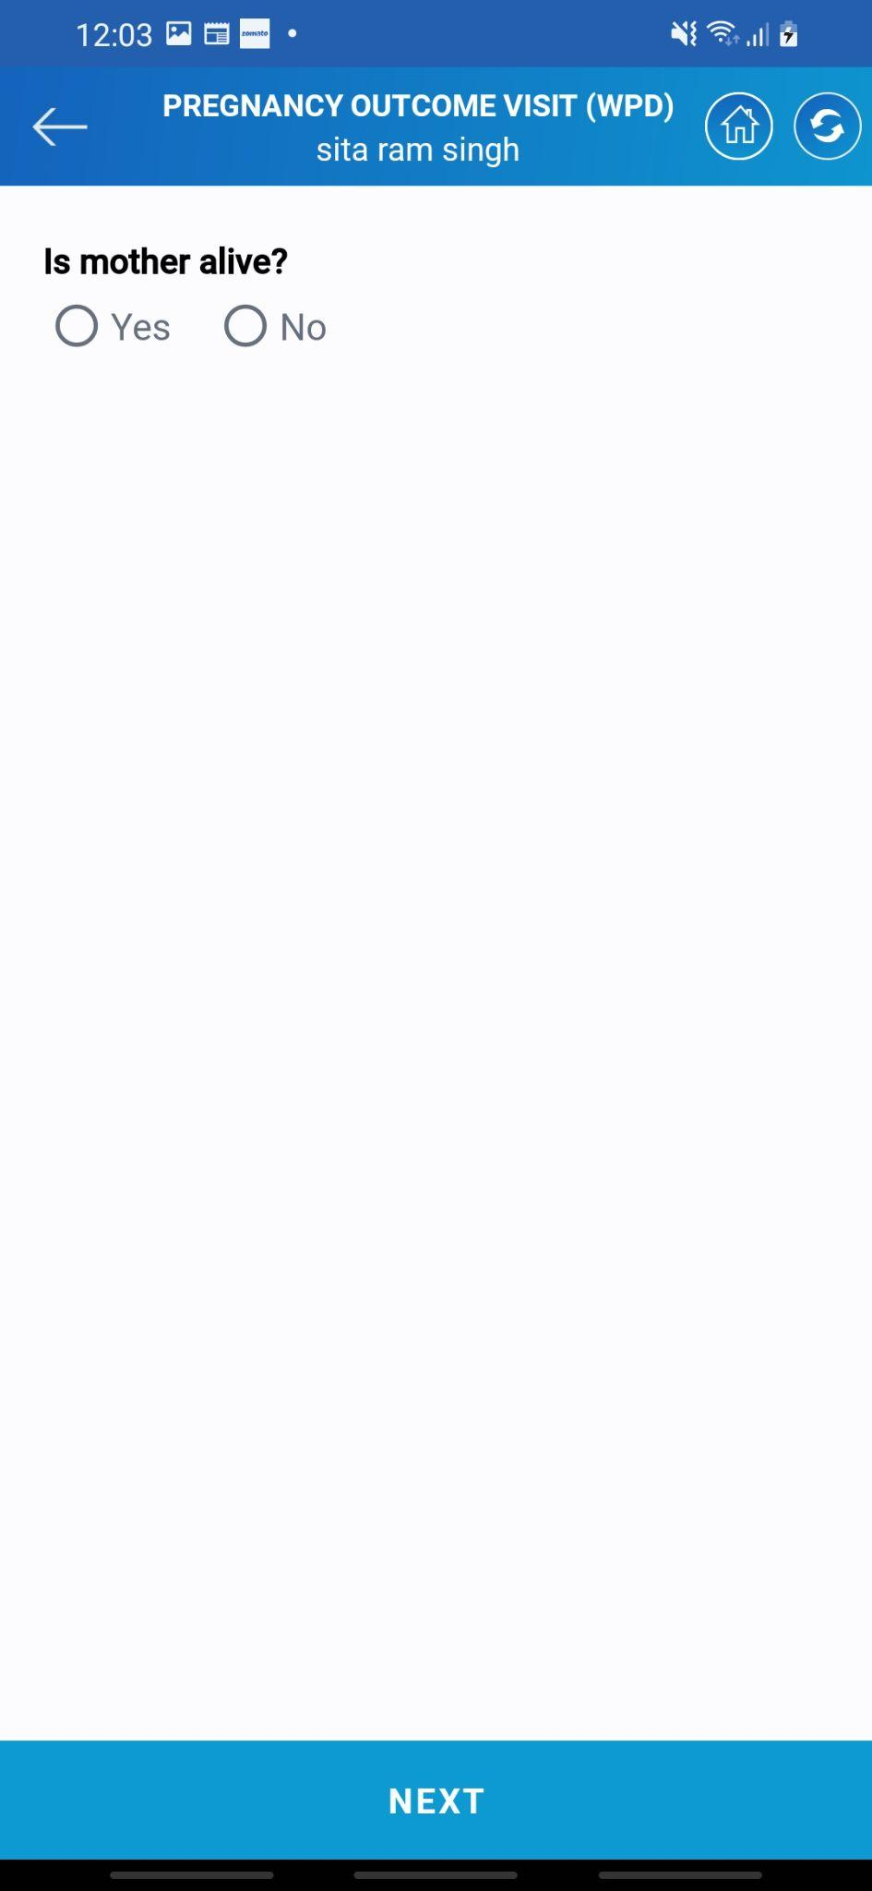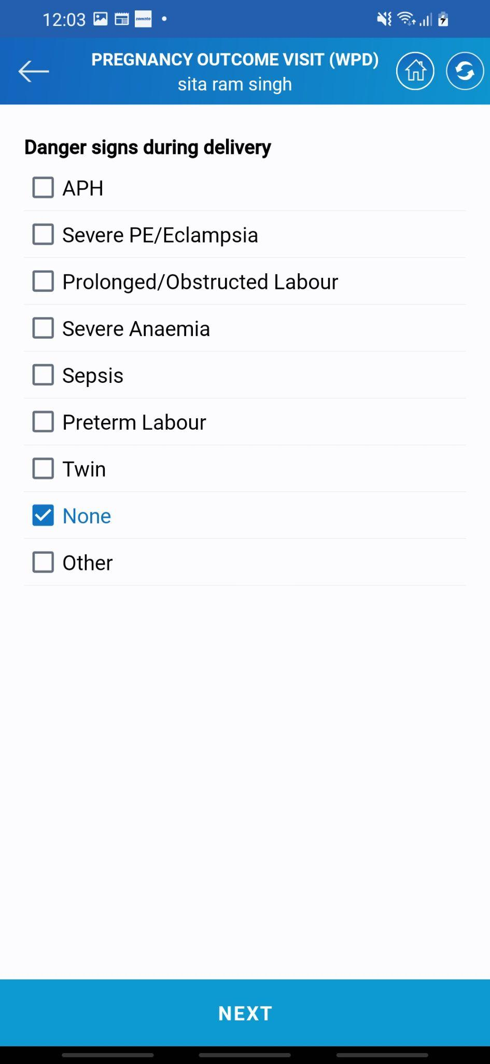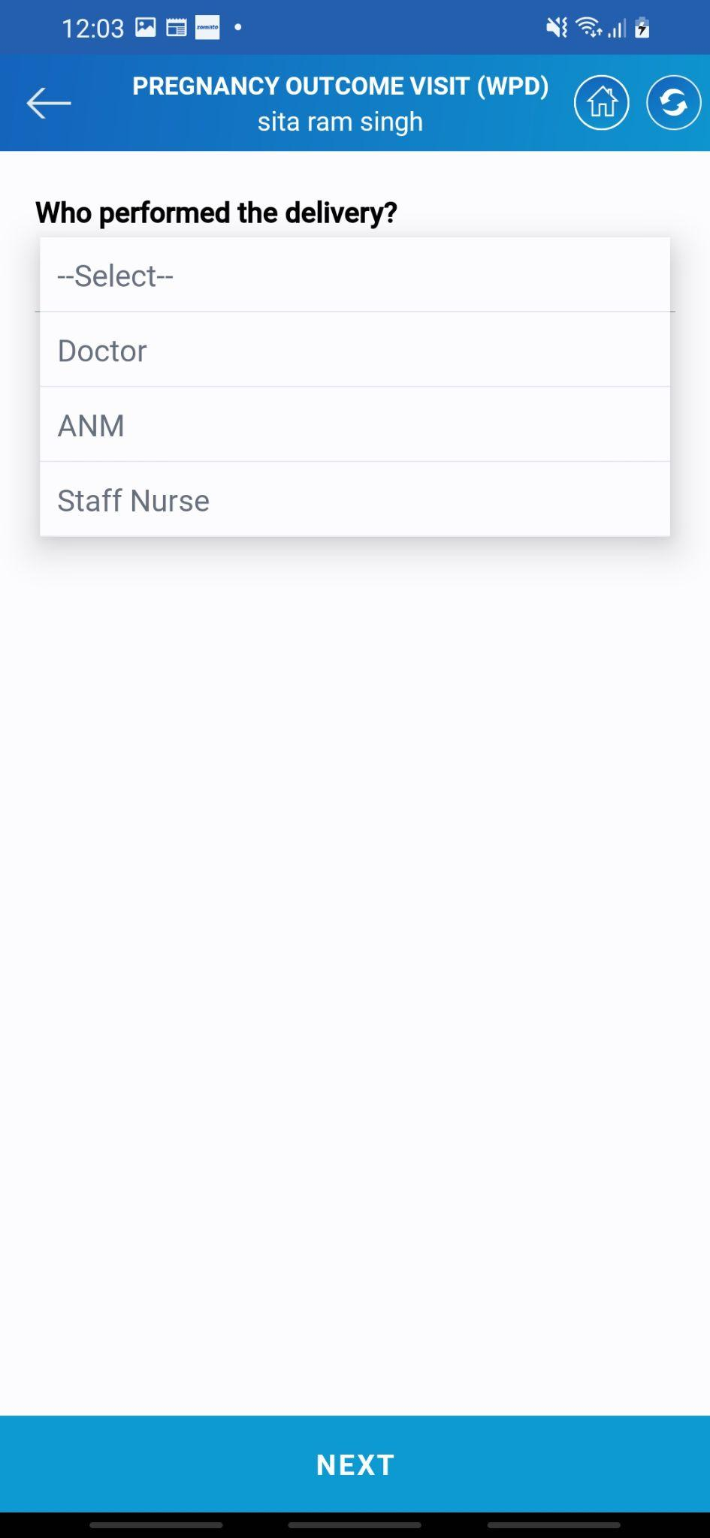

* The next set of questions is related to the delivery-related complications and lady health.
* Asha needs to enter who did perform the delivery. Next, if the mother is alive select yes else no, and enter the death of death.
* The next screen is the danger signs a mother can have post-delivery. Ashna needs to verify this and enter it into the system.
* Once all the data is entered tap on the NEXT button to proceed ahead with the visit.

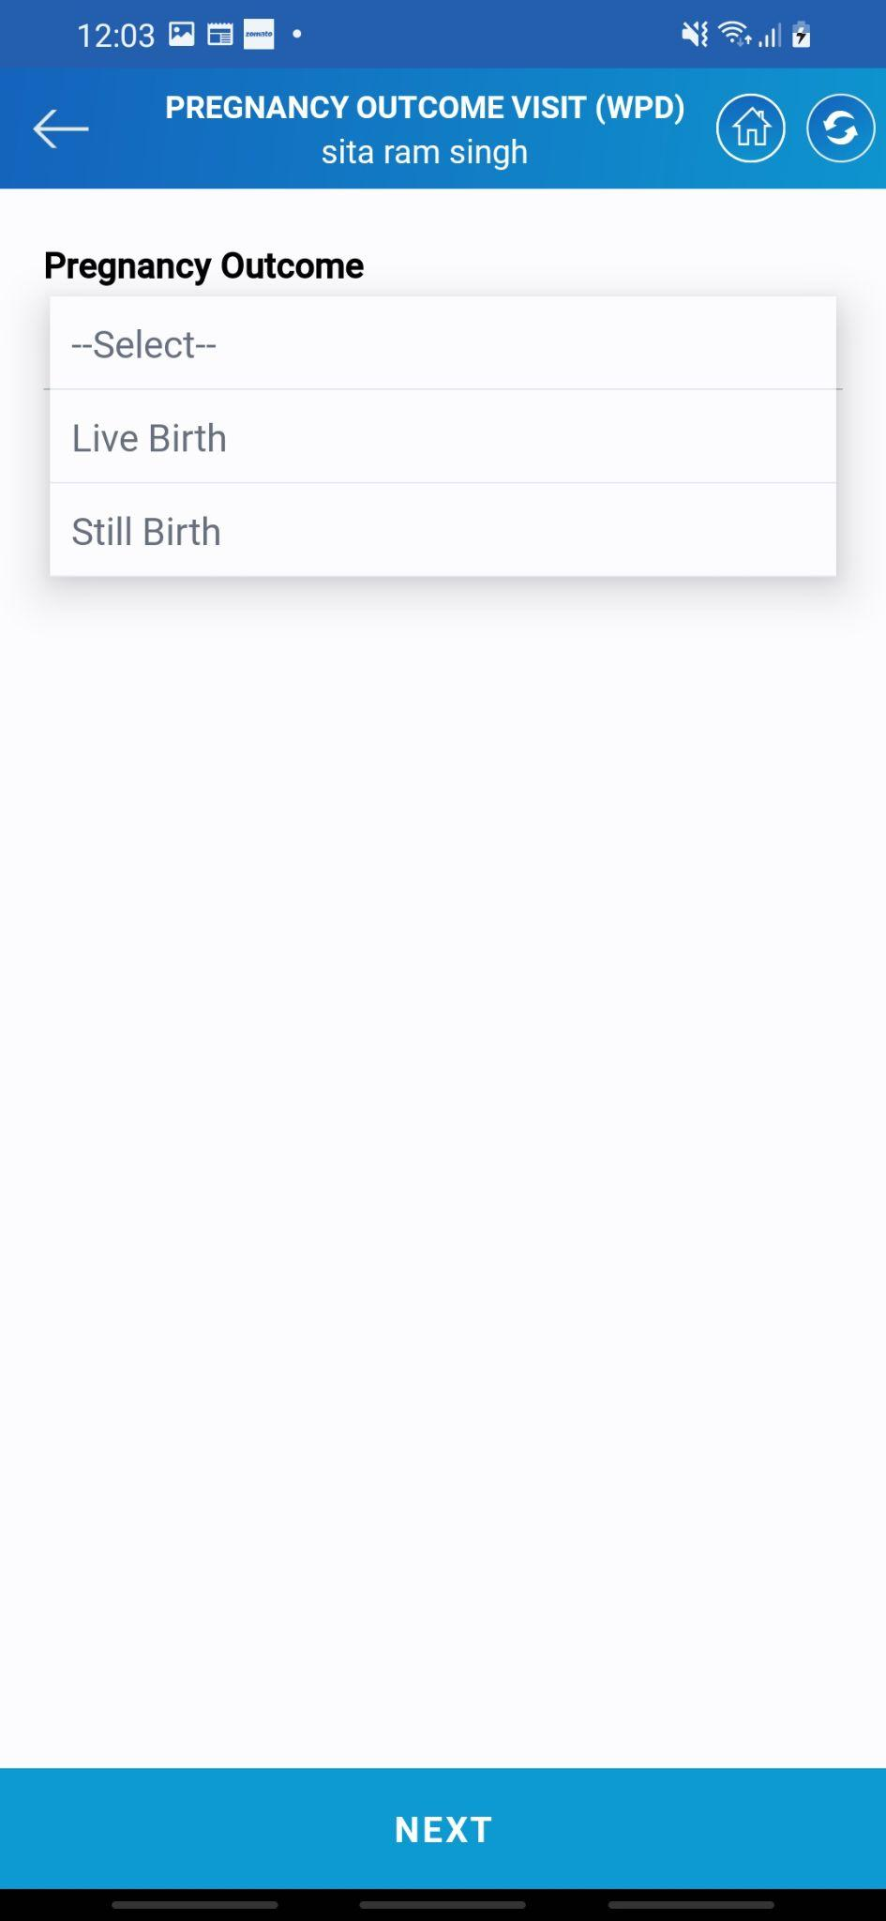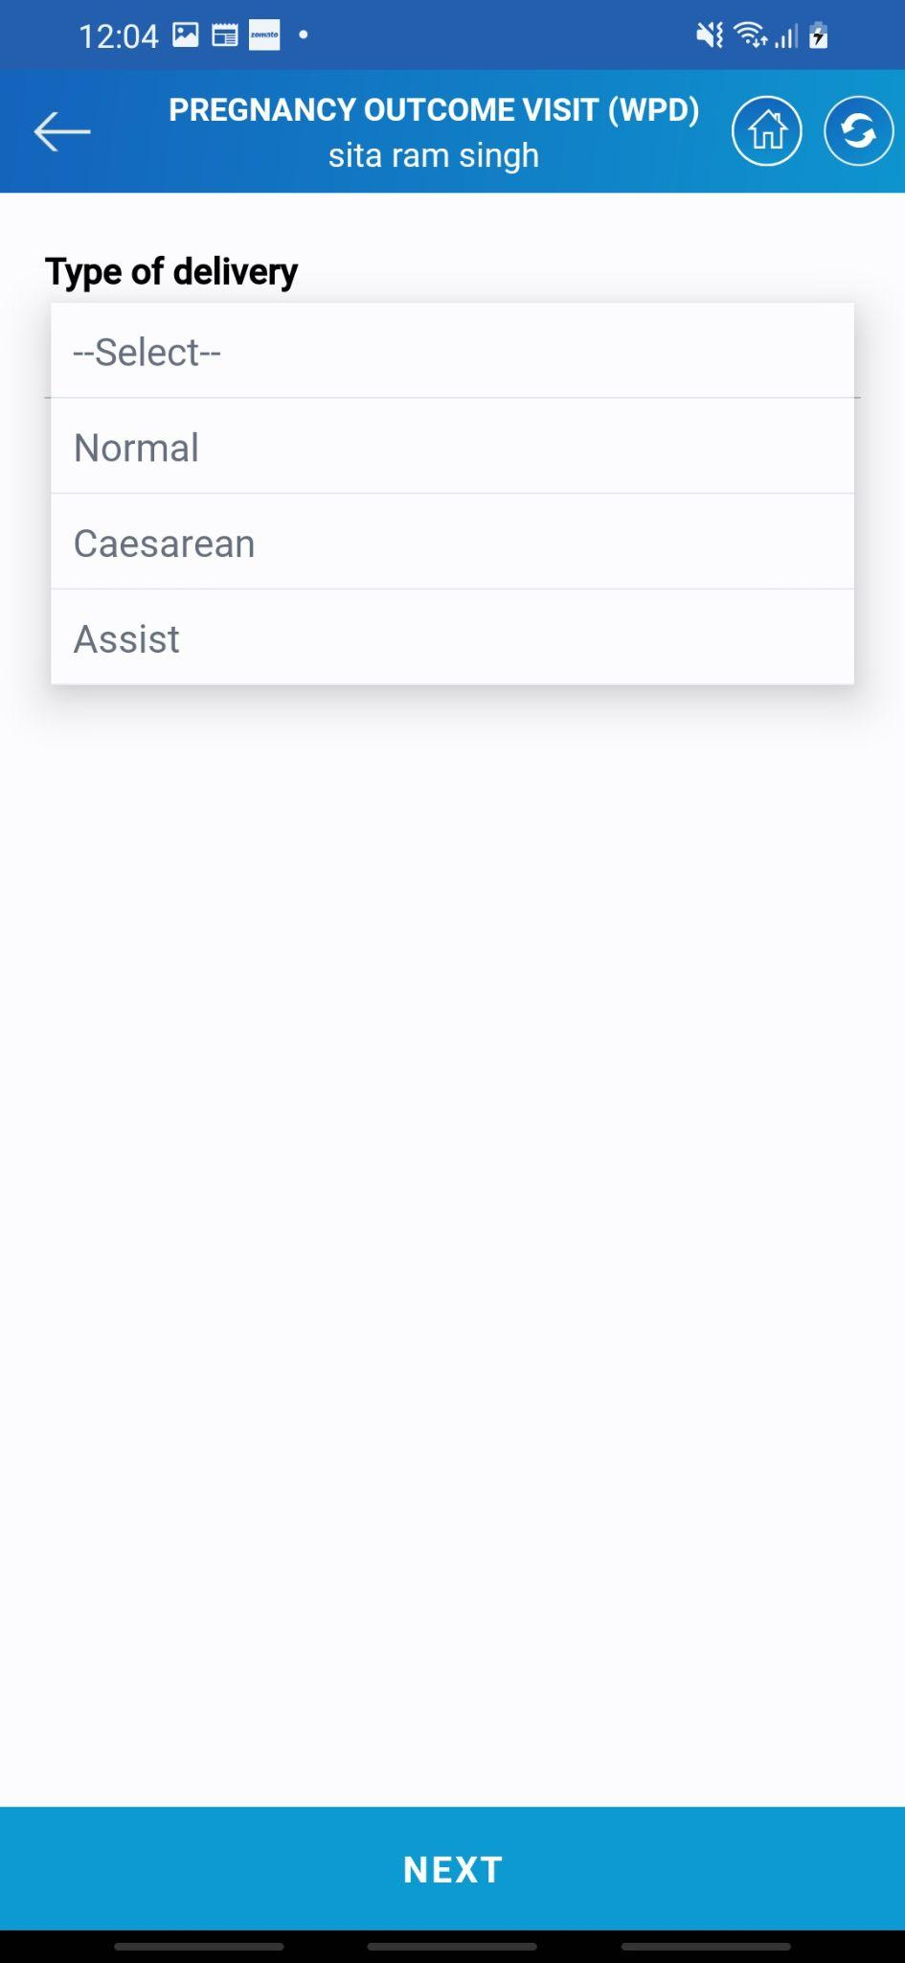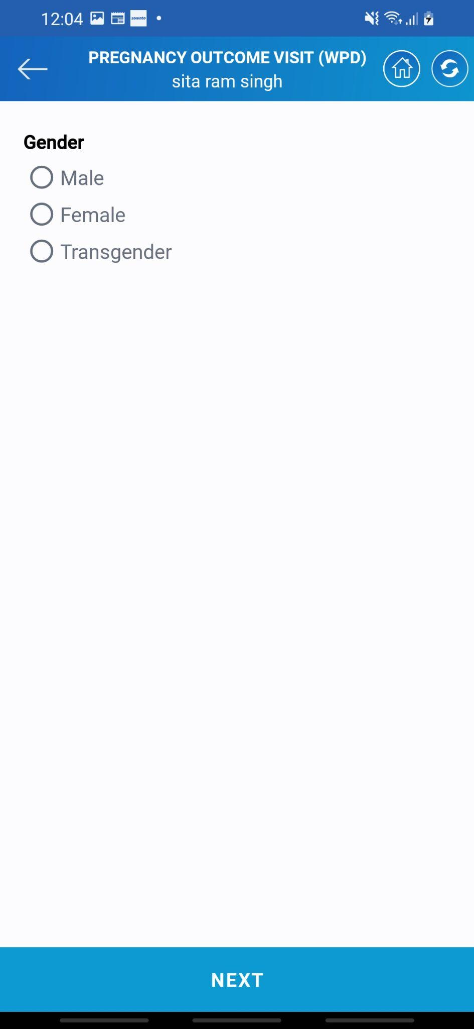

* The next question is related to the child's birth status. If there is a live birth select that and if there is a stillbirth select the option as relevant.
* Next comes the type of delivery whether normal, cesarian, or assist. Asha needs to select the relevant option.
* Next comes the gender of the child. Asha needs to select the gender of the child.
* Once all the details are filled tap on the **NEXT** button to proceed ahead with the visit.

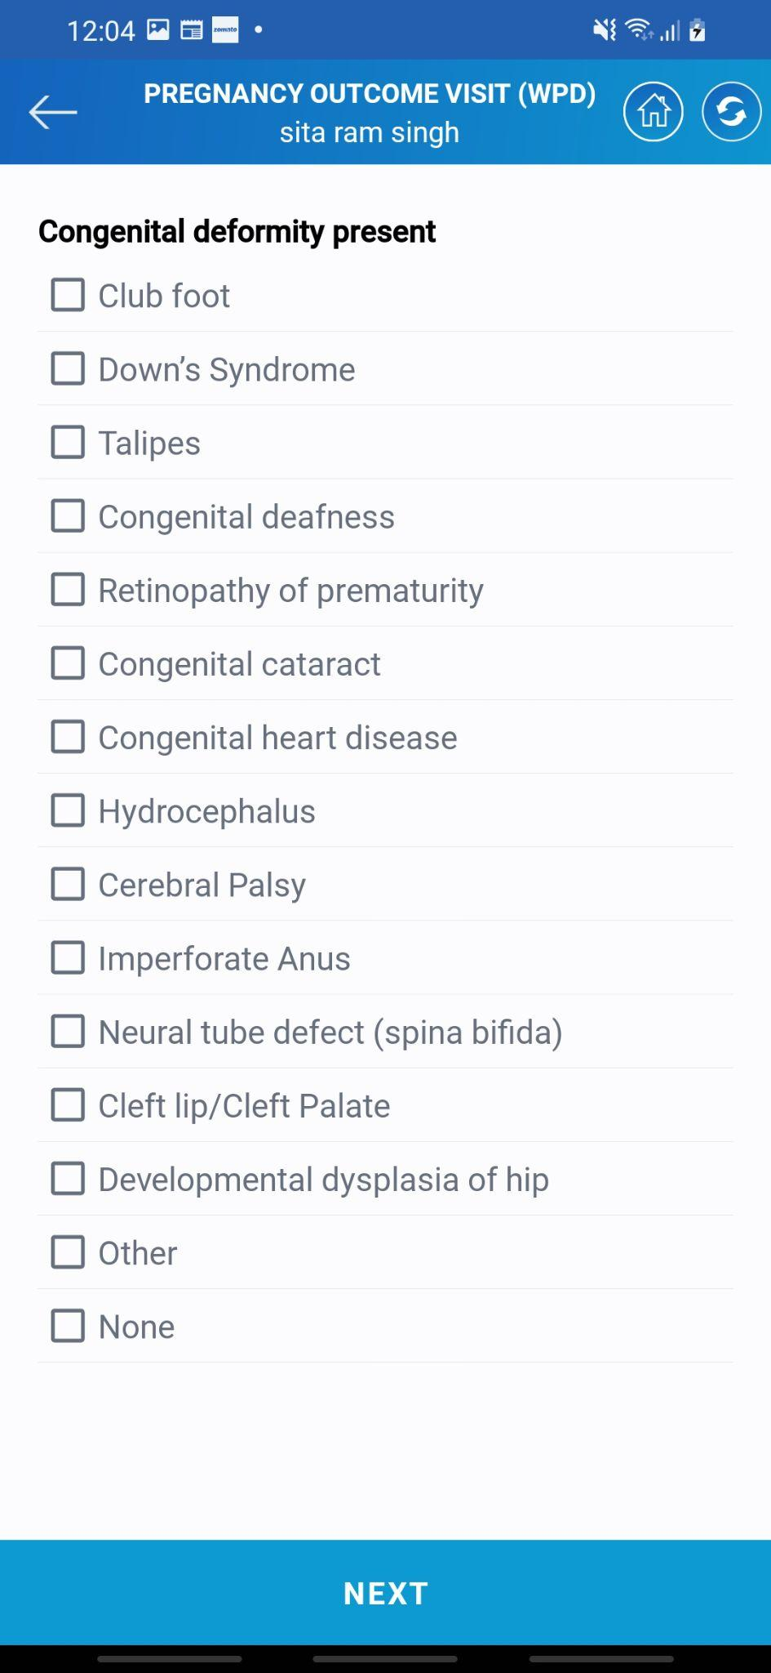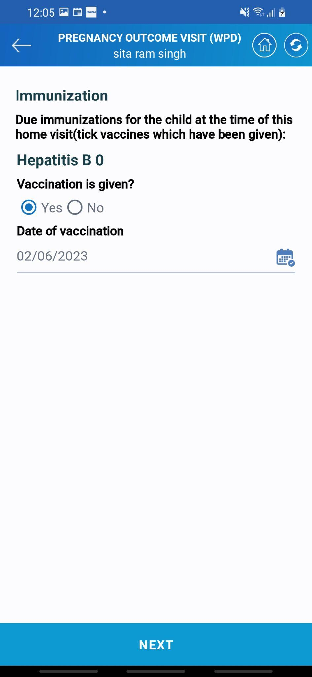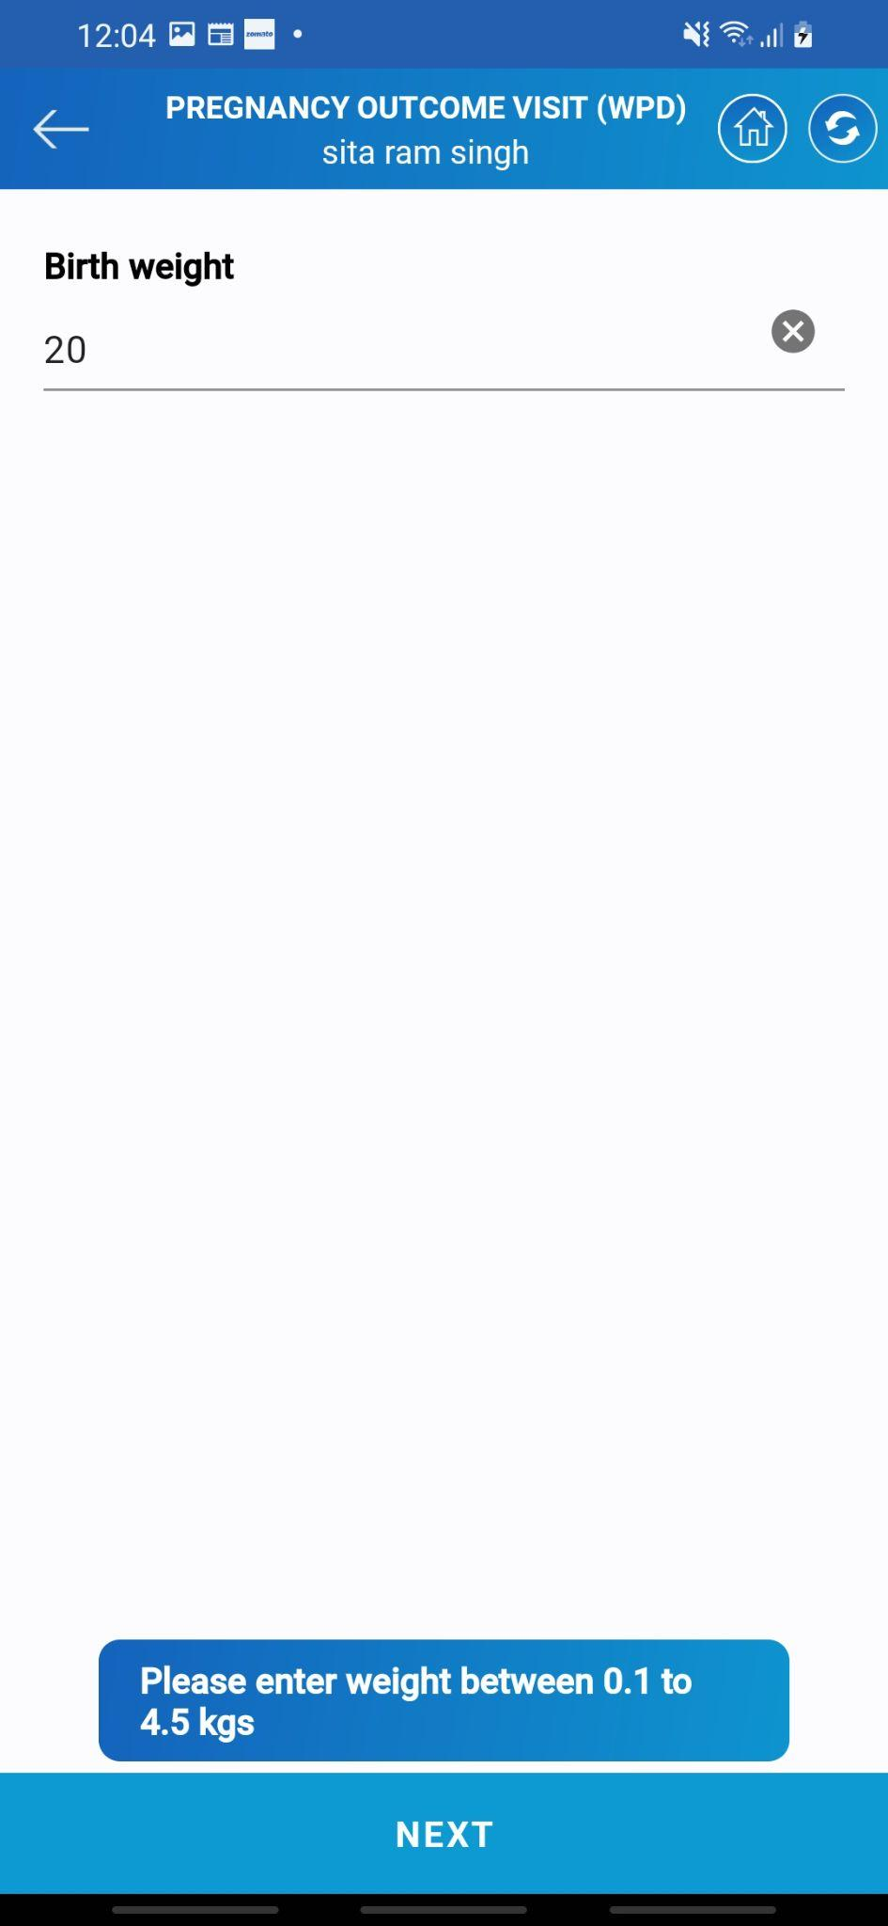

* If there are any deformities present in the child at the time of birth Asha needs to select it.
* There is a list of probable deformities. There is also an option to add any other deformities which are not present in the list.
* Next comes the weight of the child. Asha needs to enter the weight of the child.
* As shown on the screen the weight cannot be **less than 0.1 kg and more than 4.5 kg**
* The next couple of screens will have questions related to the immunization. Asha needs to confirm the date of immunization given to the child.

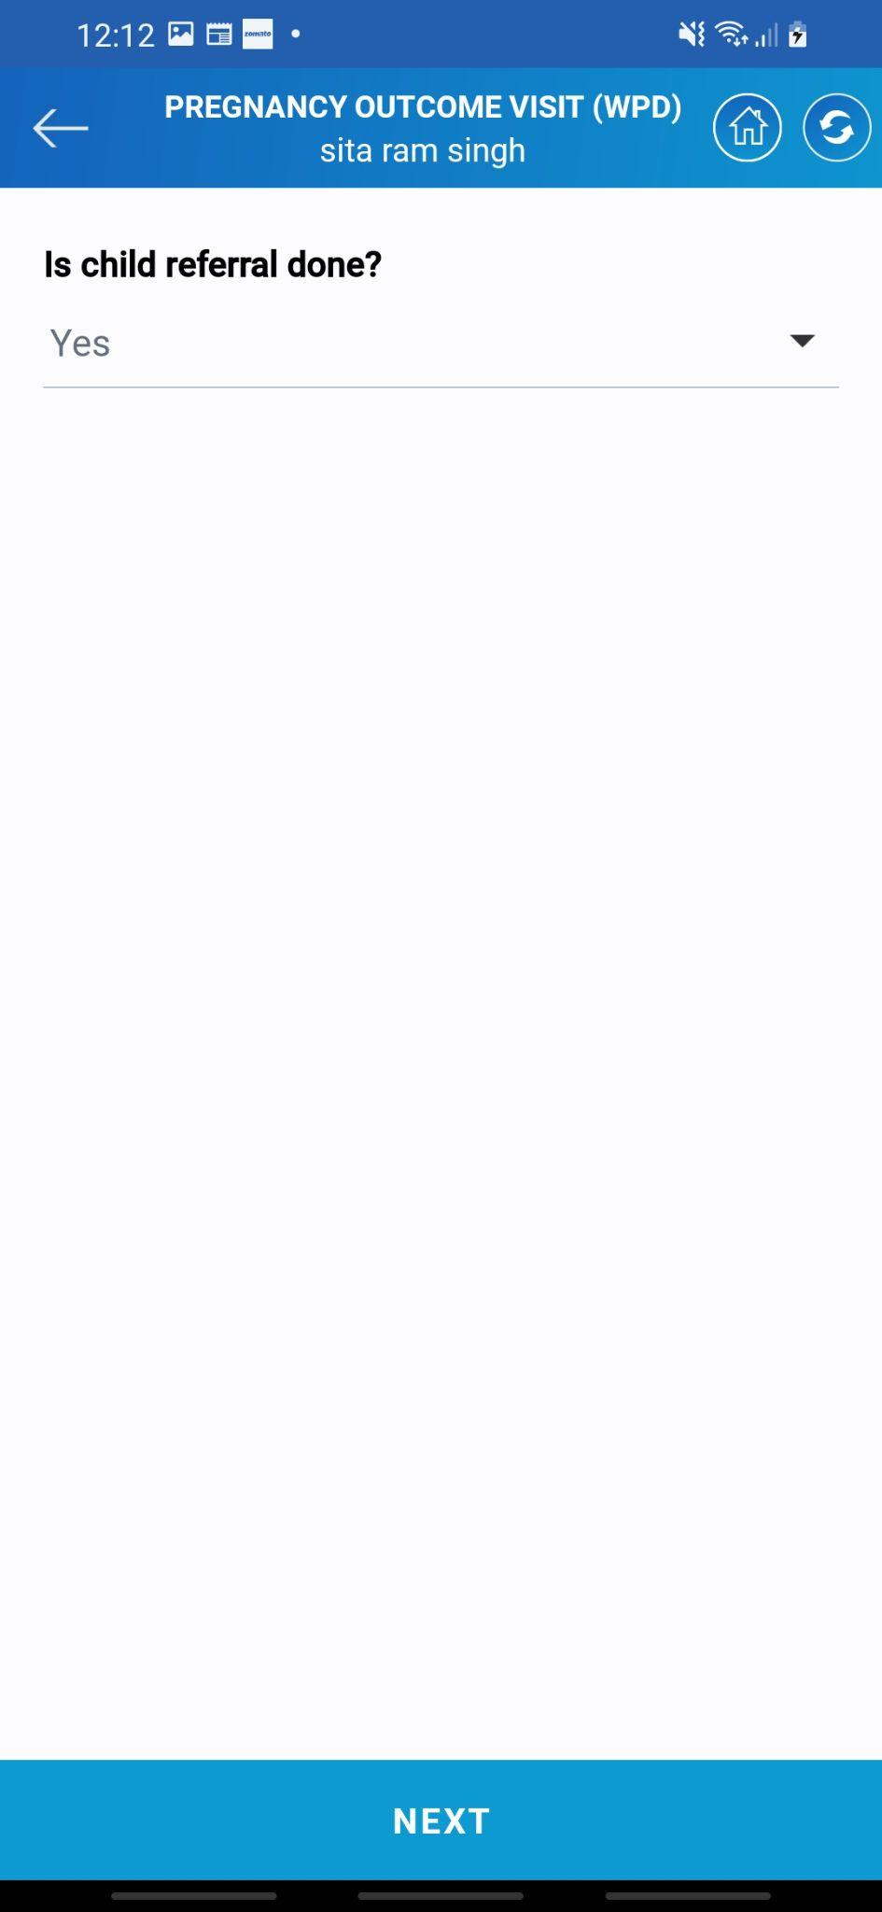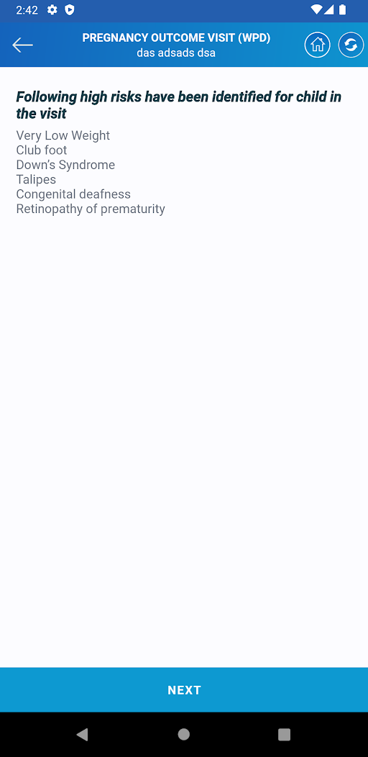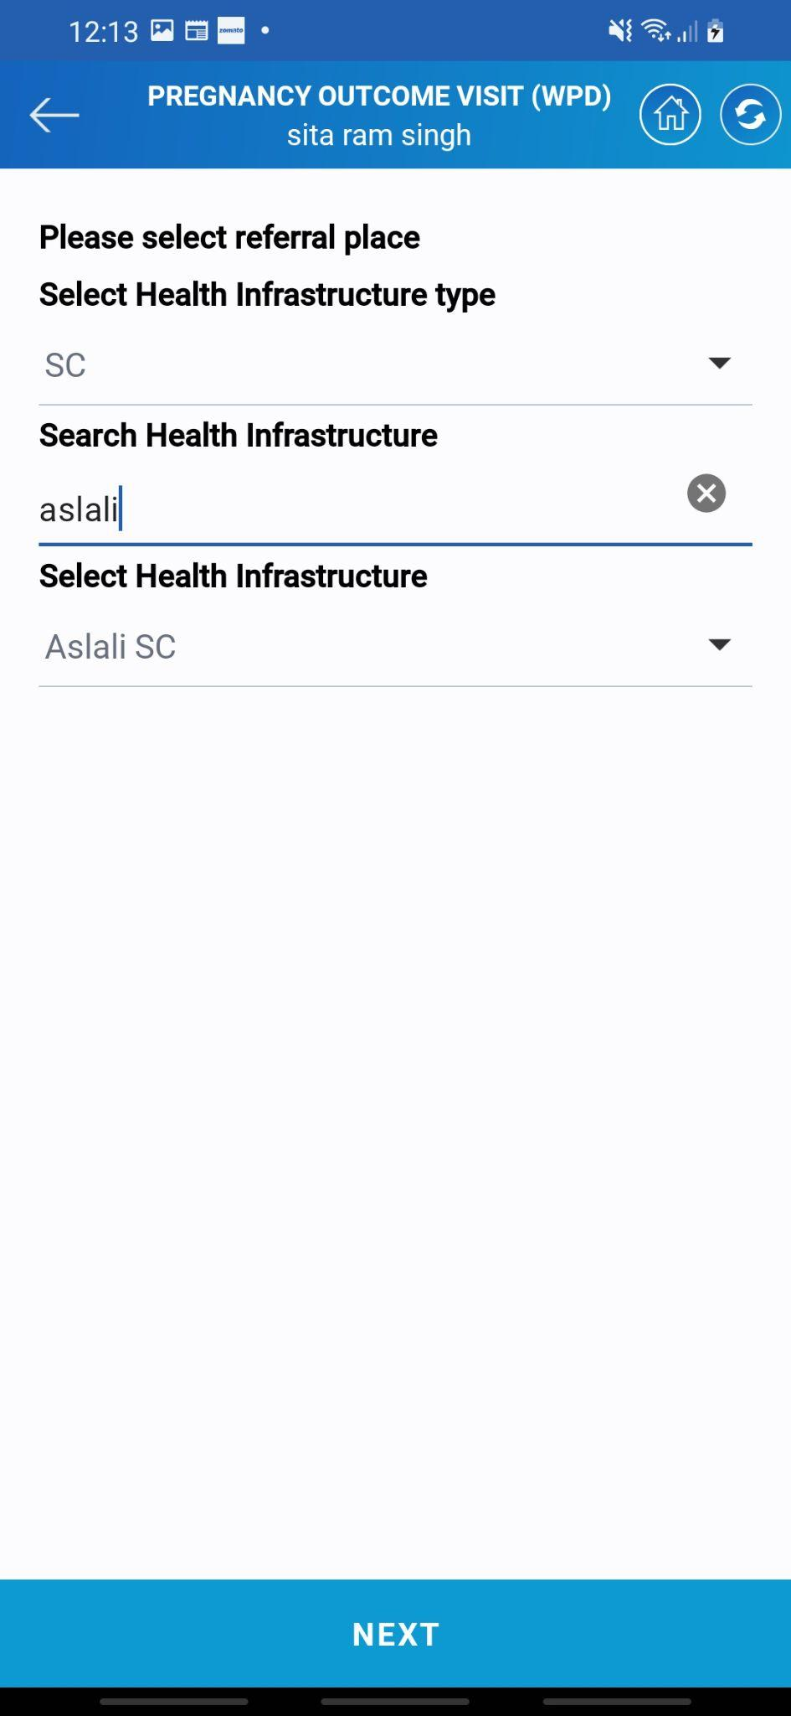

* If Asha thinks that the child needs to be referred then she must select yes. The next screen will ask for the place of referral.
* Asha needs to select the place where the child is to be referred. Enter the location details for the same
* Once all this information is filled the system will show the list of high risks the child can have. This is a warning sign that must be looked into carefully
* Tap on the ***NEXT*** button to proceed ahead with the visit.

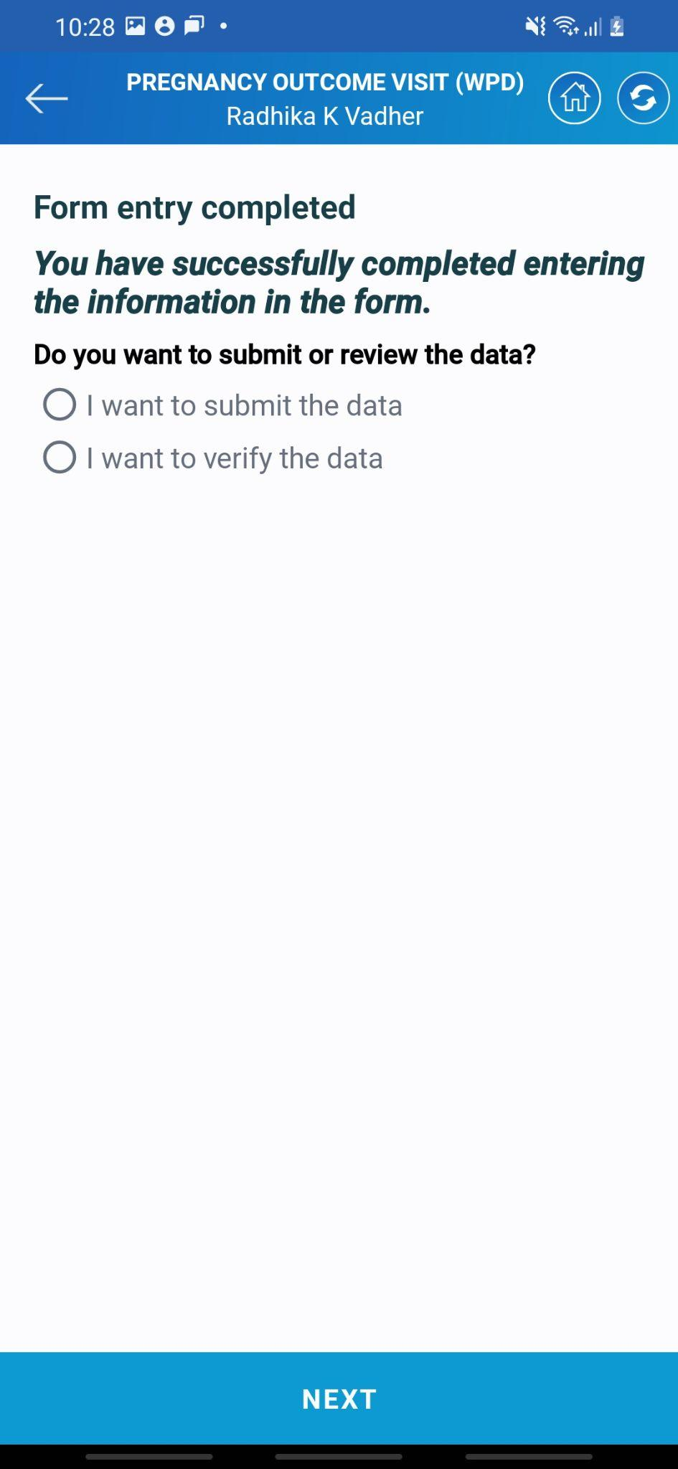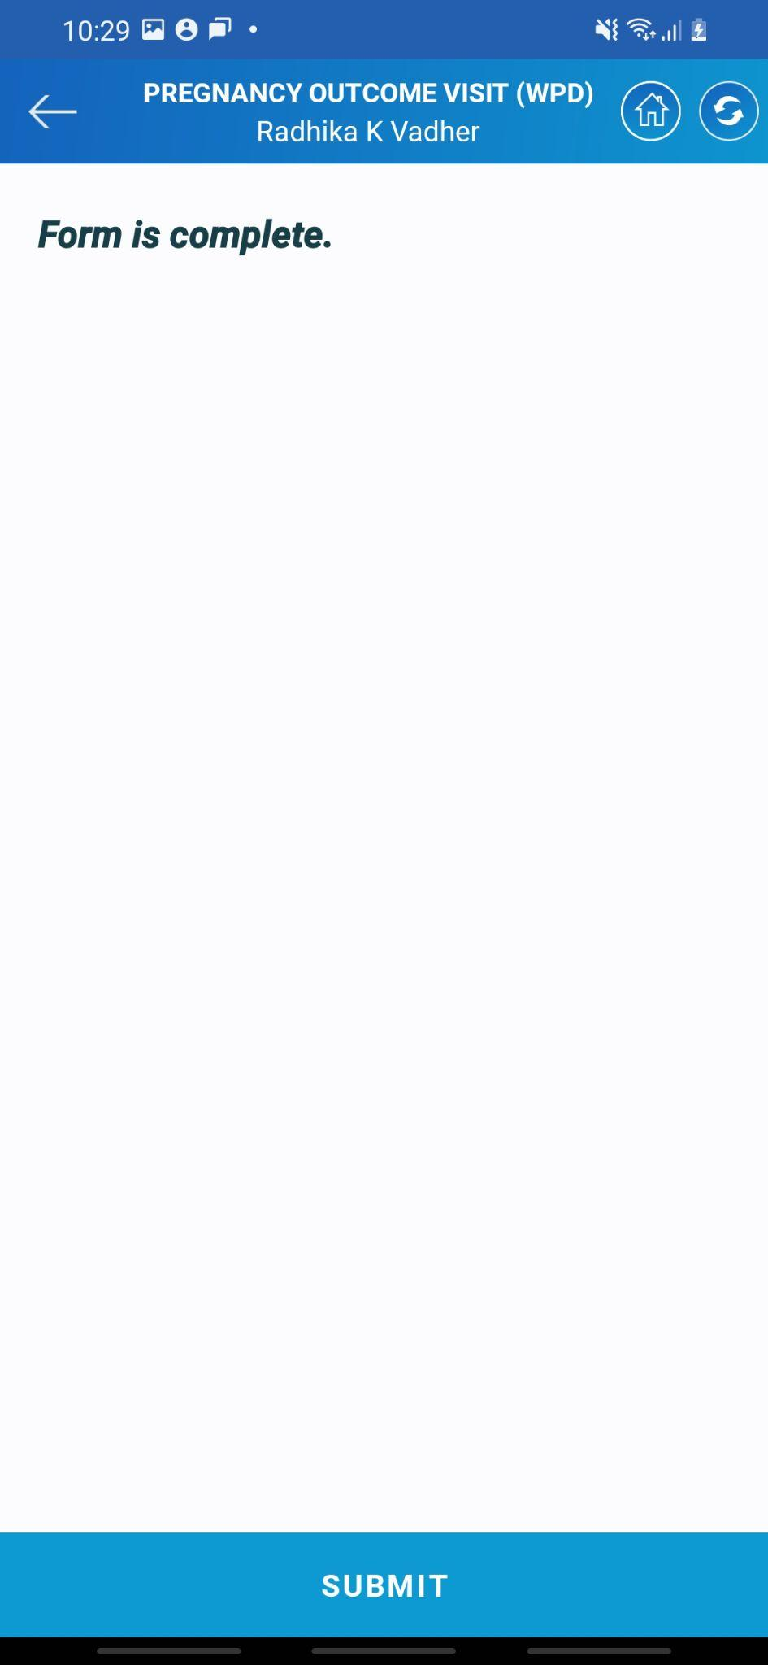

* The system will ask to verify the data. If Asha selects verify the data the system will show her the complete entered data.
* Select the Subbmit option to proceed ahead.
* Tap on the ***NEXT*** button to submit the data.
* At last the system will show the form is complete as the confirmation of submission of data.
* Here the ***WPD*** visit of the beneficiary gets over. Now we will start with the WPD visit i.e. Pregnancy outcome visit.

### 4.3 PNC Women

Postnatal care, also known as postpartum care, is the medical and emotional care provided to a mother after childbirth. It is a crucial period to ensure the mother's well-being, recovery, and adjustment to her new role as a parent. Some essential aspects of postnatal care for mothers are Physical Recovery, Emotional Support, Breastfeeding Support, Nutrition and Hydration, Postnatal Check-ups, Family Planning, Monitoring for Postpartum Complications, etc.

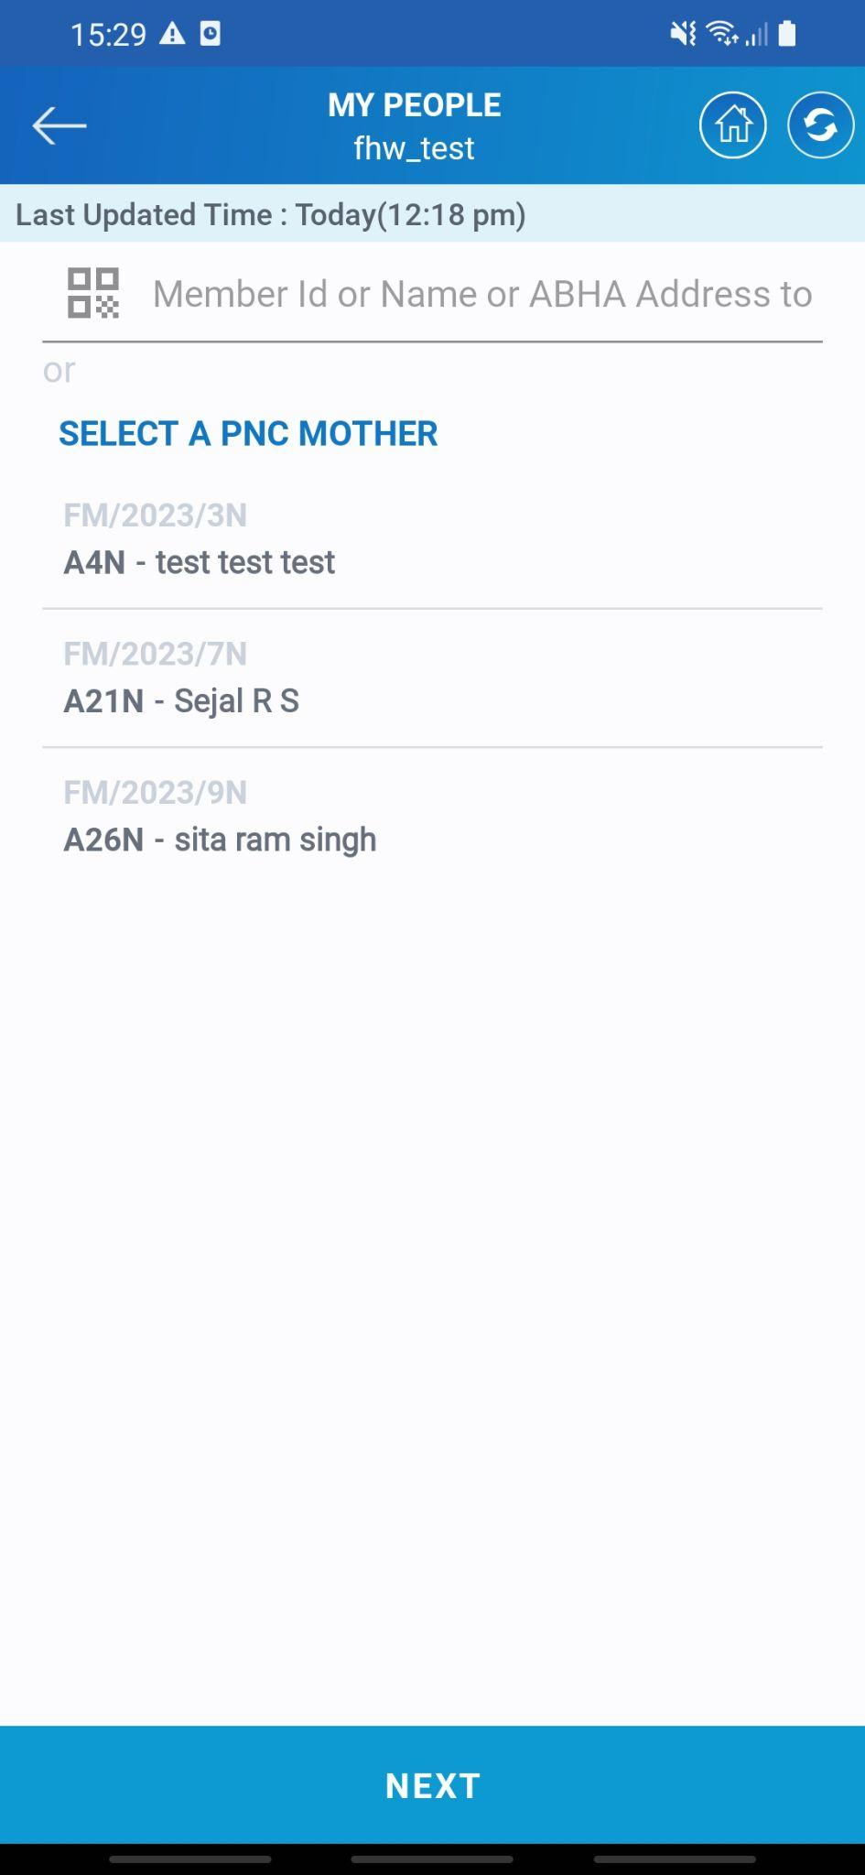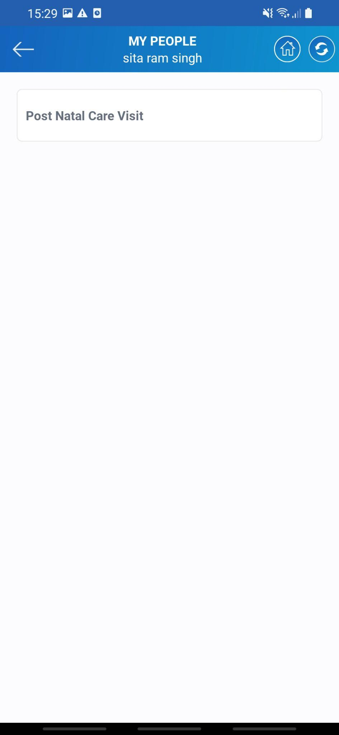

* Tap on the ***PNC Women*** which is highlighted on the screen. Once you click on the next Asha needs to select the beneficiary for whom the visit is to be done. Searching and selecting is similar to all the other visits. Tap on ***Post Natal Care Visit*** to continue with the visit.

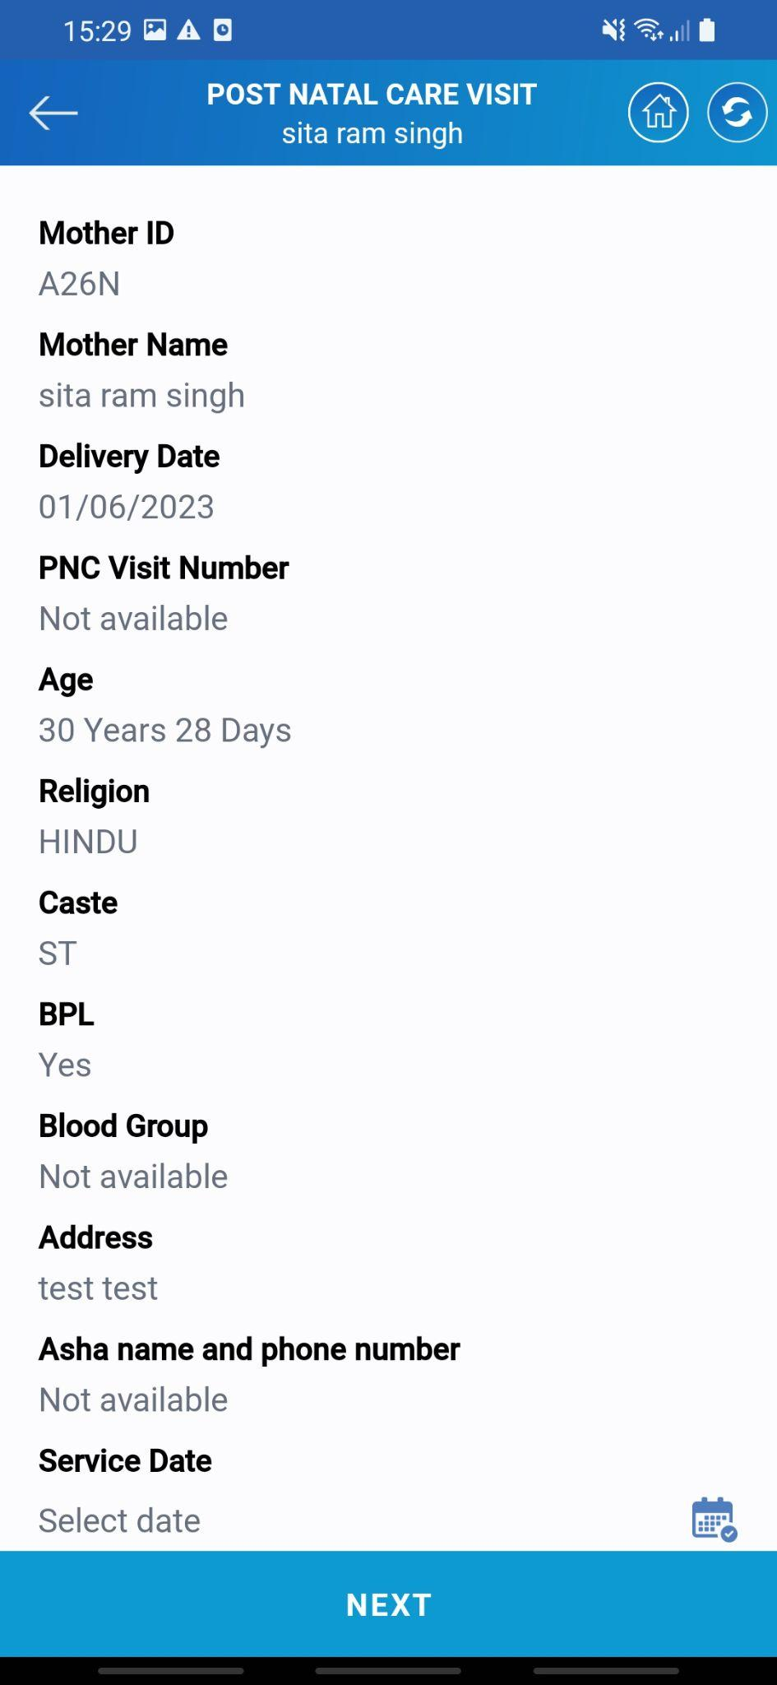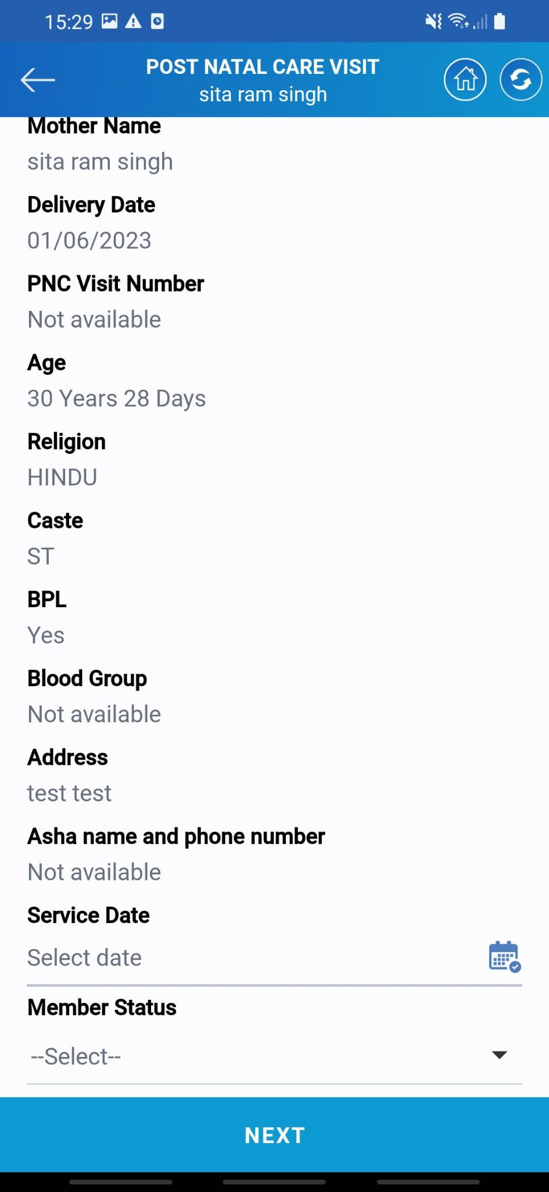

* The system will display the complete information of the beneficiary which is present in the system.
* Asha needs to select the date of service that she gave.
* The date can be of the current date or before it.
* Once the date is selected tap on the ***NEXT*** button to proceed ahead with the service.

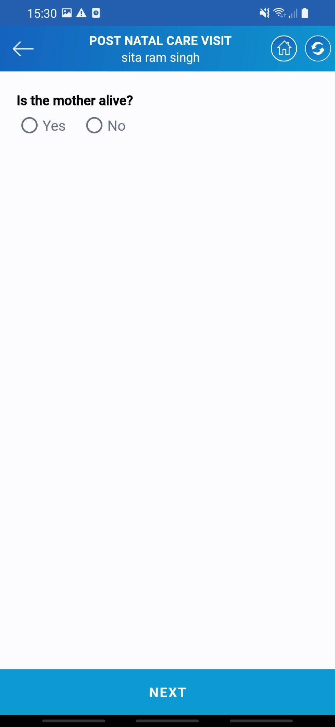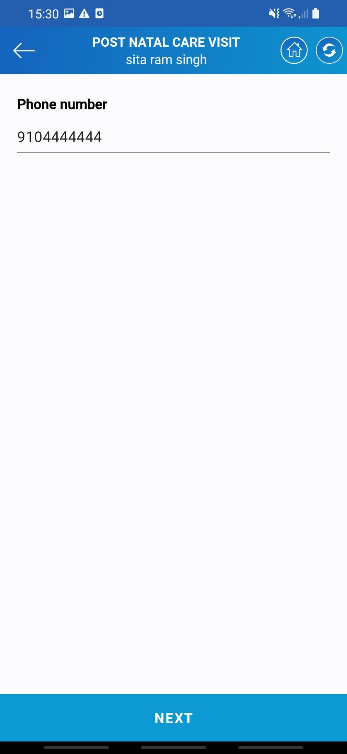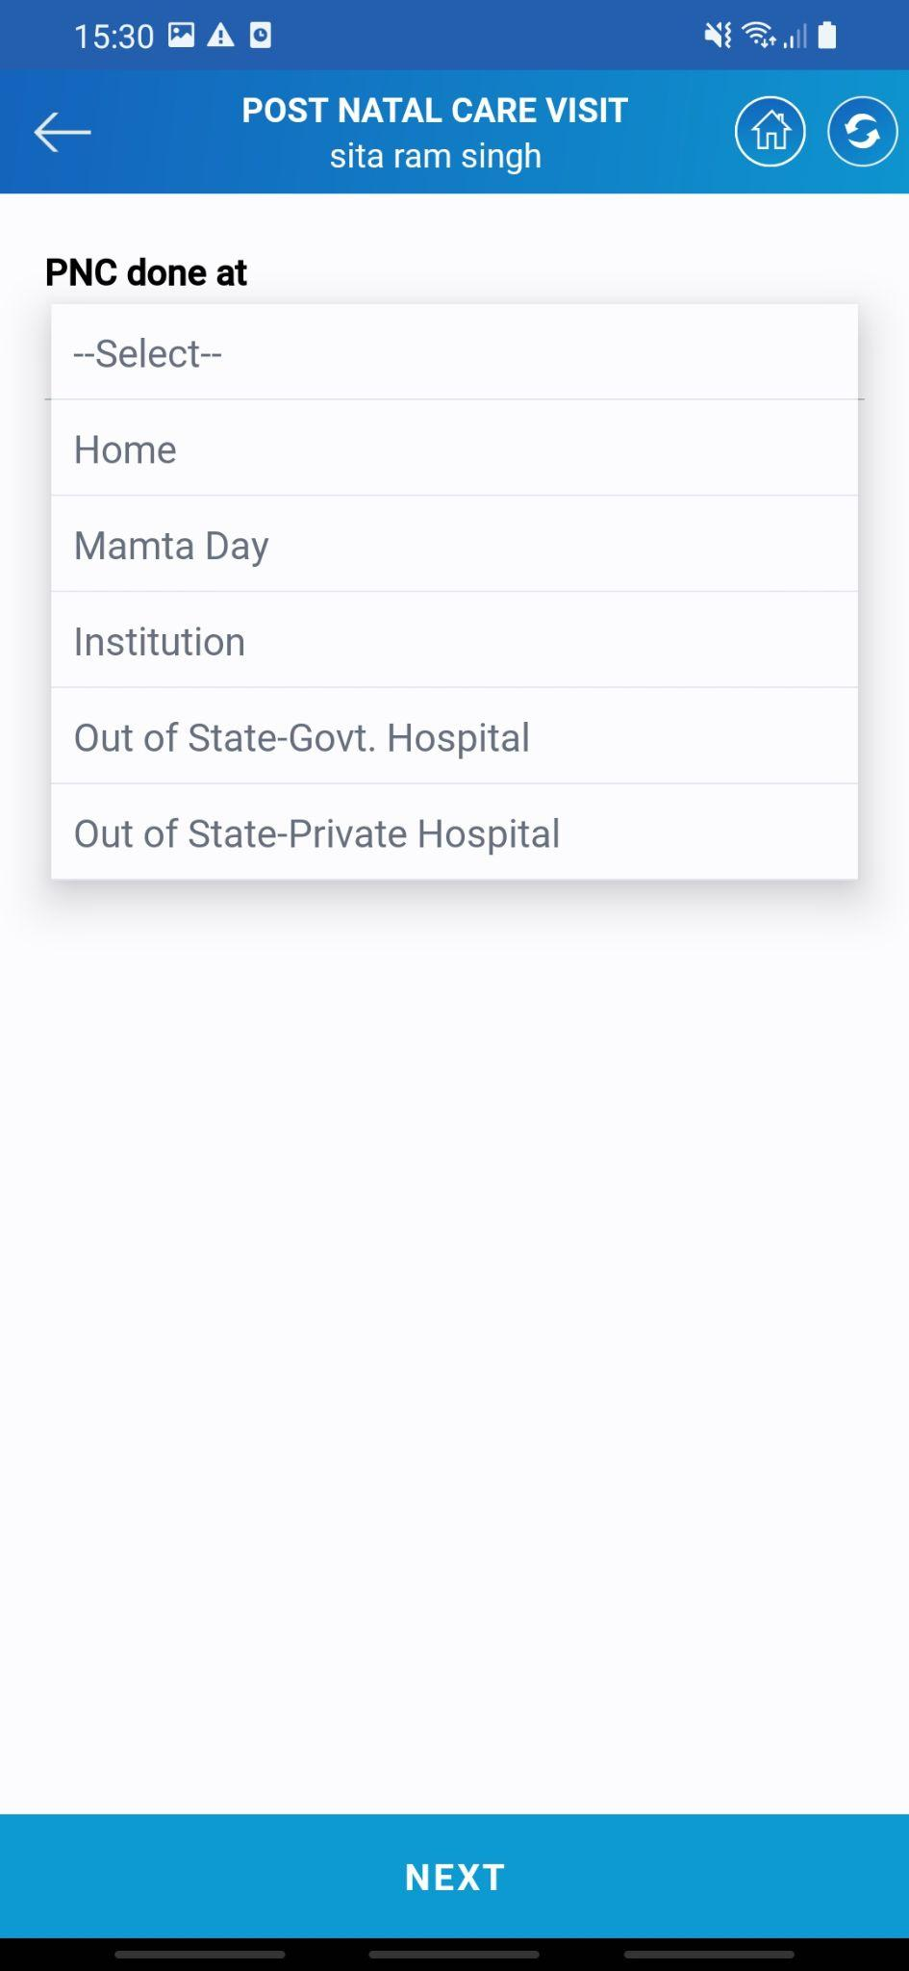

* The next Asha needs to enter the mother's status whether she is alive or dead. Next comes the contact number of the beneficiary.
* Once both the details are entered the system will ask the location for the PNC. There is a list of different locations out of which Asha needs to select the place where she is currently giving the service.

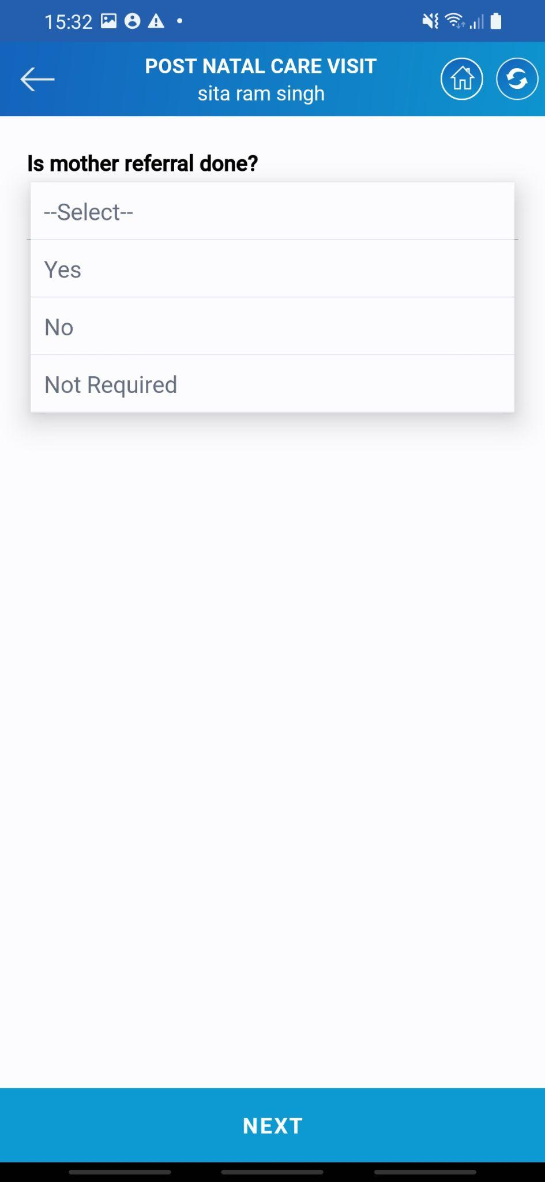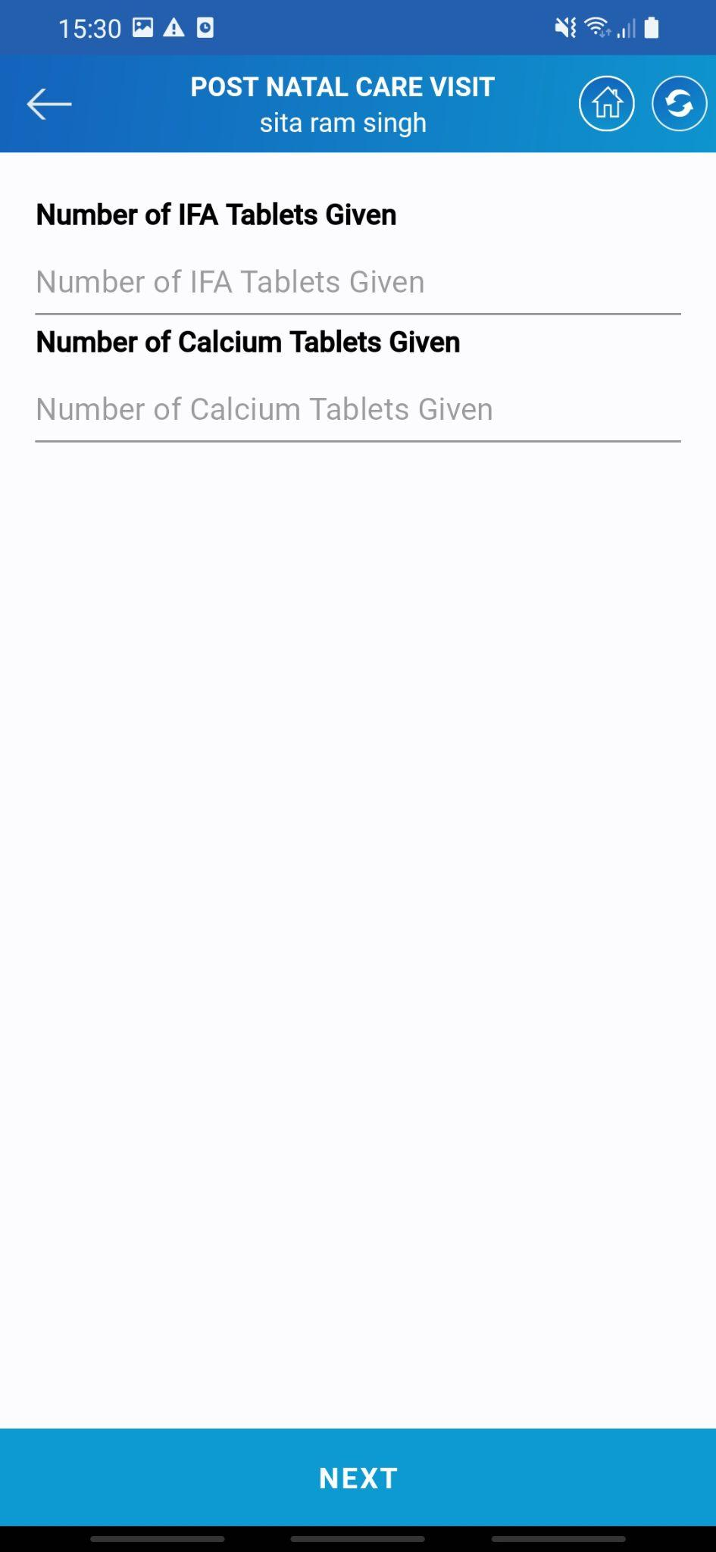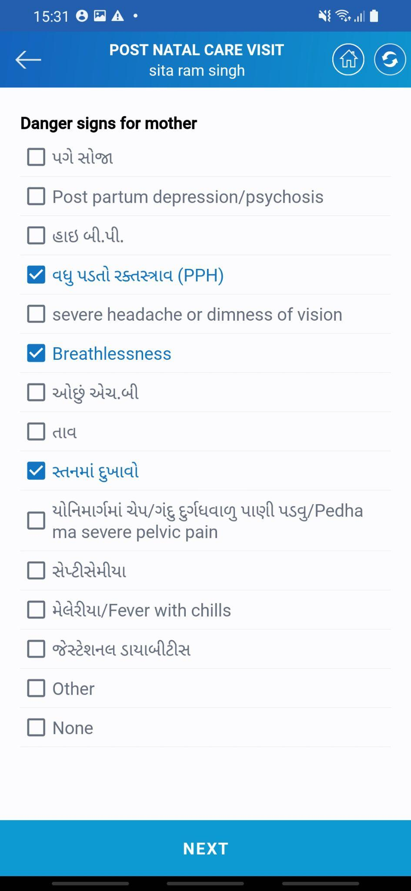

* The next questions will be related to medicines given to the beneficiary. Asha needs to enter the number of tablets given to the beneficiary.
* The next comes the list of questions related to complications the benificary might face post pregnancy. Asha needs to select the relavant if applicable.
* If the referral of mother is done asha needs to select yes else relevant option must be selected.
* Once all the information is provided tap on the ***NEXT*** to proceed ahead with the visit.

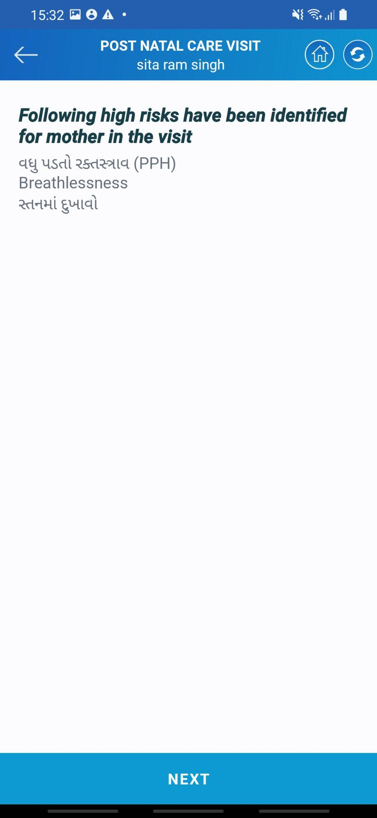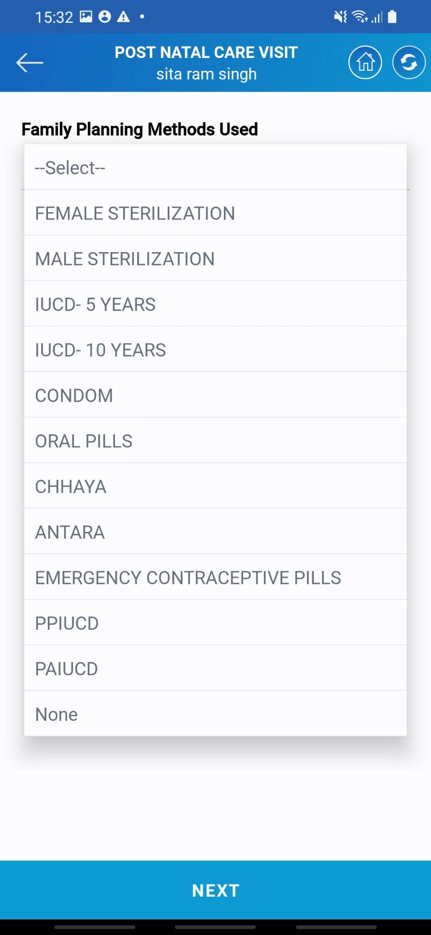

* The next comes the selection of family planning methods. There is a list of several options out of which one is to be selected. Asha needs to select the relevant if applicable
* Once the information is entered the mothers service gets completed.
* The next screen will display the list of risk factors which the system found out of the information provided by Asha.
* Once all the information is filled tap on the ***NEXT*** button to proceed ahead with childcare.

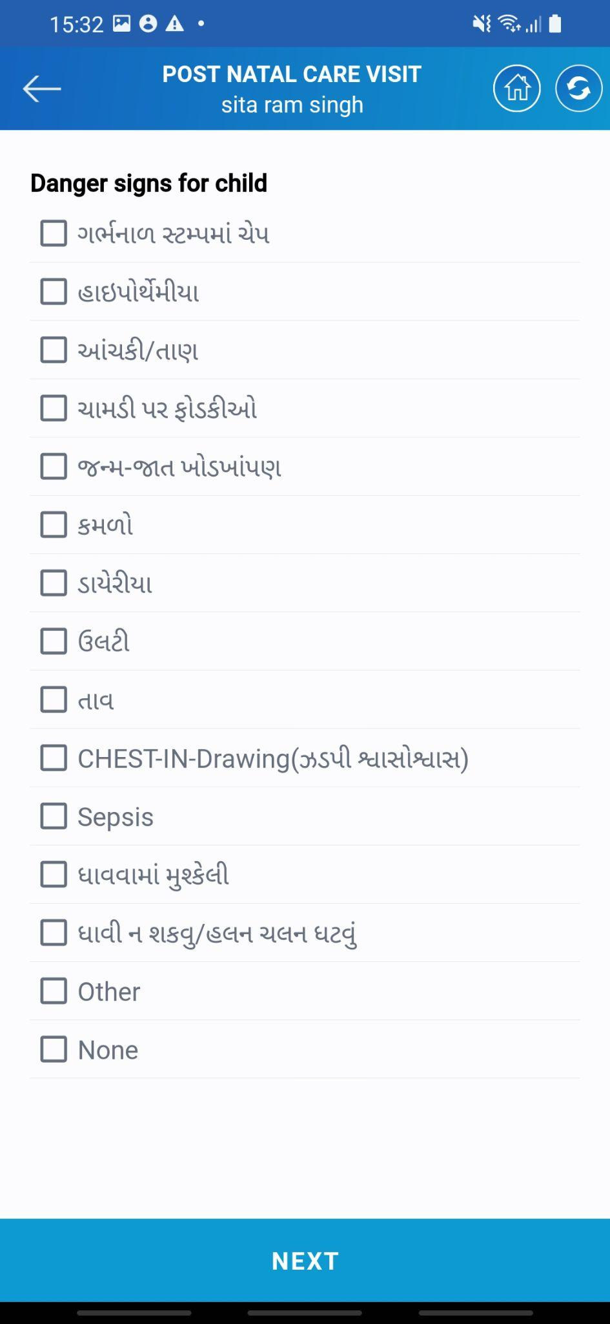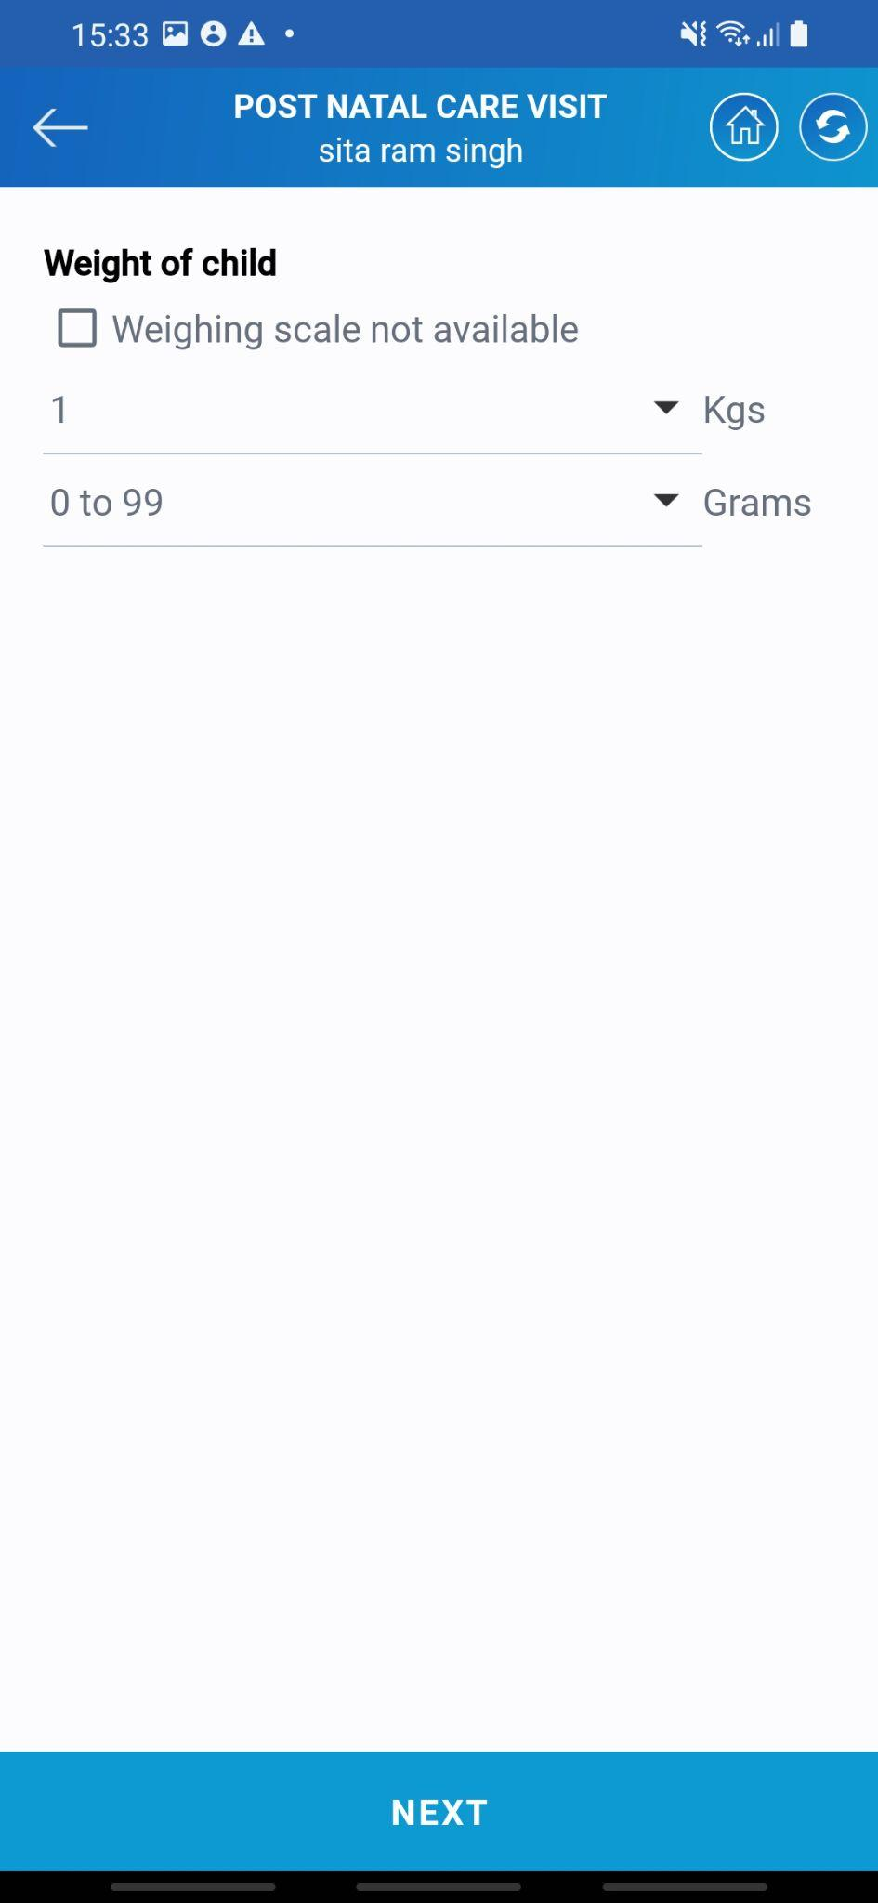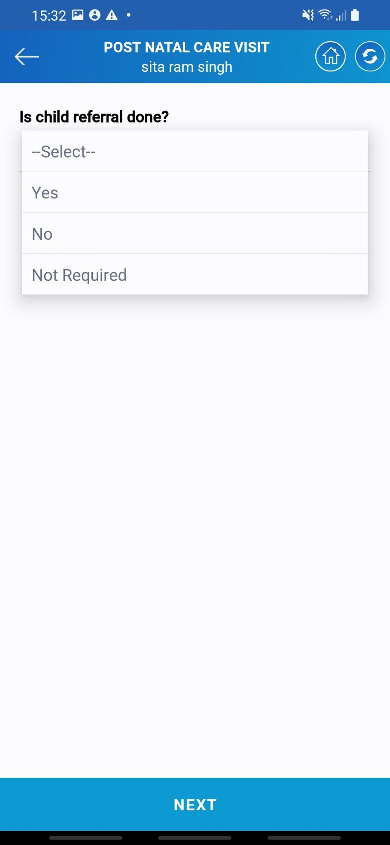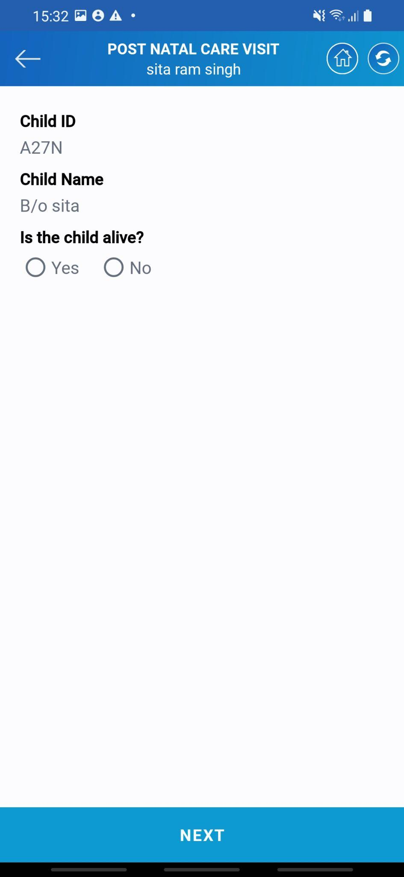

## 

## 

* Similar to mother for child also there are a set of questions related to any kind of deformity or risk facotors.
* Asha needs to enter the details of any kind of deformity the child has from the list of options available from the list of different options available.
* If referral is done asha alsi needs to mention that. At the last asha needs to enter the weight of the child.
* Once all the information is filled tap on the ***NEXT*** button to proceed ahead with childcare.

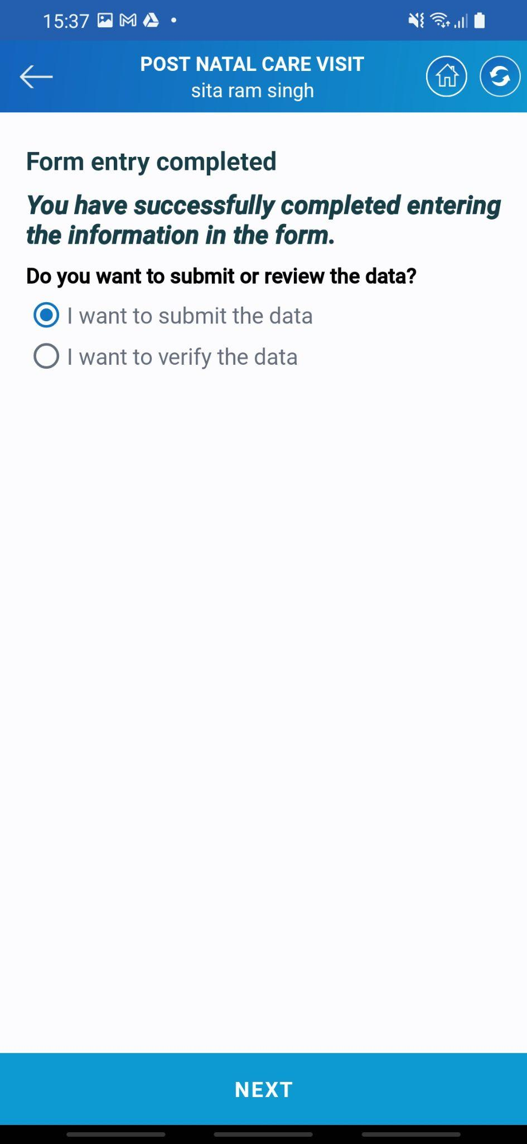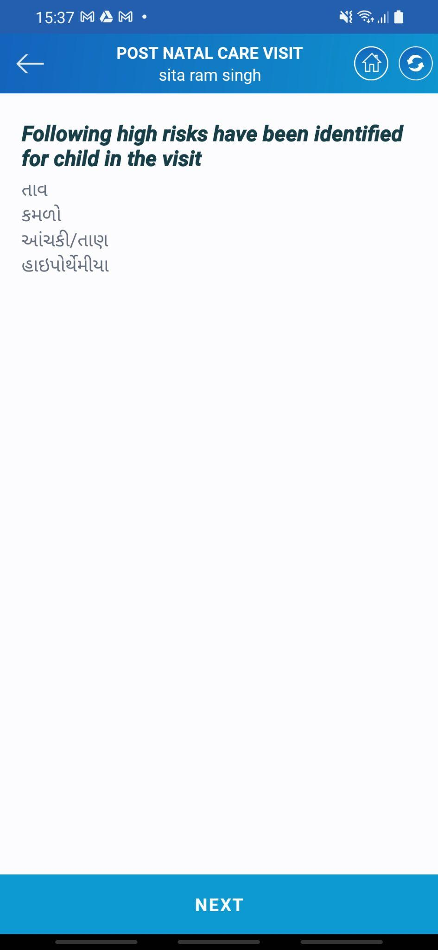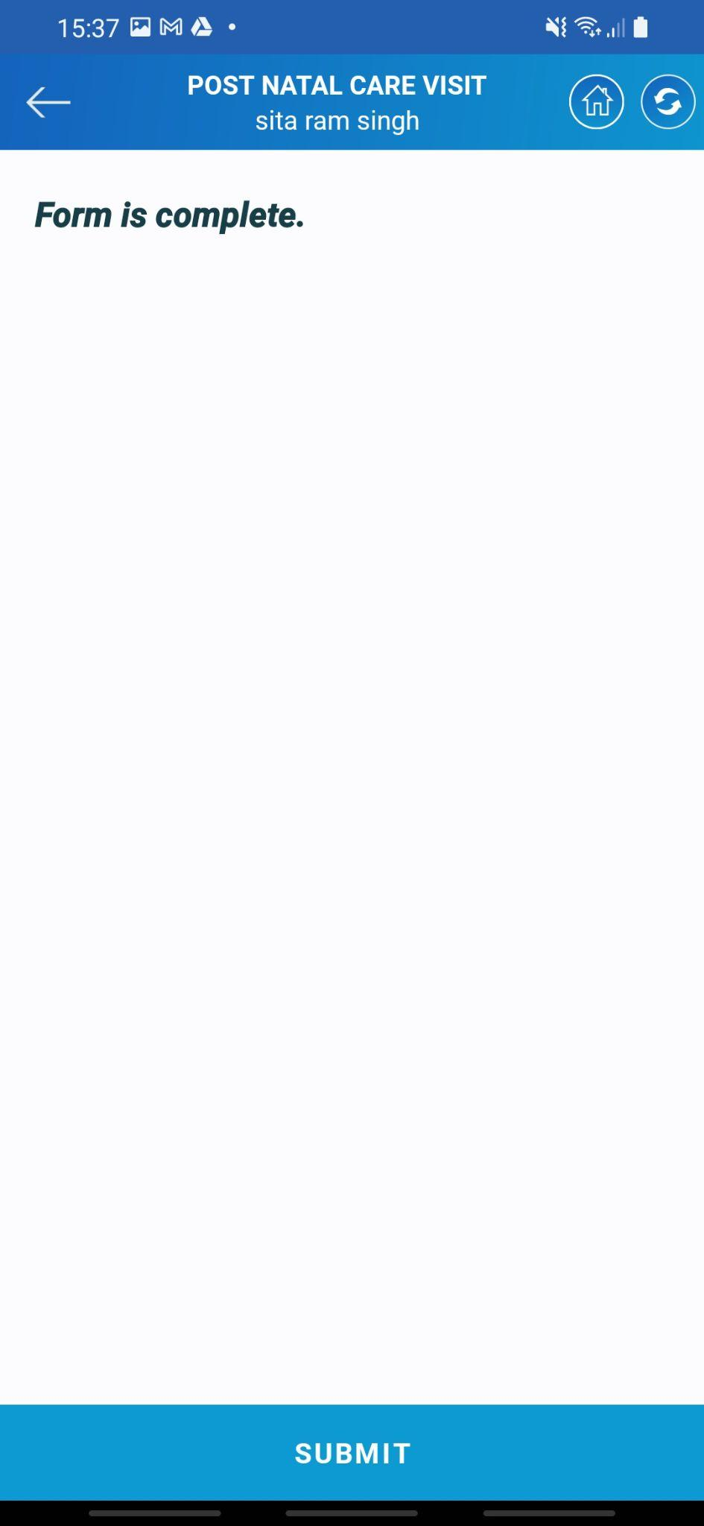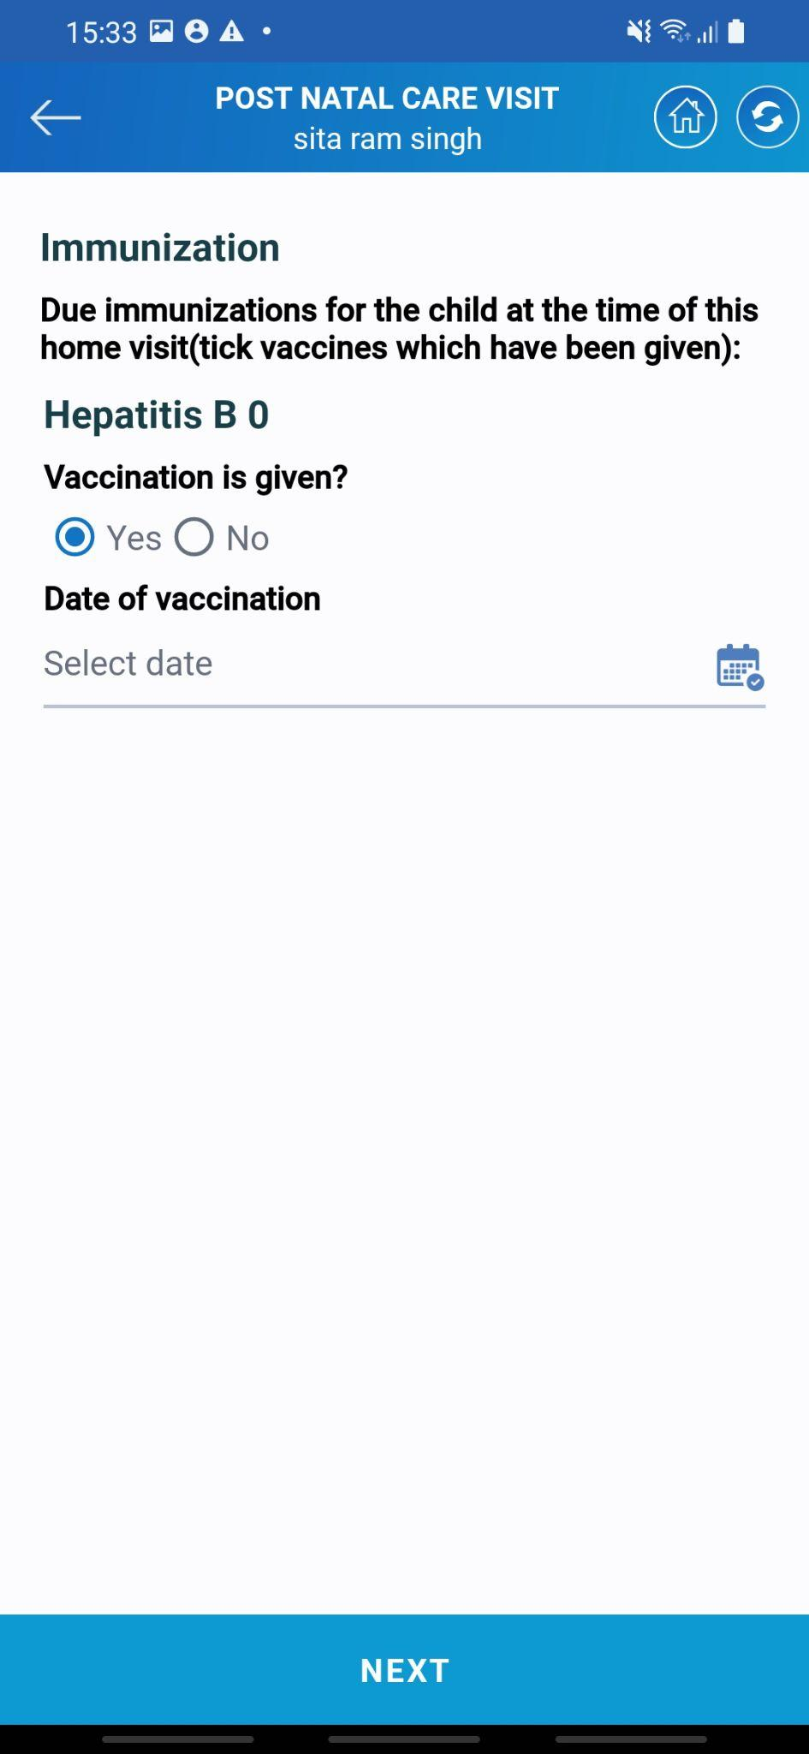

* The next couple of questions will be for child immunization. The list of different vaccines will be there. If given, Asha needs to select yes and enter the dateof immunization.
* Lastly the system will show risk factors if it detects any from the information entered by the asha.
* The system will ask for confirmation of the data. Select the submit option tos submit the data
* System will also show the confirmation once everything is submitted tot the system

### 4.4 Child Services

Postnatal care, also known as postpartum care, is the medical and emotional care provided to a mother after childbirth. It is a crucial period to ensure the mother's well-being, recovery, and adjustment to her new role as a parent. Some essential aspects of postnatal care for mothers are Physical Recovery, Emotional Support, Breastfeeding Support, Nutrition and Hydration, Postnatal Check-ups, Family Planning, Monitoring for Postpartum Complications, etc.

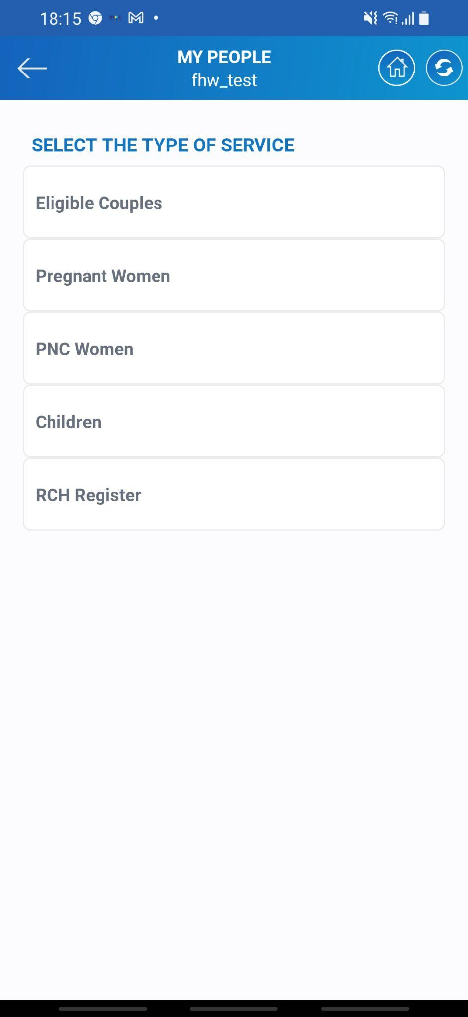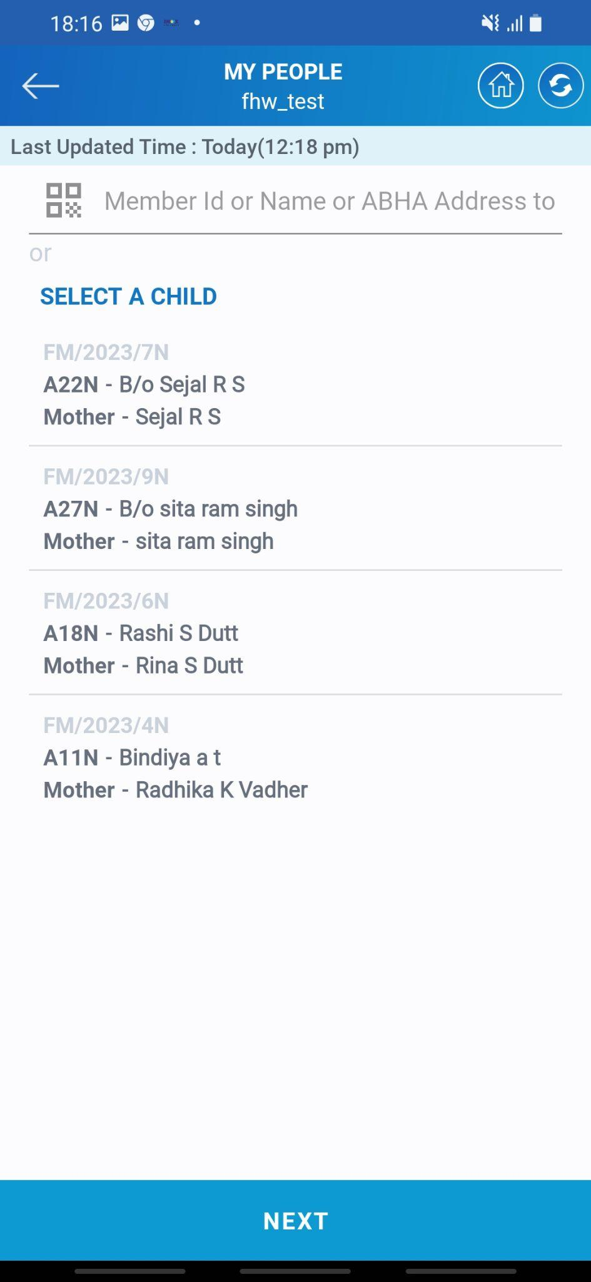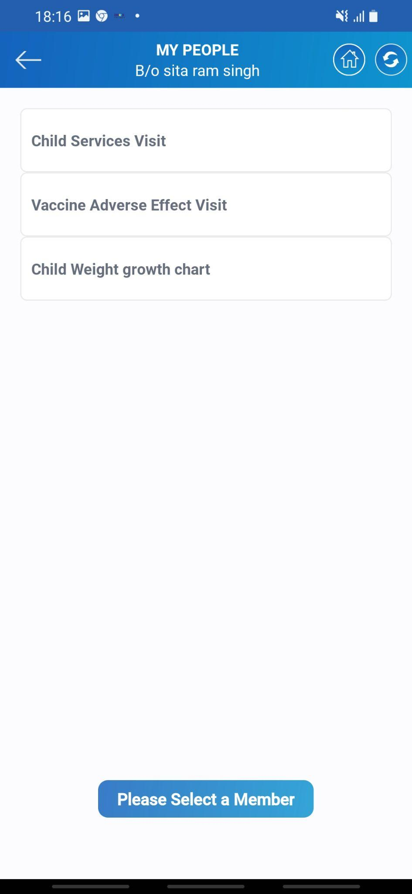

* Tap on the ***Children*** which is highlighted on the screen. Once you click on the next Asha needs to select the beneficiary for whom the visit is to be done. Searching and selecting is similar to all the other visits. Tap on ***Child Services Visit*** to continue with the visit.

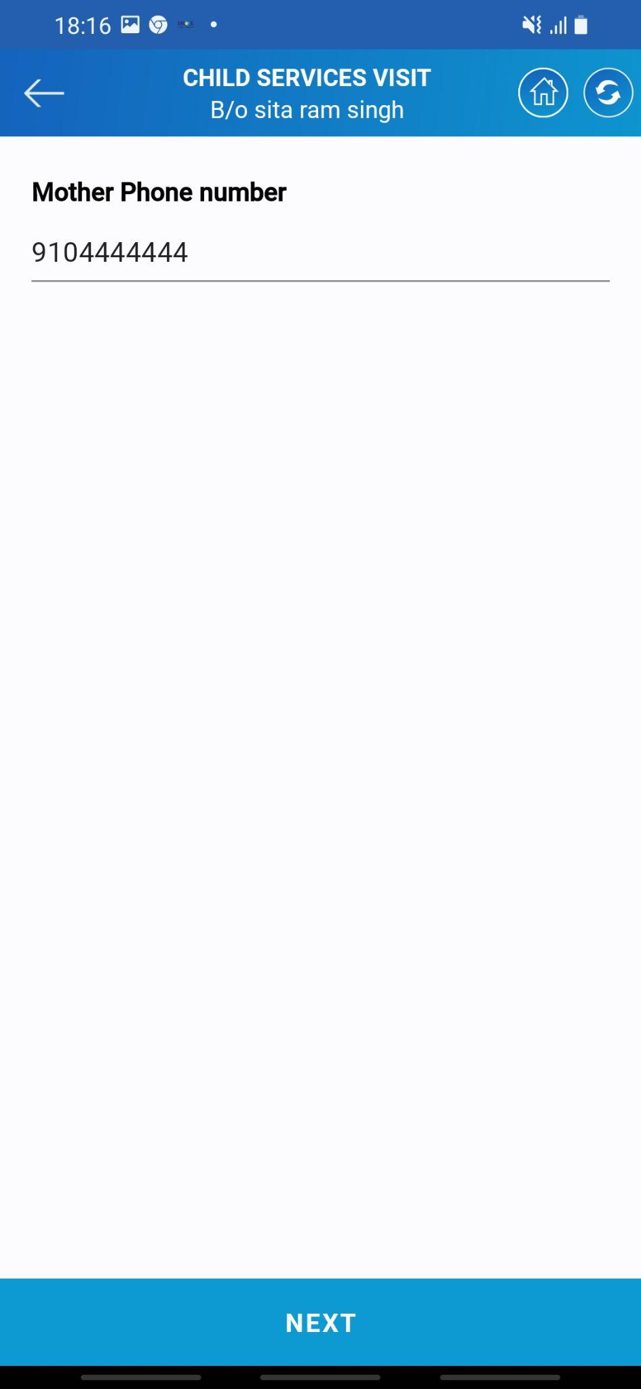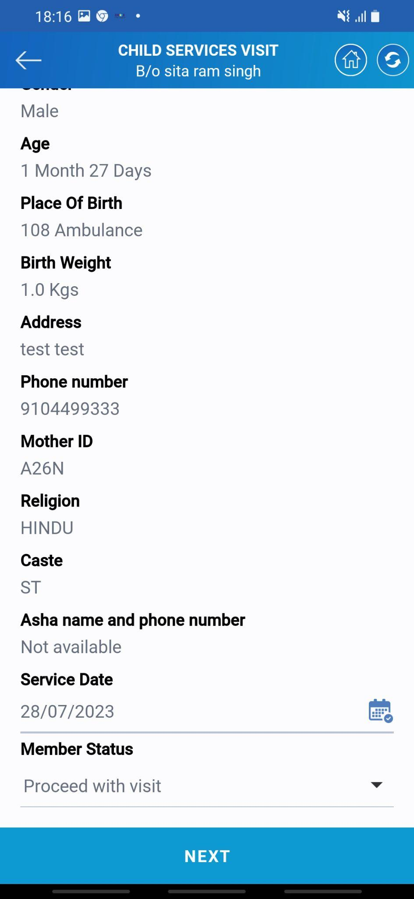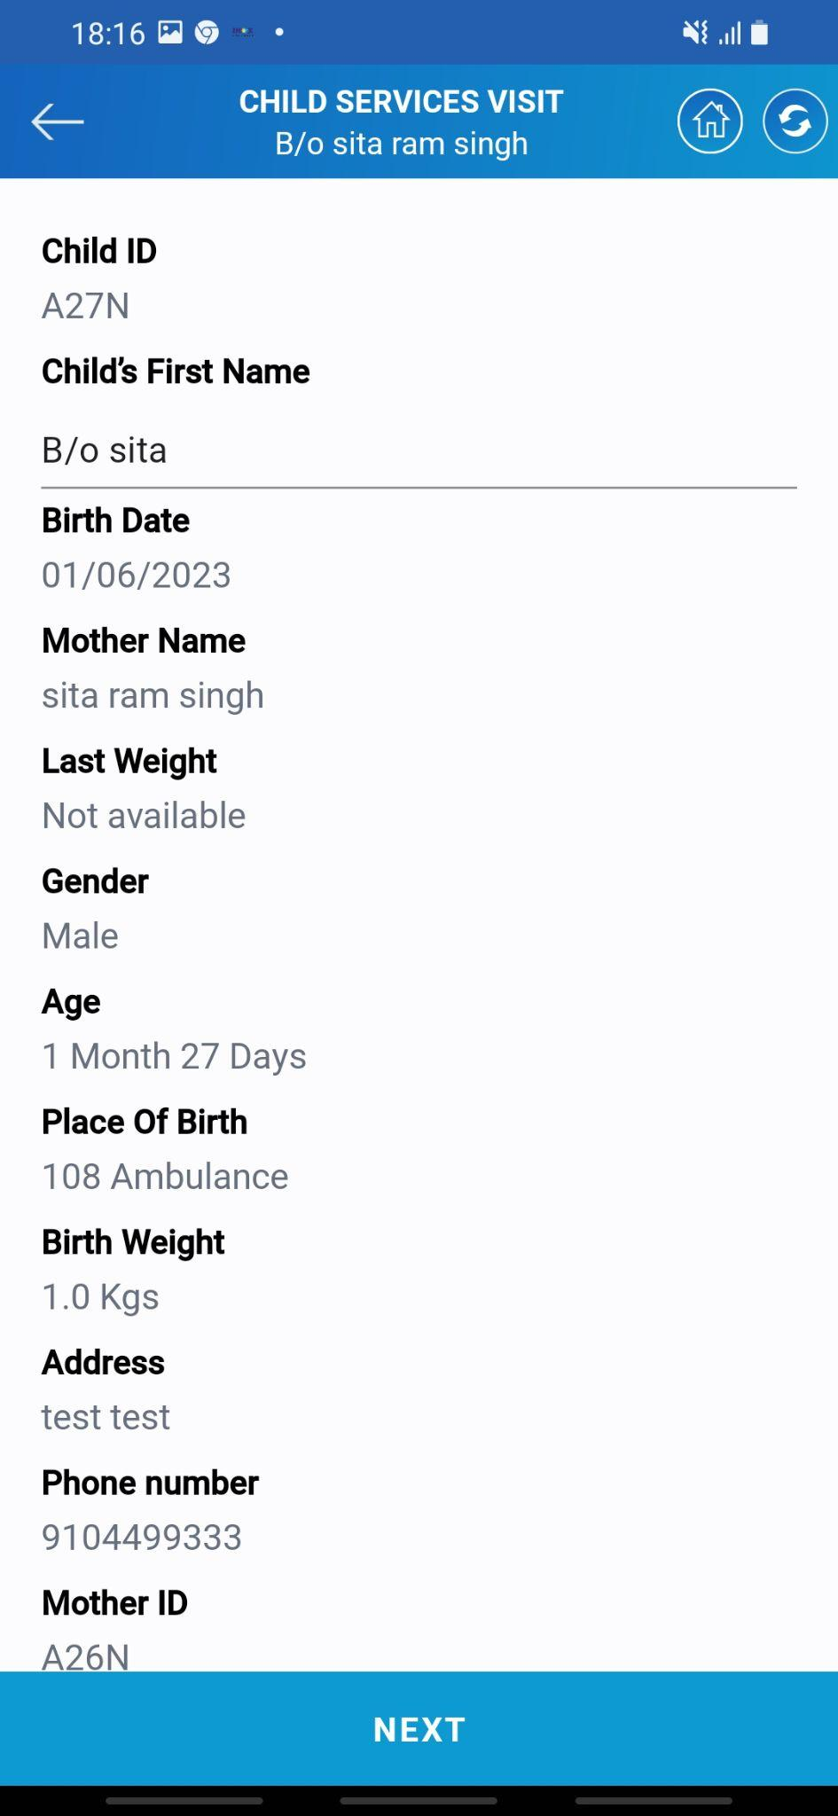

* The system will display the complete information of the beneficiary which is present in the system.
* Asha needs to select the date of service that she gave. The date can be of the current date or before it.
* The next comes to enter the contact details. Asha needs to enter the phone number of the family member.
* Once the information is entered in the system tap on the ***NEXT*** button to proceed ahead with the service.

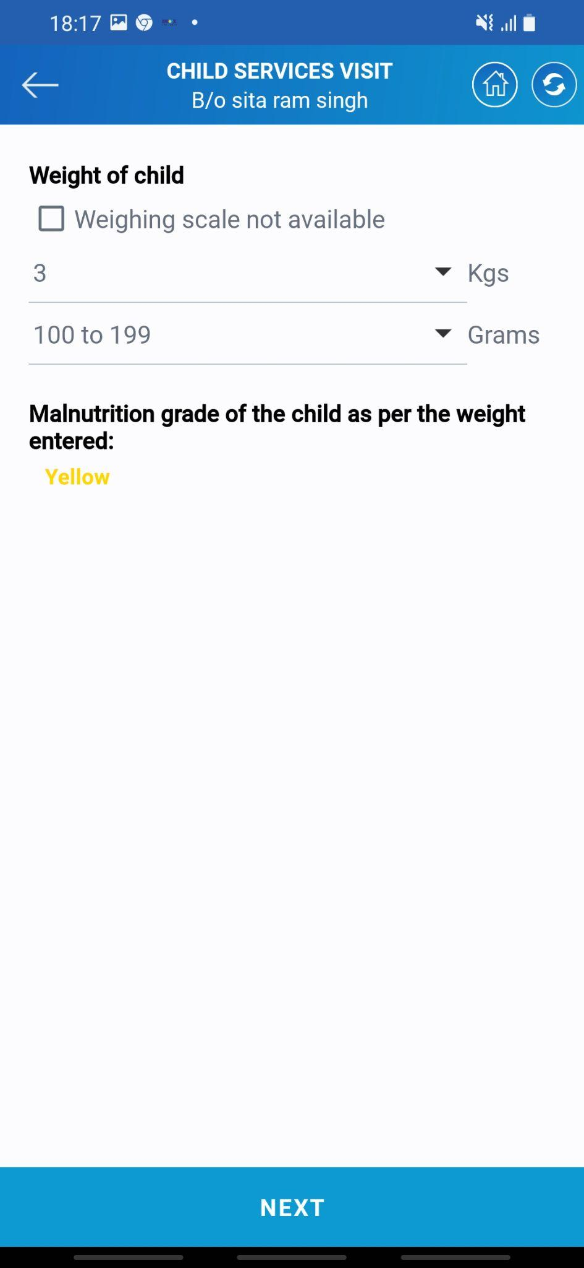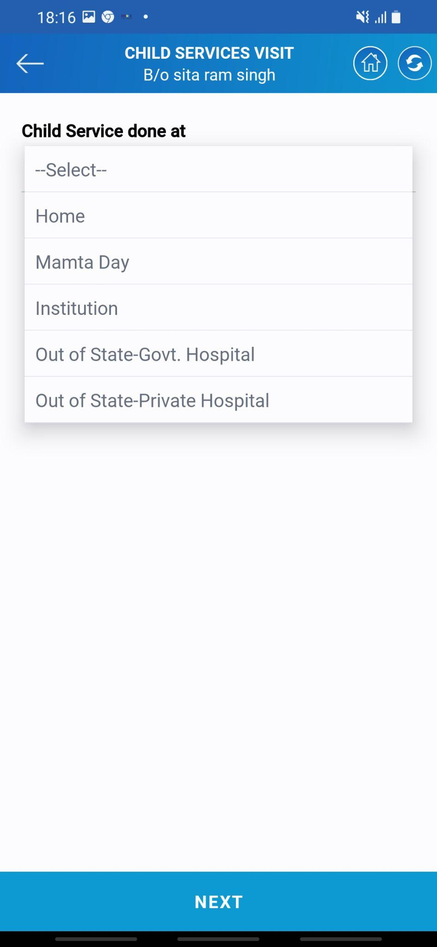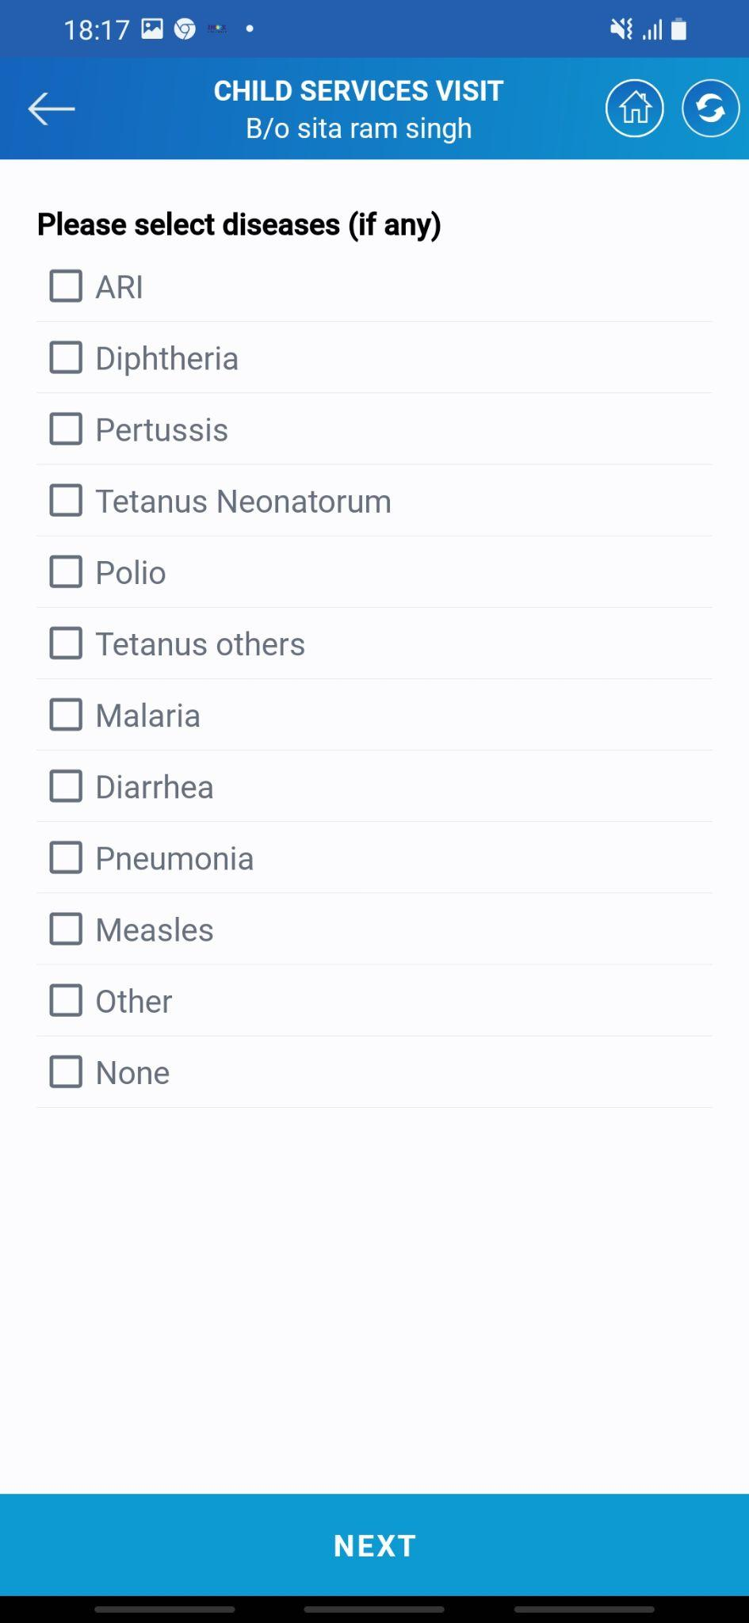

* The next comes the comes the location at which the child service is done. There is a list of different option available.
* Asha also has to enter the weight details for the same. The amount will show the chances of malnutrition in different color code. Red for mal-nurrish, yellow for endangered, and green for normal.
* There is a list of different diseases among which if the child is facing any of them asha must select those.
* Once all the information is entered tap on the ***NEXT*** button to proceed ahead with the visit.

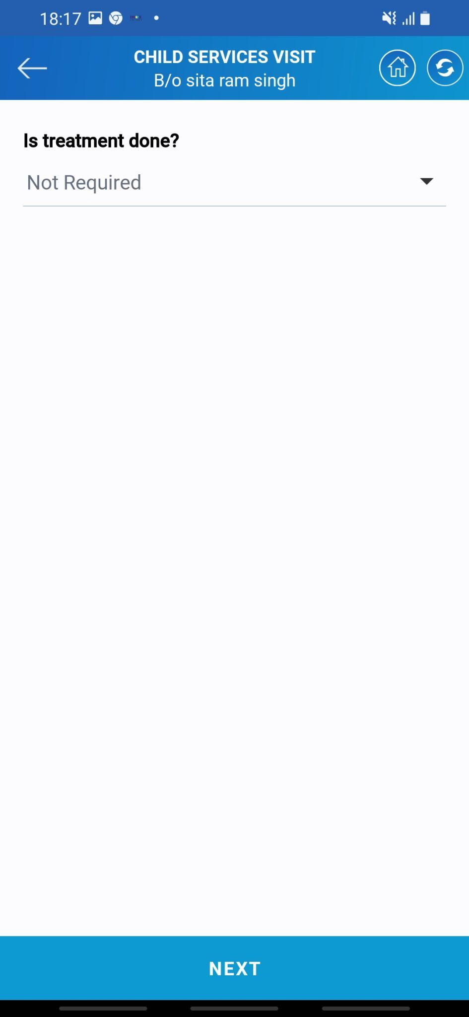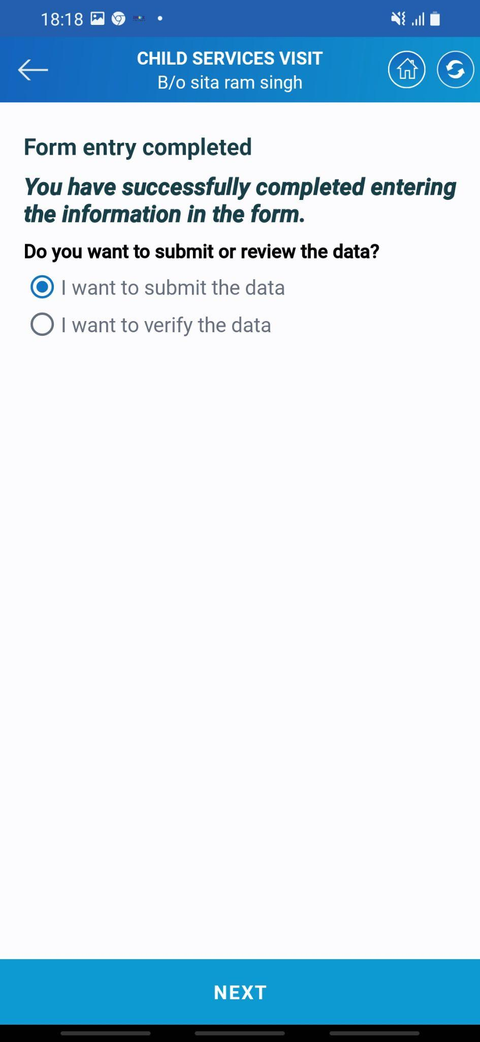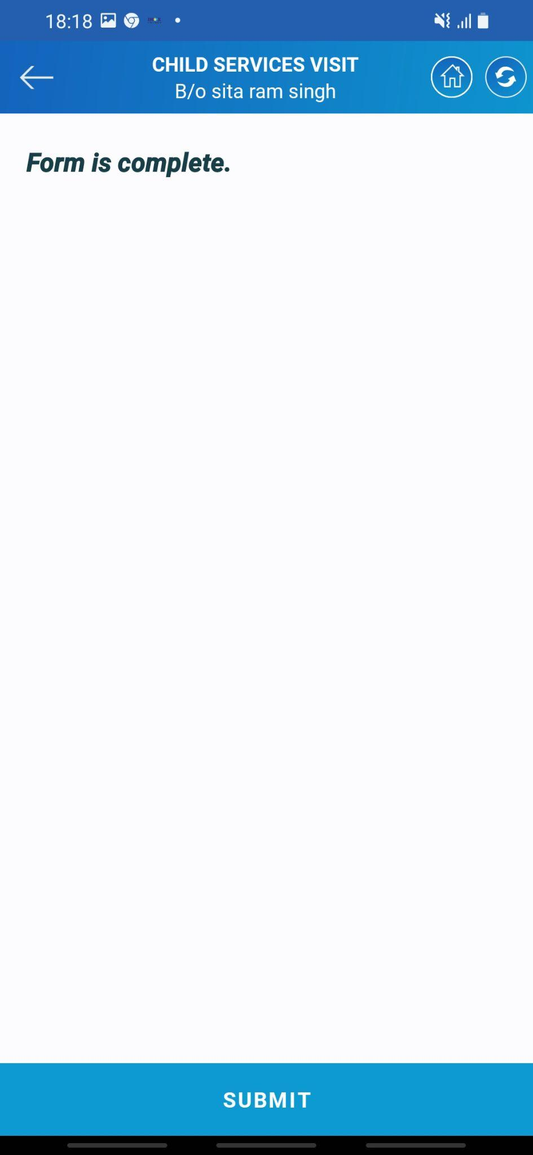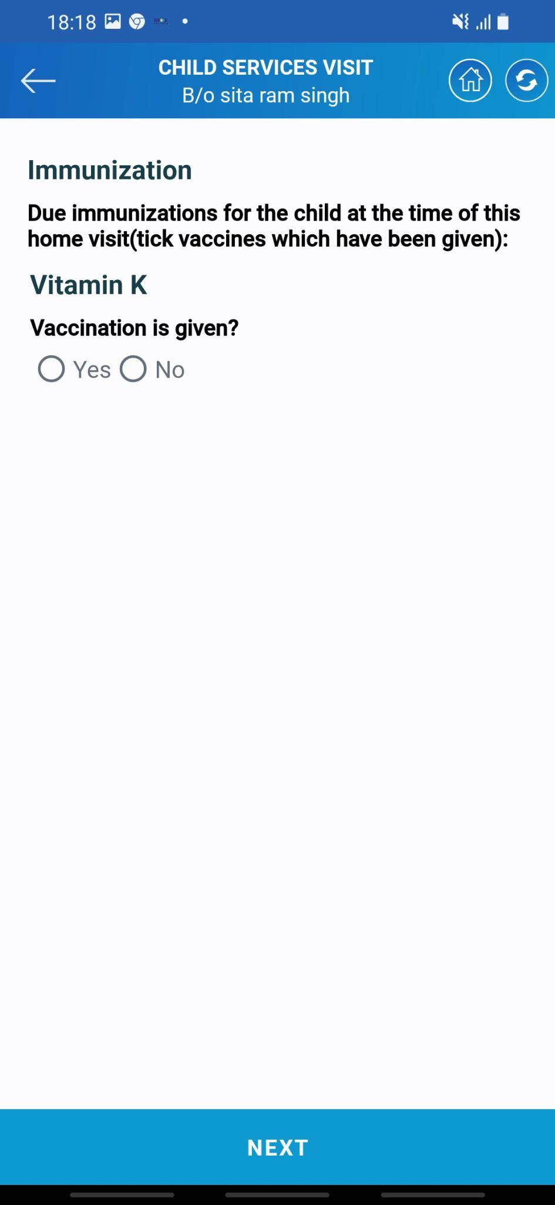

* If any treatment is given to the child than Asha needs to select relavant option.
* The next comes diffrent immunization details. There is a list of different vaccines which need to be given to the child. Asha needs to enter the details of these vaccines if given along with the date of immunization.
* Last the system will ask for confirmation to submit he data. Click on submit the form and tap the ***NEXT*** button to submit the form.
* System will also show the confirmation message that the information is submitted.

## Chapter 5 Glossary

|  |  |
| --- | --- |
| **CFHC** | Comprehensive Family Health Census |
| **RCH** | Reproductive and Child Health |
| **ANC** | Ante Natal Care Visit |
| **PNC** | Post Natal care |
|  |  |
|  |  |